

|  |  |
| --- | --- |
| Peter Zamiska (Project Manager)  Jordan Cole  Haohui Lu  Wheeler Weise  Shaalan Alqarni | peteyz28@siu.edu  jory@siu.edu  scofield0308@siu.edu  wheeler.weise@siu.edu  alqarni.shaalan@gmail.com |

# Table of Contents (WW)

Table of Contents (WW) 2

Table of Figures (WW) 2

Table of Tables (WW) 3

Table of Drawings (WW) 4

Acknowledgements (PZ) 5

Transmittal Letter (PZ) 6

Executive Summary (PZ) 7

Introduction (PZ) 7

Project Description (PZ) 8

Overall Printer Diagram (WW) 10

Costs (ALL) 11

Schedules (PZ) 11

Subsystem Descriptions 14

Frame (HL) 14

Process of Design 16

Process of Assembling 21

Excess Powder Removal System 22

Implementation Schedule 23

Equipment Needed 24

Health, Safety and Environmental Issues 25

Fault Analysis 25

Subsystem costs 25

Conclusions and Recommendations 26

X/Y Translation (JC) 26

Overview 26

Makerslide Aluminum Rails 27

X/Y Carriages 28

Costs 31

Roller Mechanism (JC) 31

Costs 34

Powder Platforms (PZ) 35

Description 35

Design 37

Costs 41

Implementation Schedule 42

Health and Safety Issues 43

Fault Analysis 43

Conclusions and Recommendations 43

Powder and Binding Agents (HL) 44

Printing Powder Recipe 44

Particulate Mixture Adhesive 45

Binding Agent Liquid Recipe 48

Ingredients & materials 50

Equipment Needed 51

Implementation Schedule 51

Health, Safety and Environmental Issues 52

Costs 52

Conclusions and Recommendations 53

Computer Host Software (WW) 54

Overall Functional Description 54

Design Options 54

Main Design Approach 54

Communication Protocol 55

Part Processing 59

Graphical User Interface 61

Flow of Printing Operation 63

Other Important Classes and Concepts 63

Experiments and Performance 65

Fault Analysis 68

Conclusions and Recommendations 68

Electronics (WW) 69

Overall Functional Description 69

Design options 69

Chosen Hardware 69

Costs 71

Implementation Schedule 72

Fault Analysis 73

Experiments and Performance 73

Conclusion and Recommendations 75

Microcontroller Software (WW) 76

Overall Functional Description 76

Design Options 76

Design Approach 76

Conclusions and Recommendations (PZ) 79

Other Issues (SA) 79

Health and Safety Consdierations 79

Environmental and Societal Issues 80

Conclusions and Recommendations (PZ) 80

Appendices 82

Full System Test Lab Report (WW/PZ/HL) 84

Objective 84

Procedure 84

Results 84

Drawings 89

# Table of Figures (WW)

Figure 1: Overall Printer Block Diagram (WW) 11

Figure 2: SEC Semester Schedule, As planned and as worked (ALL) 13

Figure 3: Implementation Schedule (PZ) 14

Figure 4: Original design of the frame (PZ) 15

Figure 5: Original design of the X/Y carriage and platforms (PZ) 16

Figure 6: Second design of the frame (PZ) 16

Figure 7: Third design of the frame (PZ) 17

Figure 8: Bottom base of frame (PZ) 18

Figure 9: Corner Columns of frame (PZ) 18

Figure 10: Side panels of the frame (PZ) 19

Figure 11: Front and back covers on frame (PZ) 19

Figure 12: Back cover detailed view (PZ) 20

Figure 13: Front cover detailed view (PZ) 20

Figure 14: Top panel on the frame (PZ) 21

Figure 15: Top panel detailed view (PZ) 21

Figure 16: Assembling with the corner columns (HL) 22

Figure 17: Assembling with bottom base and corner columns (HL) 23

Figure 18: Design of the excess powder funnel and cup (HL) 24

Figure 19: Door in the excess powder subsystem (HL) 24

Figure 20: Initial X/Y assembly design (PZ) 27

Figure 21: Cross section of Makerslide rail bars (JC) 28

Figure 22: Aluminum Makerslide rails (JC) 28

Figure 23: Belt clips securing the GT2 timing belts (JC) 29

Figure 24: Creo representation of belt clips (JC) 29

Figure 25: Creo representation of motor mount plates (JC) 30

Figure 26: Motor mount assembly exploded view (JC) 30

Figure 27: Linear motion mechanism (JC) 31

Figure 28: Wheels on rail system (JC) 31

Figure 27: Delrin V-wheel assembly diagram (JC) 31

Figure 30: Creo parametric representation of custom motor plate (JC) 32

Figure 31: Creo parametric representation of the rolling mechanism plate (JC) 33

Figure 32: Rolling mechanism plate, mounted (JC) 33

Figure 33: Rolling mechanism coupled with the stepper motor (JC) 34

Figure 34: Rolling mechanism stepper motor (JC) 34

Figure 35: Rolling mechanism mounted to X/Y translation assembly (JC) 35

Figure 36: Powder Platforms Subsystem (PZ) 36

Figure 37: Pwdr. 3D Printer Project [10] (PZ) 37

Figure 38: Linear positioning system (PZ) 37

Figure 39: Powder Print Platform (PZ) 38

Figure 40: Nanotec Linear Positioning System [11] (PZ) 39

Figure 41: Anti-backlash nut design (PZ) 40

Figure 42: Nylon-insert nut [12] (PZ) 40

Figure 43: Working details of the Powder Source Platform and the Powder Print Platform (HL) 45

Figure 44: Powder Recipe Diagram (HL) 46

Figure 45: Powdered sugar (HL) 47

Figure 46: Plaster of Paris (HL) 47

Figure 47: Maltodextrin (HL) 48

Figure 48: Lecithin (HL) 48

Figure 49: Lecithin (HL) 49

Figure 50: Distilled water (HL) 49

Figure 51: Glycerol (HL) 50

Figure 52: Ethylene Glycol Dicetate (HL) 50

Figure 53: Navy blue dye (HL) 51

Figure 54: Cartridge and Ink Assembly (SA) 52

Figure 55: Holes on the cartridge (SA) 52

Figure 56: Overall Software Flow (WW) 55

Figure 57: Communication Protocol Flow (WW) 57

Figure 58: Packet Processing Flow (WW) 57

Figure 59: Appending the payload header and footer (WW) 58

Figure 60: Code snippet of Checksum calculation method (WW) 59

Figure 61: Sending Packet Format (WW) 59

Figure 62: G Code Processing Flow (WW) 60

Figure 63: Code snippet of LayerProcessing (WW) 61

Figure 64: Main GUI For Printer Control (WW) 62

Figure 65: Screenshot of G Code processing tab (WW) 63

Figure 66: Flow chart of packets to print a part (WW) 64

Figure 67: Code snippet of PacketHolder and Translate classes (WW) 65

Figure 68: LayerProcessing Test Using MATLAB (WW) 67

Figure 69: TestPart code result on some binding powder (WW) 67

Figure 70: TestPart code fixed (WW) 68

Figure 71: Sliced and printed gear on some binding powder (WW) 68

Figure 72: Code snippet of Checksum calculation method [7] (WW) 70

Figure 73: EasyDriver Stepper Motor Driver [6] (WW) 70

Figure 74: Small heatsink used for stepper motor drivers [9] (WW) 71

Figure 75: Stepper Motor Driver for X and Y axes [8] (WW) 71

Figure 76: InkShield attached to an Arduino MEGA with connected inkjet cartridge [4] (WW) 71

Figure 77: Arduino MEGA [3] (WW) 71

Figure 78: Big Easy Driver viewed with IR Camera (WW) 75

Figure 79: Printer Electronics Wiring (WW) 76

Figure 80: Microcontroller Software flow (WW) 78

Figure 81: Code snippet of Powder Platform Translation (WW) 78

Figure 82: Code snippet of Platform completion notification code (WW) 79

Figure 83: Code snippet of print line information processing (WW) 79

Figure 84: Sample for recommended platform system (WW) 82

Figure 85: DuPont Teflon non-stick dry film lubricant product [15] (WW) 82

Figure 86: Example of frame design recommendation (WW) 83

Figure 87: The surface of powder on the platforms (WW) 86

Figure 88: Powder sticking on the rolling bar (WW) 86

Figure 89: Unsmooth surface on the platform and product (WW) 87

Figure 90: Recover of part from powder bed (WW) 87

Figure 91: Dusting off of recovered part (WW) 88

Figure 92: Broken Product (WW) 88

Figure 93: Uneven powder distribution (WW) 89

# Table of Tables (WW)

Table 1: Prototype Costs 11

Table 2: Implementation Costs 11

Table 3: Detail of parts in frame subsystem (HL) 21

Table 4: Prototype cost of frame subsystem 25

Table 5: Implementation cost of (PZ)frame subsystem 25

Table 6: Prototype cost of X/Y translation subsystem (JC) 31

Table 7: Implementation cost of X/Y translation subsystem (JC) 31

Table 8: Production cost of roller mechanism subsystem (JC) 34

Table 9: Prototype cost of powder platforms subsystem (PZ) 41

Table 10: Estimated implementation cost of powder platforms subsystem (PZ) 42

Table 11: Powder and Binding Agent Recipe compositions (HL) 50

Table 12: Prototype cost (HL) 52

Table 13: Implementation Cost (HL) 53

Table 14: PrintTimeEstimator Accuracy Test Results (WW) 68

Table 15: Part Processing Time Comparison (WW) 68

Table 16: Motor Selections with respective Stepper Motor Drivers (WW) 69

Table 17: Actual Design Costs (WW) 71

Table 18: Implementation Costs (WW) 72

# Table of Drawings (WW)

Drawing 1: Makerslide cross section (JC) 90

Drawing 2: Roller plate - Motor (JC) 91

Drawing 3: Pwdr. Project's X/Y Translation assembly drawing (JC) 92

Drawing 4: Rolling Plate - Bearing (JC) 93

Drawing 5: Makerslide belt clip (JC) 94

Drawing 6: Makerslide motor mounting plate (JC) 95

Drawing 7: Makerslide eccentric nut (JC) 96

Drawing 8: Rolling Mechanism Flange (JC) 97

Drawing 9: Base Panel (PZ) 98

Drawing 10: Back Panel (PZ) 99

Drawing 11: Coupler Set Screw (1/16th) (PZ) 100

Drawing 12: Coupler (PZ) 101

Drawing 13: Frame Column A (PZ) 102

Drawing 14: Frame Column B (PZ) 103

Drawing 15: Front Panel (PZ) 104

Drawing 16: Glass Panel 7.5 x 4 in (PZ) 105

Drawing 17: Glass panel 7.5 x 6 in (PZ) 106

Drawing 18: Glass side panel (PZ) 107

Drawing 19: Lead Nut (PZ) 108

Drawing 20: Nema stepper motor (PZ) 109

Drawing 21: Platform panel bracket (PZ) 110

Drawing 22: Platform Subsystem (PZ) 111

Drawing 23: Platforms Exploded View (PZ) 112

Drawing 24: Powder Platform side panel (PZ) 113

Drawing 25: Powder Print Platform base panel (PZ) 114

Drawing 26: Powder Print Platform top panel (PZ) 115

Drawing 27: Powder Source Platform base panel (PZ) 116

Drawing 28: Powder Source Platform top panel (PZ) 117

Drawing 29: Side Panel A (PZ) 118

Drawing 30: Side Panel B (PZ) 119

Drawing 31: Teflon - Powder Print Platform (PZ) 120

Drawing 32: Teflon - Powder Source Platform (PZ) 121

Drawing 33: Wood Spacer (PZ) 122

Drawing 34: Z Motor Screw (PZ) 123

Drawing 35: Ink Assembly - plexiglass mounting plate (PZ) 124

Drawing 36: Electronics Circuit Wiring Diagram (WW) 125

# Acknowledgements (PZ)

First and foremost, we would like to express our very great appreciation to Dr. Tod Policandriotes. He was undoubtedly a tremendous asset to the design project. Our team’s progress was much larger than it would have been without his generous donations of tools, hardware, electronics, time, and guidance.

We are particularly grateful for the assistance of Tim Attig of the SIUC Mechanical Engineering Machine Shop, as well as his student employees. His superior machining knowledge and skills had an enormous positive impact on the project’s progression. His willingness to give his time and technical advice so generously was very much appreciated.

We also take this opportunity to express a deep sense of gratitude to the team’s Faculty Technical Advisor, Dr. James Mathias, for his constant support, valuable guidance, and professional advice throughout the various stages of the design project.

We offer special thanks to the local businesses that were involved with the design project: Crispin Glass & Auto, Morris Library of SIUC, and Rix Enterprise.

We also thank Smalley Steel Ring Company, and BoltDepot.com for their generous fastener donations.

Last but not least, we would like to thank the faculty of the College of Engineering of SIUC for their critical advice and guidance, without which this project would not have been nearly as successful.

# Transmittal Letter (PZ)

April 18th, 2014

Saluki Engineering Company

Southern Illinois University Carbondale

College of Engineering – Mail Code 6603

Carbondale, IL 62901

Joseph Lenox

Electrical and Computer Engineering

Southern Illinois University Carbondale

Carbondale IL, 62901

Dear Mr. Lenox,

On behalf of Saluki 3D Innovations, I would like to thank you for choosing our team to design you a 3D printer. Attached is a design report for a personal inkjet-based 3D printer. Along with the report, we have included the computer host software code, engineering drawings of the prototype’s components, and a lab report describing printing results.

A prototype has been constructed that implements a unique printing process to produce physical models of CAD generated parts at a low cost to the user. My team and I have just recently began testing the prototype, the results have not been optimum. However, we have various experiments and upgrades in mind to increase the quality of the printed models.

The printer has been designed to be user friendly and affordable, while being capable of producing quality models. The X/Y translation has been designed to resemble that of common tabletop CNC machines. Its carriage is equipped with a rolling mechanism that is utilized to evenly distribute printing material throughout the top panel of the frame to the appropriate printing area. Said frame has been designed to allow significant freedom to mount electronics and allow for proper ventilation, while being structurally sound. The Z-axis translation incorporates linear positioning systems that are able to raise and lower the printing platforms at a user specified distance.

We thank you again for the opportunity to design and build a personal 3D printer prototype. If you have any questions or concerns regarding the attached documents, feel free to contact us.

Sincerely,

Peter Zamiska

Project Manager

Saluki 3D Innovations: Team 54-3DPR

Saluki Engineering Company

(309)-319-0916

peteyz28@siu.edu

# Executive Summary (PZ)

The goal of this project is to design and prototype a personal, open-source, three-dimensional inkjet printer. At this stage in the project the prototype has just recently became operational. For that reason, the actual performance data and results of the prototype are limited. The team has conducted an experiment involving two printing trials. These two trials involved printing a single gear, the first one scaled 1:1 and the second one scaled up to 2:1 with a few adjustments to the printer settings. Although the results were not optimum, they were still better than the results of numerous projects of a similar nature. Prior to the full system tests of the prototype, the team has been successful in small-scale performance tests. Printing in two-dimensions on a sheet of paper and thin layer of powder has been successful. A layer of a test square has been printed on paper and powder. In addition, a CAD model of a small gear was successfully sliced and transferred into printing instructions by the Computer Host Software, and printed on a sheet paper as well as a thin layer of powder.

The major subsystems of the prototype include: the Rolling Mechanism, Frame, X/Y Translation System, Powder Platforms, Microcontroller, Computer Host Software, and the Electronics. Our team is still striving to achieve the lowest possible cost, while maintaining a superior level of quality. To minimize costs, the frame was assembled using Baltic Birch plywood and wood screws. To ensure quality, the X/Y translation system was redesigned and built based on that of standard tabletop CNC machines.

Numerous design activities and decisions deem our prototype more desirable than the competition. For example, the Powder Platforms Subsystem incorporates a Teflon-to-glass relationship; rather than most of the other similar models who leave a clearance between their platforms and the walls of the chamber, our prototype found an excellent solution that eliminates the clearance AND minimizes friction while the platform is in motion. A second superiority of our prototype is the X/Y translation System. We chose to sacrifice a small amount of funding in order to have a significant increase on simplicity and quality. The translation system is that of common tabletop CNC machines. It is simple to assemble, functions much better than designs of similar prototypes, and ensures uniform motion of the X/Y carriage, which ensures consistent quality.

This printer is expected to have the capability of producing high quality, low-cost models for our client. Initial goals included: keeping the total cost of this project under $1000, not exceeding a printer size of 2x1.5x1.5 ft. while providing a build volume of at least 6𝑖𝑛3, have an average printing speed of less than 2 minutes per layer, and be capable of printing layers at least 500 microns thick with a resolution of at least 96 DPI.

The prototype adequately met the initial goals. The project ended up costing the team about $1311. However, the cost to implement the design has been estimated to be only about $1045. This amount is only a mere $45 above the goal of the project. Plus, it is highly likely that an in-depth review of vendors could result in an implementation cost that is well under $1000. The size goals of the printer were met. In fact, the total volume that the prototype incubuses is 7.5𝑖𝑛3 less than the set goal. The build volume is slightly less than the set goal, but is still quite large at 5𝑖𝑛3. The print layer thickness and resolution goals have also been met. However, the quality of the printed models still need significant improvement. The team advises to allow further experimentation and innovation in order to improve the quality of the prints, only then will this venture be profitable.

This report consists of: a project description to introduce the report, a cost analysis that compares the prototype cost to the estimated implementation cost, an implementation schedule, detailed subsystem descriptions, a section focusing on broad picture issues, a recommendations section, and an appendix.

# Introduction (PZ)

3D Printing is an up-and-coming technology that utilizes additive technology to create a physical model, or part. From the business standpoint, as a result, time is saved during decision-making. Additionally, cost is decreased by decreasing the amount of money put into bad ideas and products that were unable to be visualized or physically held prior to the decision to invest, as well as decreasing the amount of money spent on labor.

Although there are large amounts of commercial and industrial applications, our team’s focus targeted making it easy and affordable to have a 3D printer in the household. The benefits to owning a personal three-dimensional printer are endless. Many parts and products that are in demand are no longer available or are extremely expensive; these could be printed at a low cost, right at home. Currently, the market for 3D printers is growing at a rapid pace. However, the price and quality of personal 3D printers is not improving as fast as the market. Different models are being designed and produced, but most of them are essentially the same design. Our initial request for proposal was based on this design. This popular design uses a programmed tip that heats up plastic filament and extrudes it in a predetermined pattern. The quality, speed, and cost of these printers are moderate. However, they can be unreliable, unexpected errors can occur frequently, and the quality of the prints is not appropriate for intricate and small models. Consumers, including our client, need a machine that they can depend on, are affordable, and can produce high quality models. That is why we communicated and worked with him to focus on a design that would result in his maximum satisfaction of printing quality and abilities.

Saluki 3D Innovations is working towards designing and constructing an open source 3D printer prototype that is capable of meeting these requirements. We incorporated a printing process that is virtually nonexistent in the personal 3D printer market. The technology is much like 2D inkjet printing; rather than printing on new sheets of paper, it deposits a binding agent onto new layers of powder. This process has the capability of printing quality parts at a low cost to the user. It is our goal to design and construct a printer prototype along these criteria. Currently, printers of this classification are being sold on the market at an average price of $15,000; the professional and commercial systems are being sold for an upwards of $50,000. A high quality prototype as a result of our design would have drastic effects on the 3D printer market. It has been a significant learning experience putting our engineering skills and talents together to achieve this goal, we are excited to strive to achieve an optimum prototype in the near future.

# Project Description (PZ)

To satisfy our client’s request, our team has designed a personal, affordable, open-source three-dimensional printer that has the capability to produce high quality models. We have just recently been successful with the prototype being fully operational. Therefore, we have had a limited amount of time to test the prototype. We were able to carry out two full system tests in this limited time. The tests ended up being successful. However, we concluded that a significant amount of experimentation will be needed to understand the appropriate adjustments and innovations necessary to obtain high quality prints. We highly advise this further experimentation. If successful, it will allow this design to be quite profitable.

The initial request for proposal was to design and build a better RepRap machine: an open-source, self-replicating, personal, desktop-sized, three-dimensional printer. This RepRap Project was based on the Gada Prize contest. The printer specifications of this project would have been extremely difficult and expensive to achieve (such as printing with three different types of materials). Therefore, with the agreement of the client, the request was modified.

All of the various printing techniques and processes were analyzed for plausibility of a project basis. This plausibility was concerned with the project’s financial cost, labor cost, and potential innovation and engineering activities. The most common 3D printing process is Fused Deposition Modeling, or FDM. We chose not to base our project on FDM because it did not seem like we would be able to incorporate enough engineering activities while staying within budget. Stereolithography was another printing process that was analyzed. We found that it seemed to be too expensive and labor intensive. While considering Photo-Polymerization, we found that the print material was too expensive for our desired criteria. Laminated Object Manufacturing, or LOM, was found to be very environment unfriendly. The rest of the printing processes that were considered incorporated a high-powered laser to print. These types of projects would have required significant knowledge of optics, as well as too much funding and too much time needed to base our project on. For these reasons, we decided to focus our design project on 3D Inkjet Printing. This process was deemed to be the most affordable and least time consuming. Plus, it offered the capability of significant innovation and superior quality of prints.

Thus, our deviation from the initial request for proposal included an entirely different printing process and printing technology. This process is much like two-dimensional inkjet printing; rather than printing on sheets of paper, the 3D printer prints on sheets of powder that are layered on top of each other. The powder has plaster-like characteristics. Instead of depositing ink, the ink cartridge deposits a binding agent, mostly made up of distilled water. Once the binding agent comes into contact with the powder, it activates the binding characteristics of the powder, initializing a solidification process.

Our client, being a member of the Electrical and Computer Engineering Department of our university, will be allowed personal access to the printer. He will receive a User Manual, Technical Manual, a CAD model of the printer, the powder and binding agent recipes, and a limited amount of powder and binding agent. The maximum build volume of the printer is about 5 cubic inches. The printer is desktop-sized, specific maximum dimensions are 21.5x16.5x20.75 inches.

The mechanics block diagram describes the printing process that our prototype will follow. To begin, the computer host software communicates with the electronics and initializes the printing process. Electronics cause the two X translation stepper motors of the X/Y carriage to move the carriage across the printing platform, they operate in unison. In addition, another X translation motor attached to the X/Y carriage causes the powder distributing rod, part of the rolling mechanism, to roll in reverse while the carriage moves across the printing platforms. This helps make sure that each print layer is flat, smooth, and of the same consistency. Once the X/Y carriage is completely across the platforms, it may begin printing the first layer. The X translation motors move the X/Y carriage back across the powder print platforms, in steps (intervals). Between each step, the Y translation stepper motor forces the X/Y carriage to move in the positive and negative Y direction. This is conducted in order to position the ink cartridge, which is connected to the X/Y carriage via the ink assembly, in the right spot to print the current layer of the model. At the same time, electronics communicate with the ink cartridge when to deposit binding solution. Once the layer is done being printed, the X/Y carriage returns to its home location. At this moment, the Powder Print Platform is lowered the distance of one layer thickness. Then the Powder Source Platform is raised far enough to allow the Rolling Mechanism to adequately spread a new layer of powder over the entire surface of the Powder Print Platform. An excess powder chamber was included in the frame design of the printer to allow for a relatively clean and simple collection of the extra powder. Thus, the rolling mechanism, attached to the X/Y carriage, distributes another layer, completing the first layer of the printing process. The printer will continue to print the model layer by layer until completion. The number of print layers depends on the height and orientation of the model being printed.

Since the prototype has just recently been deemed operational, the possibility of significant fault does exist. During the initial full system tests it is crucial to monitor the prototype while it is printing. This will ensure that the user will be able to respond quickly to any errors or faults that may occur. These faults may result from improper wiring, loose powder, loose connections between electronics, or mechanical failure. The prototype’s GUI is equipped with an emergency stop option for these types of situations.

This project may be appropriately classified as a competitive research project. As mentioned in the executive summary, our prototype implements several design superiorities, or improvements, in reference to similar printer projects. Our printer design is not superior to *all* of the 3D inkjet printers on the market, but it does have the potential to rival the quality and cost of similar models. It is quite plausible that the 3D printer we have designed could be commercially practical in the future. However, this depends if we are allowed to continue optimizing the prototype, and the amount of success we achieve from said optimization.

## Overall Printer Diagram (WW)

**Product**

**Ink Cartridge**

**Powder Bed**

(Jets of Binding Agent)

**Powder Print Platform**

**Linear Positioning System**

**Higher Power Stepper Motor**

**Powder Source Platform**

**Linear Positioning System**

**Higher Power Stepper Motor**

*Electronics*

(Powder is distributed onto the Powder Bed layer by layer)

*Frame*

*Electronics*

**Y Translation Stepper Motor**

**X Translation Stepper Motor**

**Ink Carriage**

**Rolling Mechanism**

**Rolling Motor**

*Frame*

**X/Y Carriage**

*Electronics*

**Ink Assembly**

*Electronics*

**Legend**

Timing Pulley Electronic devices

Misc. physical connections Physical devices

(Covered in other subsys. (Covered in other

descriptions) subsys. descriptions)

Figure 1: Overall Printer Block Diagram (WW)

# Costs (ALL)

The following costs of the projects are split into two separate tables: one for the initial cost of the prototype (including parts that were either damaged, or not used in the final design), and the implementation cost, the cost of all parts used and suggested to be used for later implementation. Each subsystem's costs are detailed in their respective subsystem description subsection.

|  |  |
| --- | --- |
| Table : Prototype Costs | |
| Total Electronics: | $537.95 |
| Powder Platforms: | $118.55 |
| Frame: | $110.44 |
| Powder and Binder: | $164.24 |
| X/Y Translation: | $379.56 |
| Total Mechanical: | $772.79 |
| Total Project: | **$1,310.74** |

|  |  |
| --- | --- |
| Table : Implementation Costs | |
| Total Electronics | $502.80 |
| Total Powder Platforms | $136.98 |
| Total Frame | $77.69 |
| Total Powder & Binder | $144.65 |
| Total X/Y Translation | $182.36 |
| Total Project | **$1,044.48** |

# Schedules (PZ)

The following two schedules are as follows: First is the SEC schedule that was created for the design and implementation phase of this project, including the time actually spent on different areas of the project. The second timeline is a timeline that would outline the construction that is to be done to actually implement the described design in this document.

Figure : SEC Semester Schedule, as planned and as worked (ALL)

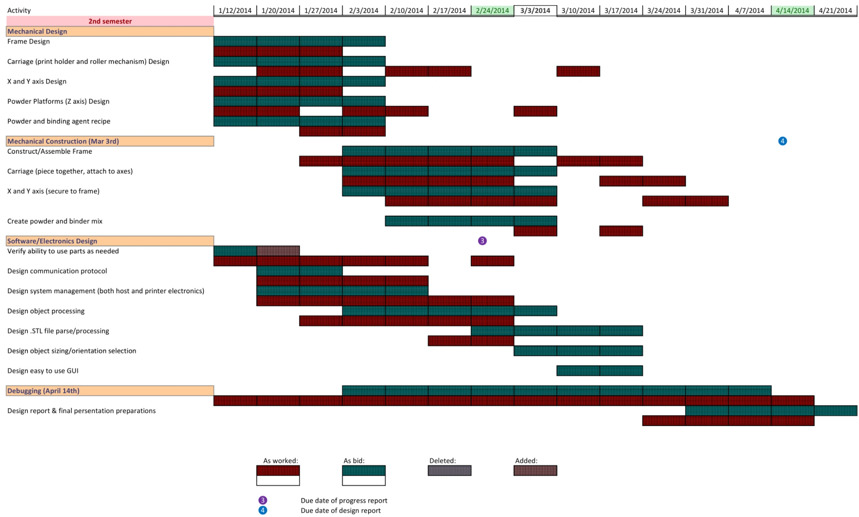

Figure : Implementation Schedule (PZ)

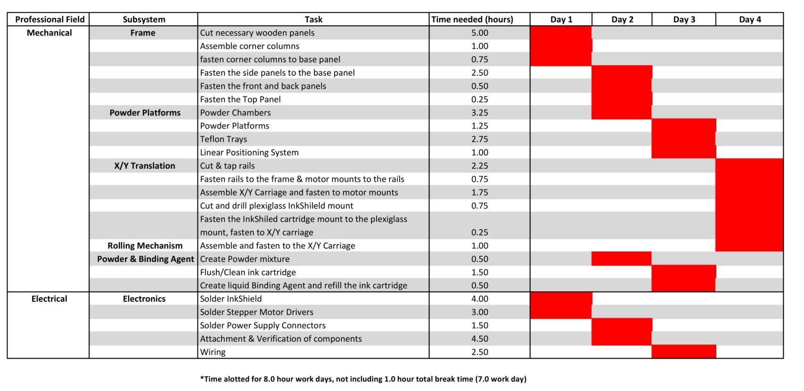

# Subsystem Descriptions

## Frame (HL)

The printer frame subsystem encompasses the housing and the support system for the inkjet 3D printer. The frame plays a major role in the performance of the printer, and any failure or miscalculation will have a direct effect on the created product. Printing is all about accuracy, so the frame needs to be solid, precise, and able to resist the stress and forces generated by constantly moving parts. The frame is built mainly of Baltic irch plywood, providing a rigid support structure. Every millimeter of unanticipated movement in the frame translates to a millimeter of error on the powder bed. Therefore, the design of the frame subsystem is exactly based on the scale of the digital CAD model.

The printer frame is one of the most important subsystems in the inkjet 3D printer. This is because its design and assembly needs to integrate with the design of other subsystems, including X/Y carriage, rolling mechanism, ink cartridge, powder source platform, and powder bed platform. The design of the frame has been changed three times in the design process of mechanics system. At the beginning, the design of the frame (shown in Figure 4) is based on the original design of the X/Y carriage and both platform subsystems (shown in Figure 5). The stainless steel rods are fastened to the top, and they act as rails for the carriages to move along the X and Y axes. In order to obtain easier assembly and control, the design of the X/Y carriage and ink assembly subsystems were changed. Although they remained the same methods before and after changing, the design of the frame needed to be changed to correlate with the new design of the X/Y carriage subsystem. Finally, because the rolling mechanism design was unable to traverse to the far edge of the powder source platform, the design of the frame needed to be changed once more (shown in Figure 7), mainly to reduce the volume of the source platform due to a few design miscalculations.

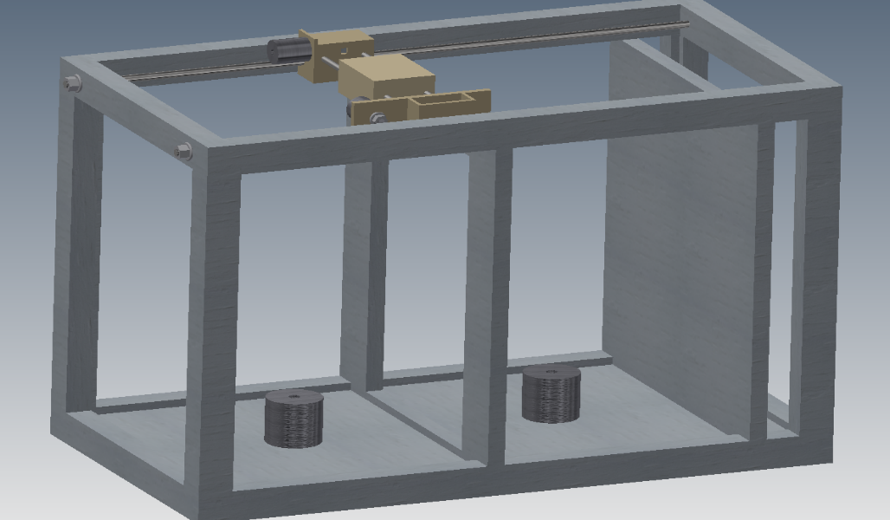

Figure : Original design of the frame (PZ)

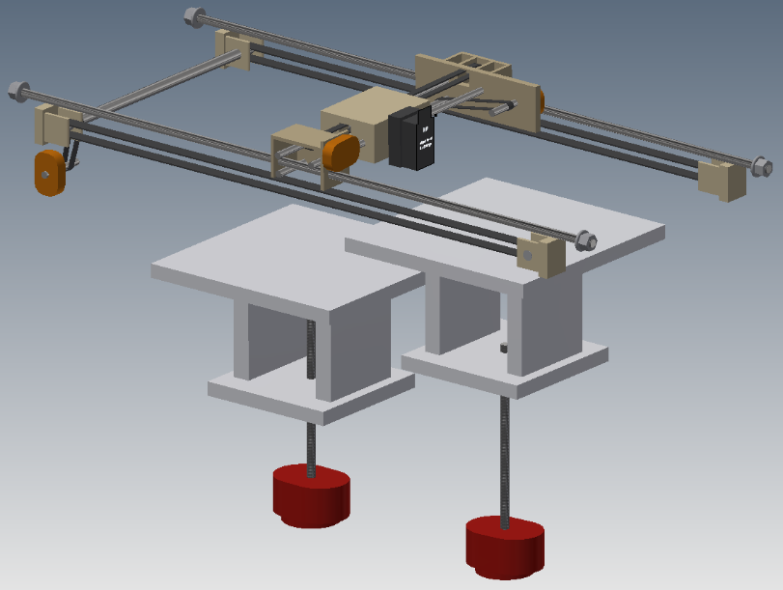

Figure : Original design of the X/Y carriage and platforms (PZ)

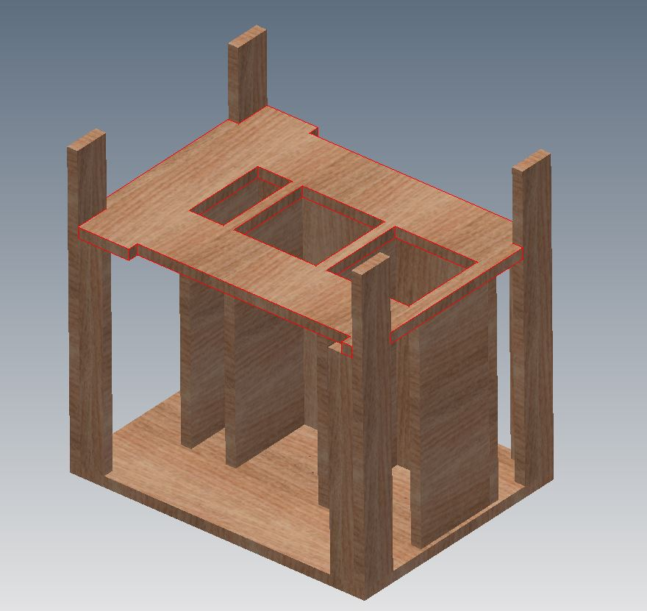

Figure : Second design of the frame (PZ)

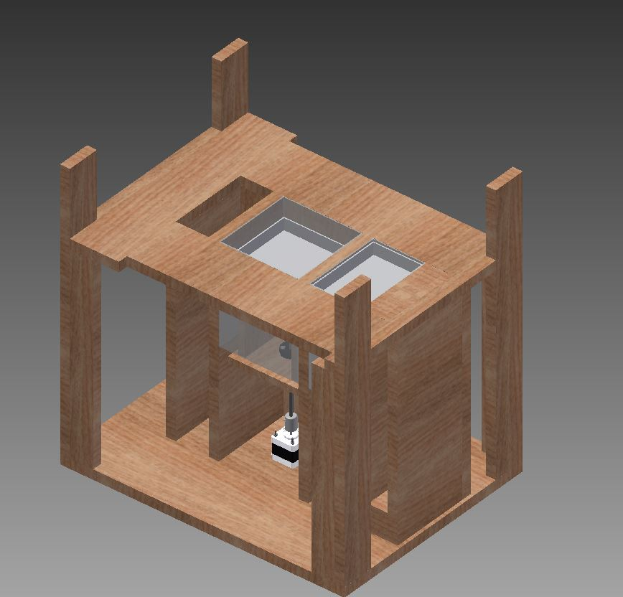

Figure : Third design of the frame (PZ/HL)

### Process of Design

Autodesk Inventor 2014 Professional was the main software used to design the frame subsystem. The design of the frame subsystem may be divided into six minor subsystems; from bottom up they include: fundamental base panel, corner columns, side panels, front and back panels, and the top panel.

The fundamental base panel subsystem is the base of the 3D printer. Therefore, length and width of the base panel should be exactly the same scale of the X and Y axis of the printer system, which is 21.5 inches length by 16.5 inches wide (shown in Figure 8).

The corner columns are designed to be positioned on the top of each corner of the base panel. The corner columns minor subsystem is designed as two parts, which includes the long columns and the short columns (shown in Figure 9). The short columns are for supporting the weight of top panel in each corner, and the long columns are for containing two aluminum rails of the X/Y carriages on each side. Additionally both columns are to be assembled perpendicular and flush with the edges of each corner.

The side panel minor subsystem is composed of four identical wooden panels. Although all of the panels have the same size, the clearance between them vary; this clearance is based on the dimensions shown in Figure 10.

The front and back panels were designed to fasten to the front and rear sides of each of the side panels. However, the front panel is not identical to the back panel. The front panel dimensions was reduced. This reduction allows for a view of the motors to make sure no faults occur, for allowing proper ventilation to the motors to avoid them overheating, and to make incorporating the powder source and printing platform subsystems into the frame easier. Also, there is a small clearance that allows the cup in the excess powder removal subsystem to be moved in and out of the frame. The dimensions of both components are shown in Figure 12 and Figure 13.

The top panel was designed to cover the upper surface of the frame. Not only does it need to have notches cut into each corner, allowing the long columns to be fastened to it, but it also needs to contain three holes in center where sizes and location must match each one in the side panel minor subsystem. Furthermore, in order to let the rolling mechanism move on top of the frame, it needed to be cut to allow for enough space on the bottom of both X/Y carriage rails (shown in Figure 14). Details of this are shown in Figure 15.

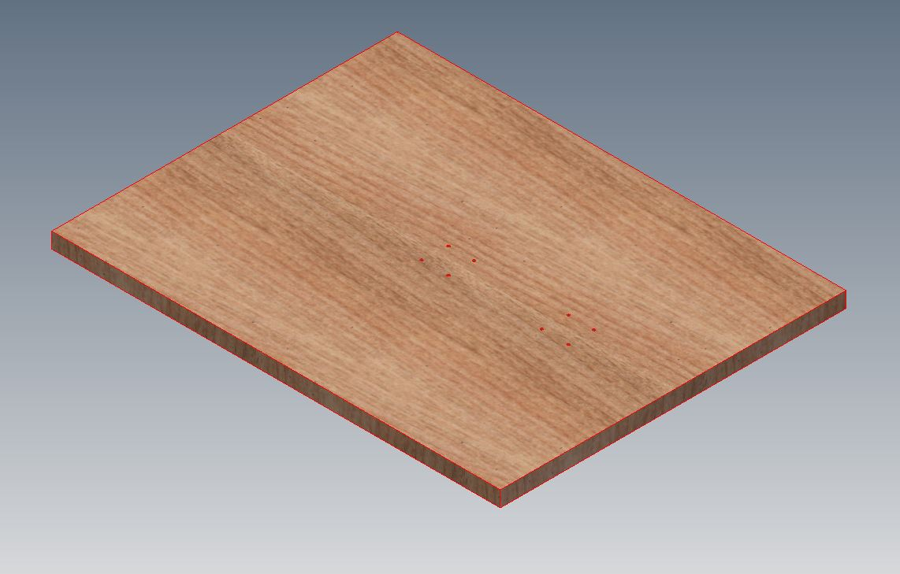

Figure : Bottom base of frame (PZ)

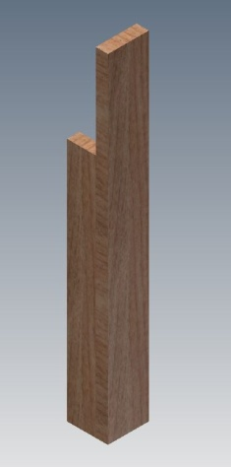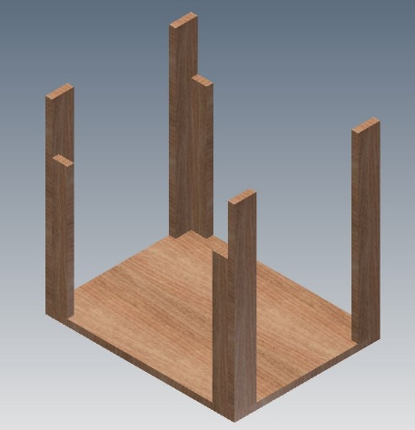

Figure : Corner Columns of frame (PZ)

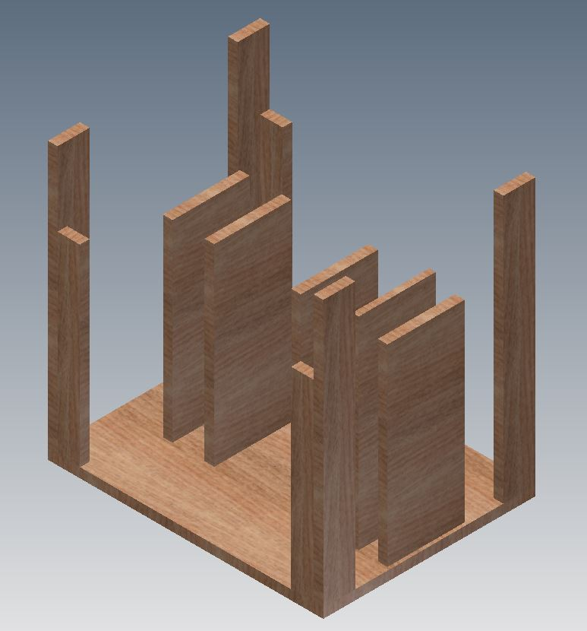

1. Gap for reducing volume
2. Powder Source Platform
3. Printing Platform
4. Gap for excess powder

2

3

4

1

Figure : Side panels of the frame (PZ/HL)

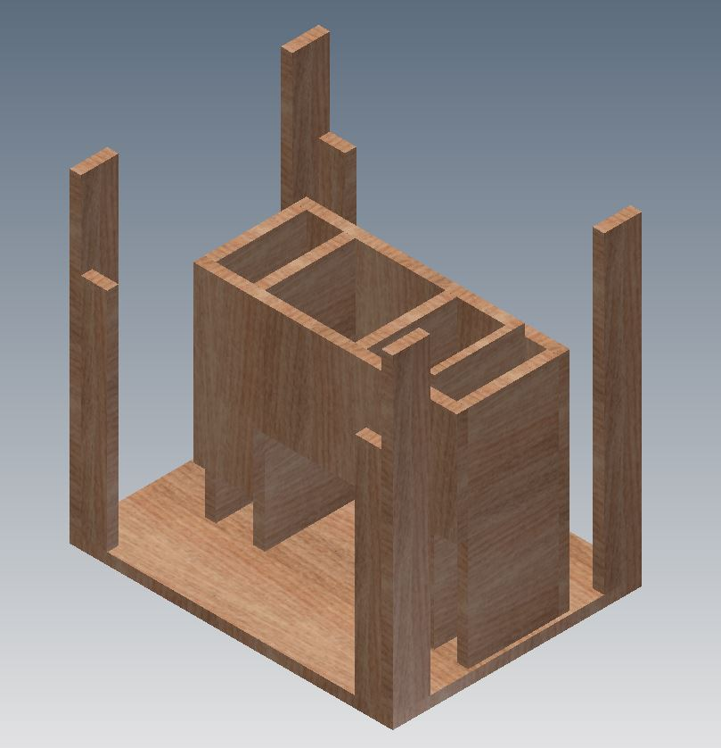

Figure : Front and back covers on frame (PZ)

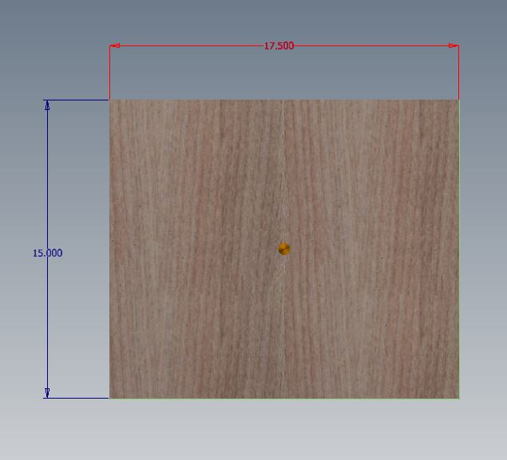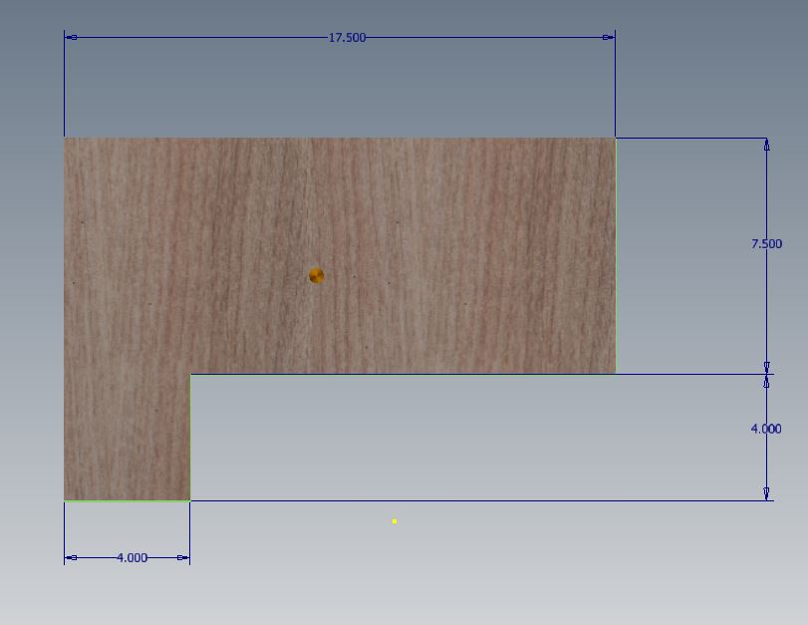

Figure : Back cover detailed view (PZ/HL)

Figure : Front cover detailed view (PZ/HL)

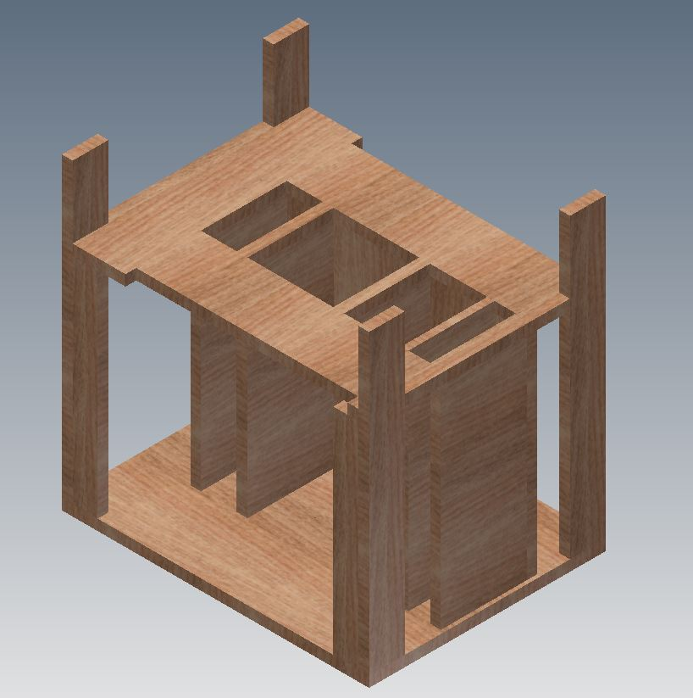

Figure : Top panel on the frame (PZ)

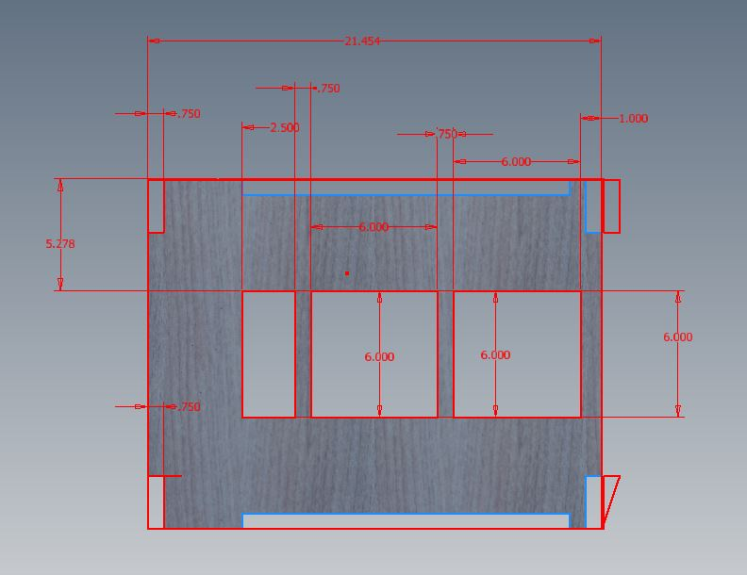

Figure : Top panel detailed view (PZ/HL)

### Process of Assembling

To begin, a ¾” 4x8ft sheet of Baltic Birch plywood was bought from a local hardware store. Then, a table saw was used to cut and create each part according to the dimensions shown in Table 3. Unfortunately, it is difficult to saw every component to exactly the same scale as the ideal CAD model. Therefore, the size of every part may have 0.1 to 0.3 inches of error. Furthermore, both the long corner columns and the front panel were cut via a local water jet cutter, which is much more precise and accurate than the table saw machine, it is able to make precise, straight cuts along a piece of wood.

Table : Detail of parts in frame subsystem (HL)

|  |  |  |  |
| --- | --- | --- | --- |
| Minor subsystem scale of the frame subsystem | | | |
| **minor subsystem** | **pieces** | **length (in)** | **width (in)** |
| Bottom Base | **1** | **21.5** | **16.5** |
| Long Corner Columns | **4** | **20.75** | **2.5** |
| Short Corner Columns | **4** | **15** | **1.75** |
| Side panels | **4** | **5.375** | **4.25** |
| Front and Back covers | **2** | **17.5** | **15** |
| Top Base | **1** | **21.5** | **16.5** |

In the first step of assembly, the long corner columns are to be assembled perpendicular with the short corner columns on the edge using a hand drill to drill three flat-head wood screws into each one (shown in Figure 16). However, it is difficult to assemble exactly the same as the CAD model, both columns’ edges of side and base cannot exactly mate together due to manufacture error. In addition, there are two problems always occurring when drilling the screws in the wood. The wood has a tendency to crack because the Baltic Birch plywood is compressed with several pieces of wood. Another problem is using the hand drill which is difficult to control when drilling the holes in the wood.

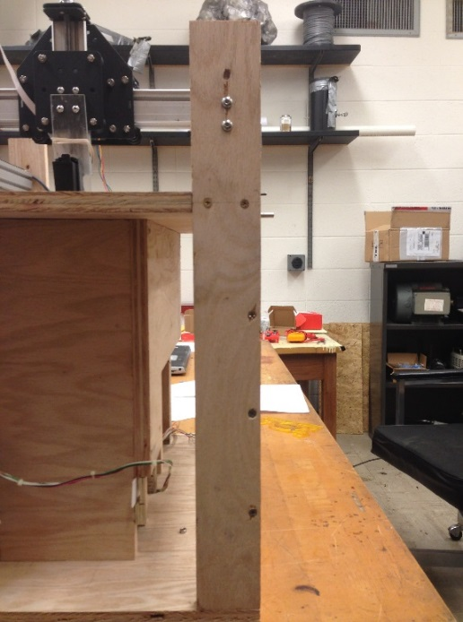

Figure : Assembling with the corner columns (HL)

After fastening the corner columns together, they need to be fastened to each corner of the base panel. This can be performed via a similar method used for corner columns assembly, which is using the hand drill to drill three flat-head wood screws from the bottom of the base panel (shown in Figure 17). Because of the issue with both columns’ edges not exactly matching together, it was necessary to use wood shims to fill in the clearance between the bottom of the short corner columns and the base panel.

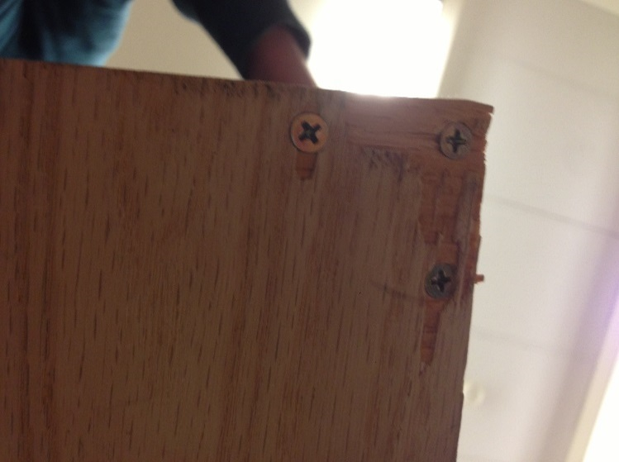

Figure : Assembling the base panel and corner columns (HL)

The next step was to fasten the four side panels to the base panel in regards to the CAD model. The method of assembly is the same, use the hand drill to drill three flat-head wood screws through the base panel to each side panel. However, it is difficult to fasten the panels exactly perpendicular to the base panel. A standard triangular ruler was used to verify that the angle between the side panels and the base panel were as perpendicular and flush as possible.

Finally, the same method was used to assemble top panel. Because of a problem that occurred during the assembling of the side panels, the edge of the side panels were not flush the top panel. Because of this, it had the potential to seriously affect the proper function of the powder source platform and the powder print platform. Therefore, it was necessary to input force by hand to place and drill screws to fix them.

### Excess Powder Removal System

The excess powder removal system was designed to trap and collect excess distributed powder such that it may be reused. This design includes two parts, the excess powder funnel and cup (shown in Figure 18). The designs were based on the space within the excess powder chute. The excess powder funnel is used to guide the falling extra powder through the center and into the excess powder cup.

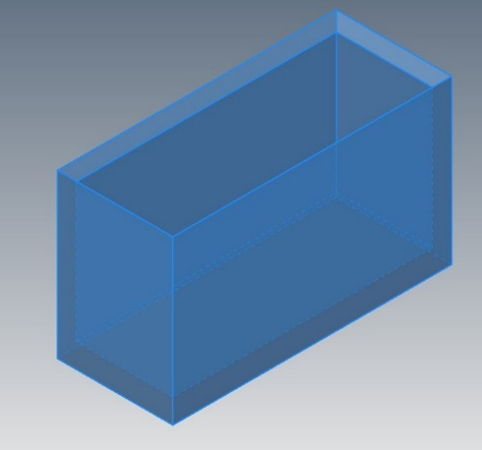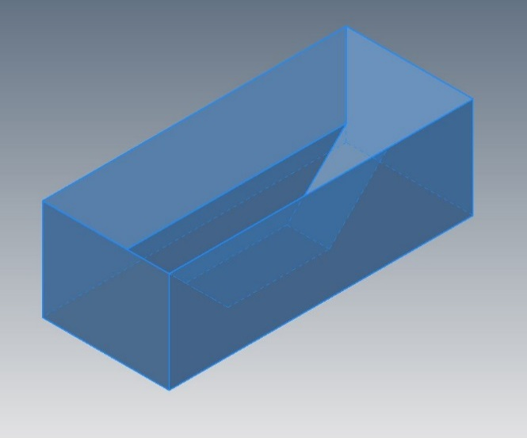

Figure : Design of the excess powder funnel and cup (HL)

Both of these designs were manufactured by the MakerBot 3D printer in Morris library of SIUC. However, the product created by this particular 3D printer was less than ideal, which created a very small gap between the edge of the funnel and the frame. In order to solve this problem, silicon rubber sealant was used to fill in this gap to keep the powder from exiting through the edge. Additionally, to keep a clean environment to protect the stepper motor, a shutter was designed and created (shown in Figure 19) to make sure no powder may exit from the gap between the top of the cup and the frame.

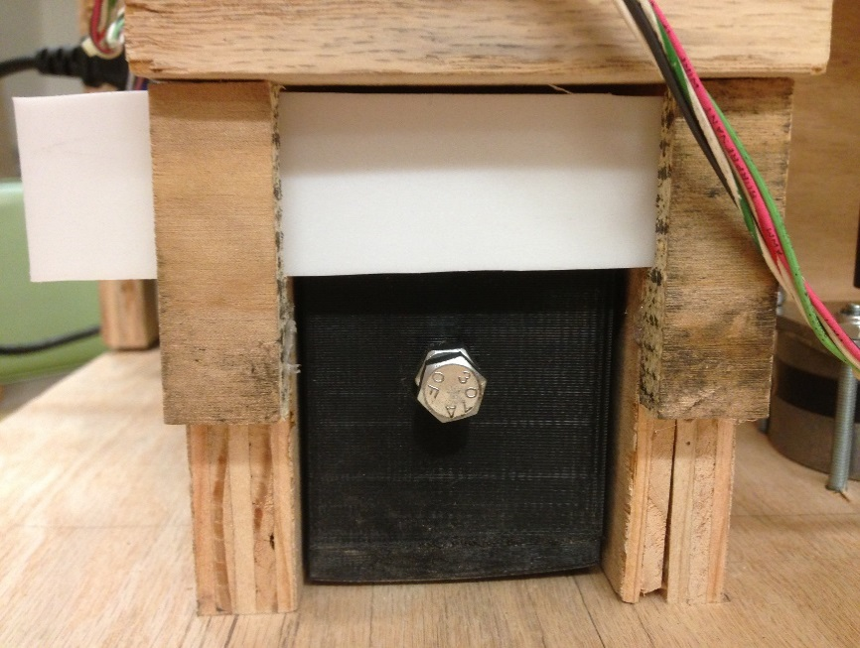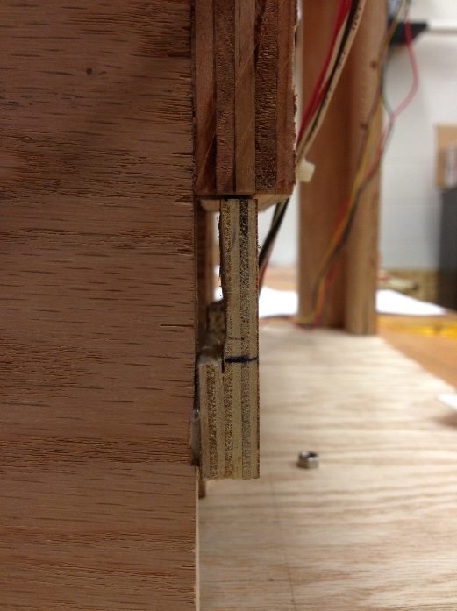

Figure : Door in the excess powder subsystem (HL)

### Implementation Schedule

The following schedule totals to about 10 hours.

1. Wood Cutting (5 hours)
   1. Cut the Baltic birch plywood on table saw machine
   2. Use the water jet cutter to cut the holes on the front panel and the top panel
2. Corner Columns Assembling (1 hour)
   1. Use a pencil to draw three holes on the long corner column from the bottom with 5 inches of clearance between each hole
   2. Use the hand drill and 1-3/4 inch flat-head wood screws to pre-drill in each drawing hole
   3. Drill the screws to connect the long and short corner column; make sure the long corner column is perpendicular with the short corner column
   4. Repeat the previous 3 steps 3 more times, to create 4 total corner column combinations
3. Assembling the Corner Columns to the Base Panel(0.75 hours)
   1. Use a pencil to draw three holes to each corner of the bottom of the base panel
   2. Use the hand drill and 1-3/4 inches flat-head wood screws to pre-drill each drawing hole
   3. Drill the screws to fix the corner columns on the bottom base; makes sure the long corner column is perpendicular with the base panel
   4. Use the wood shims to fill in the gap if there is any clearance between the corner column and the base panel.
   5. Repeat the previous 4 steps 3 more times, to fasten the corner columns onto the 4 corners of the base panel
4. Assembling the Side Panels to the Base Panel(2.5 hours)
   1. Based on the location of each side panels on the CAD model, use a pencil to draw three holes on each location with the same distance between each hole
   2. Use the hand drill and 1-3/4 inches flat-head wood screws to pre-drill in each drawing hole on the bottom of the bottom base
   3. Drill the screws to fix the side panels on the base panel, while using the triangular ruler to make sure each side panel is perpendicular with the base panel
5. Assembling the Front and Back Panels(0.5 hours)
   1. Use a pencil to mark the position of six holes on back panel; each hole is in the center of thickness of the first and last side panels
   2. Use the hand drill and 1-3/4 inches flat-head wood screws to drill in each drawing hole and fix the back cover and the side panels together
   3. Use the same scale of the four holes on the top to draw on the front panel
   4. Do the same method to fix the front panel to the side panels
6. Assembling the Top Panel (0.25 hours)
   1. Position the top panel in the appropriate location on the frame, which the bottom of the top panel should mate with the top of each panels and the each short corner columns
   2. Use a pencil to mark for two holes on outside faces of each long corner column
   3. Use the hand drill and 1-3/4 inch flat-head wood screws to drill in each marked hole and fasten the top panel

### Equipment Needed

* Table saw
* Computer
* Water jet cutter
* Hand drill
* Triangular ruler
* Glue gun
* Pencil
* Screwdriver
* Knife

### Health, Safety and Environmental Issues

While using the hand drill the wood powder and dust may be spilling out from the head of the drilling machine. As for health and safety, wear a breathing mask while operating the hand drill. The designs of the excess powder funnel and cup allow for the recycling and re-use of the printing powder

### Fault Analysis

The fault analysis results are generally concerned with the material property of the Baltic Birch plywood. Because the Baltic Birch plywood is compressed with several pieces of woods, it is possible to be deformed by drilling screws, absorbing too much water from the air, or from pressure overload. If once the structure of the fame deformed, it would seriously affect to the functionality of other subsystems and could ultimately result in system or print failure. In order to reduce possible faults, other materials should replace Baltic Birch plywood.

### Subsystem costs

Table : Prototype cost of frame subsystem (PZ)

|  |  |  |  |  |  |  |
| --- | --- | --- | --- | --- | --- | --- |
| **Item name** | **Quantity** | **Unit price** | **Sub total** | **Source of funds** | **Item used in Prototype?** | **% Used** |
| 3D-printed excess powder removal components (2) | **1** | **$38.00** | **$38.00** | **Hauhui** | **Yes** | **-** |
| 12-ct wood shims | **1** | **$1.69** | **$1.69** | **Hauhui** | **Yes** | **25%** |
| 80grit sandpaper 6-ct | **1** | **$4.97** | **$4.97** | **Hauhui** | **Yes** | **-** |
| 3/4" 4x8ft Baltic Birch hardwood | **1** | **$55.22** | **$55.22** | **ME dept** | **Yes** | **45%** |
| #10 x 1-3/4 in flat-head wood screws 50-count | **2** | **$5.28** | **$10.56** | **ME dept** | **Yes** | **40%** |

Table : Implementation cost of frame subsystem (PZ)

|  |  |  |  |  |
| --- | --- | --- | --- | --- |
| **Item name** | **Quantity** | **Unit price** | **Sub total** | **Vendor options** |
| 3D-printed excess powder removal components (2) | **1** | **$38.00** | **$38.00** | **Morris Library (SIUC), Incept 3D, Solid Concepts** |
| 12-ct wood shims | **1** | **$1.69** | **$1.69** | **Lowe's, True Value, Home Depot** |
| 80grit sandpaper 6-ct | **1** | **$4.97** | **$4.97** | **Lowe's, True Value, Walmart** |
| #10 x 1-3/4 in flat-head wood screws 50-count | **1** | **$5.28** | **$5.28** | **Lowe's, True Value, Walmart** |
| 3/4" 2x8ft Baltic Birch hardwood | **1** | **$27.75** | **$27.75** | **Lowe's, Home Depot, Menards** |
|  |  |  |  |  |

### Conclusions and Recommendations

There are several recommendations in regard to this subsystem. First, Baltic birch plywood is not theoptimum choice of material to use, if relatively larger budget than that of this project is available. Because the Baltic Birch plywood is easy to be deformed in the structure based on its material properties, it is difficult to control the error produced while using the table saw and hand drill to cut and drill into it. However, there are many better choices of material that can be used in this subsystem such as plastic, aluminum, and Plexiglas. Besides the choices of material, flat-head wood screws are is not the optimum choice to use in this subsystem, because it is hard to control when drilling inside of the material. However, design is changed to allow the use of bolts to replace the screws, it will be more accurate in the process of assembling.

## X/Y Translation (JC)

### Overview

#### Initial Design

The initial design for the X/Y Linear Translation system consisted of a steel shaft rail system, along which carriages made of methyl methacrylate would slide on bronze sleeve bearings. This design was inspired by the Pwdr. 3-D printer design. Shortly after receiving the steel shafts, the design decision was made to switch to an aluminum extruded rail system with flat, steel plates serving as the carriages.

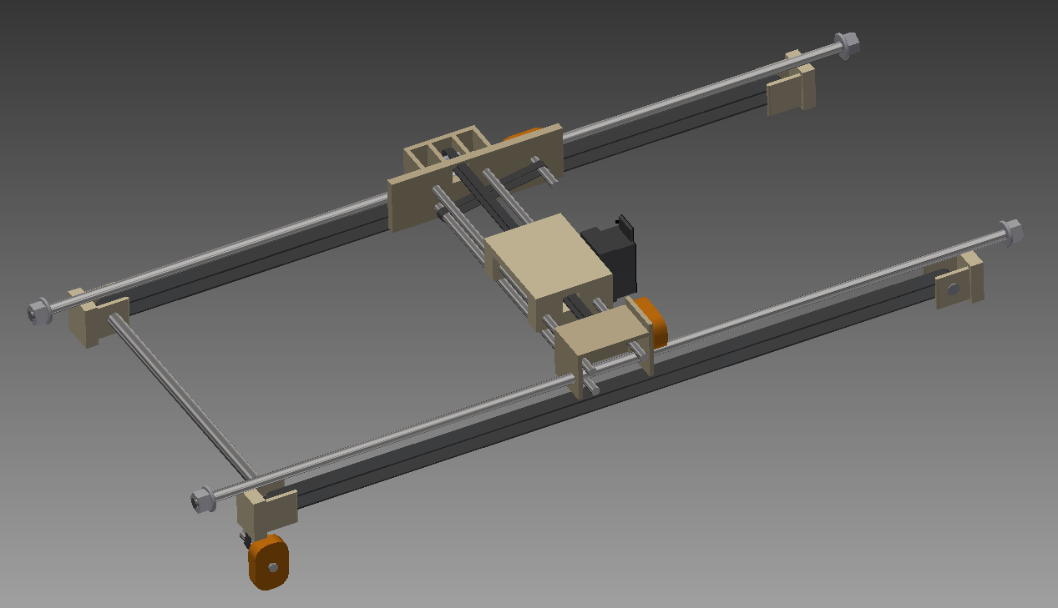

Figure : Initial X/Y assembly design (PZ)

#### Completed Design

The completed X/Y Translation system achieves linear two-dimensional motion of the ink assembly on the top surface of the machine. The translation system was inspired by one found in the build instructions for the Shapeoko 2 CNC Milling Machine. Open-source build instructions were readily available online, and the machine was specially designed and modified to accommodate our unique rolling mechanism and ink assembly. Thin steel plates act as carriages and move along modified standard aluminum extrusions on precision plastic wheels. These carriages are powered by small NEMA 17 stepper motors that translate motion along fixed pulley belts which are anchored to the ends of the aluminum rails. The translation system is very similar in nature to that found in common CNC-milling machines, with the major modifications including the attachment of the roller mechanism and the ink assembly.

### Makerslide Aluminum Rails

#### Initial Design

In early designs, the rail system consisted of stainless-steel smooth shafts, along which the carriages would slide using sleeve bearings or possibly linear roller bearings. Shafts made of 303 stainless steel were ordered, but upon receiving them it was discovered that they were not bearing-quality, and bronze sleeve bearing could not achieve satisfactory motion along them.

The timing belts were originally planned to be held in place using custom belt tensioners constructed of poly.

#### Completed Design

Makerslide is a custom aluminum extrusion profile, designed to add precise “V-shaped” rails onto a standard HSF5 aluminum profile. The purpose of this modification is to allow rotational movement along the rails by “v-wheels,” attached to carriage mechanisms. Two internal shafts run along the length of these rails, custom-tapped to allow assembly with M5 bolts. Two widely-spaces rails are attached to wooden posts at the end of the machine and account for the X-axis. The X-axis carriages support two more rails, mounted back-to-back perpendicular to the X-axis to form the Y-axis of the machine. The use of the aluminum rails provide sturdy, reliable axes with minimal-to-no shifting during printer operation due to strong fastening and the stable, rigid frame.

An attempt was made to create the belt clips using a Makerbot Replicator 2 FDM 3D-Printer. The completed parts were not able to be installed and used due to a design error with inconsistent tolerances, and standard belt clips were ordered.

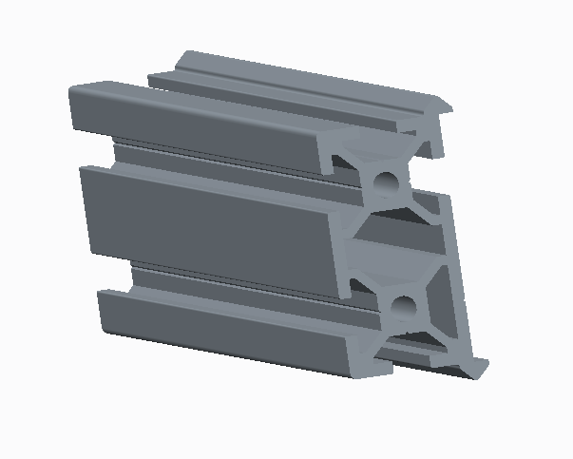

Figure : Cross section of Makerslide rail bars (JC)

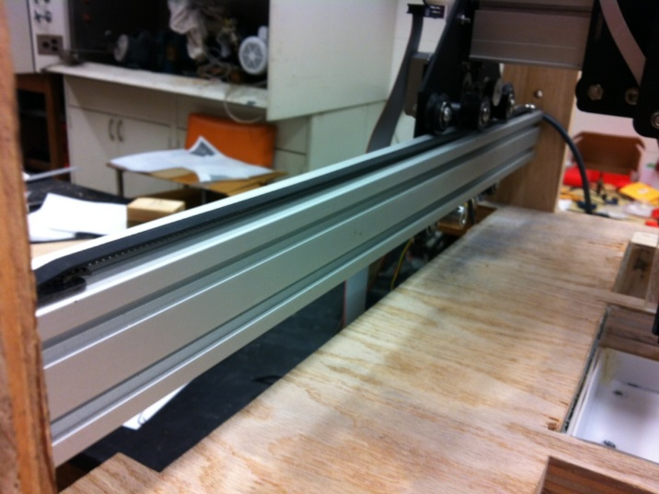

Figure : Aluminum Makerslide rails (JC)

GT2 pulley belts are securely fastened to the rails at the end of each axis by fiberglass “belt clips,” bolted to custom nuts inserted within the rail before assembly. The belts are tightly secured by forces of friction.



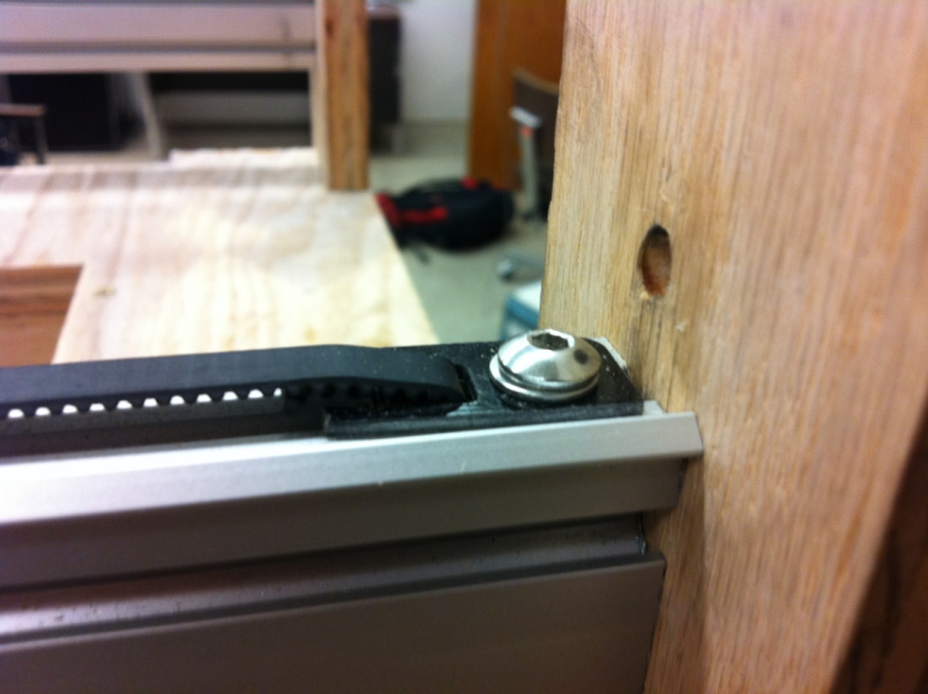

Figure : Belt clips securing the GT2 timing belts (JC)

Figure : Creo representation of belt clips (JC)

### X/Y Carriages

#### Initial Design

The X/Y carriages were initially planned to be square compartments machined out of methyl methacrylate and bolted together, similar to those used in the PWDR design. Right before design work was to begin, the decision was made to transition to the rail-plate system.

#### Completed Design

The X/Y Carriage subsystem consists of four separate metal plates. There are two X-carriages, each made up of one metal plate, and one Y-carriage formed by two metal plates bolted back-to-back. Every plate supports four precision “V-wheels,” with two wheels on each plate secured by customized nuts with off-centered holes. This allows the wheels to be slightly adjusted and brought fractions of a millimeter closer to the rails, resulting in a tighter fit between the carriage and the rail, which further reduces any printing error. The wheels are made up of a special plastic, polyoxymethylene, or "delrin." Each wheel contains two dual-shielded radial ball bearings. Both X-Carriage plates also serve to mount the Y-Axis rails, in addition to one NEMA 17 motor each and two idler pulleys, facilitating linear motion of the plate. As for the Y-Axis carriage, one plate is used to mount a NEMA 17 motor and facilitate linear motion, while the other mounts the ink assembly.

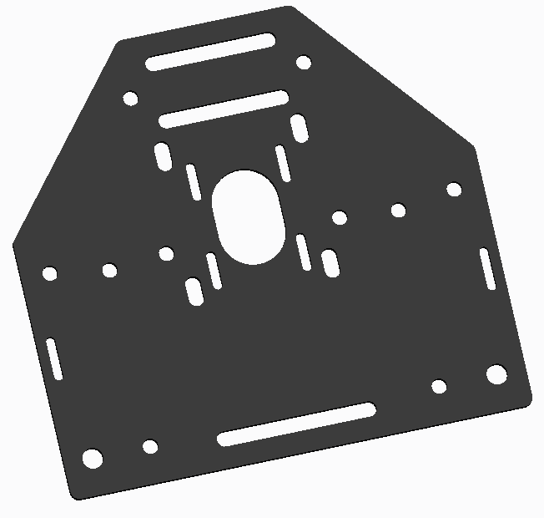

Figure : Creo representation of motor mount plates (JC)

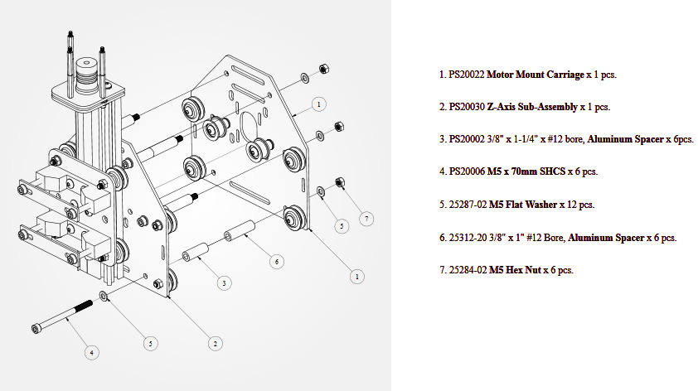

Figure : Motor mount assembly exploded view (JC)

The two plates that make up the Y Carriage are connected by M5 bolts and separated by aluminum spacers. This picture was taken from the open-source instruction website docs.shapeoko.com

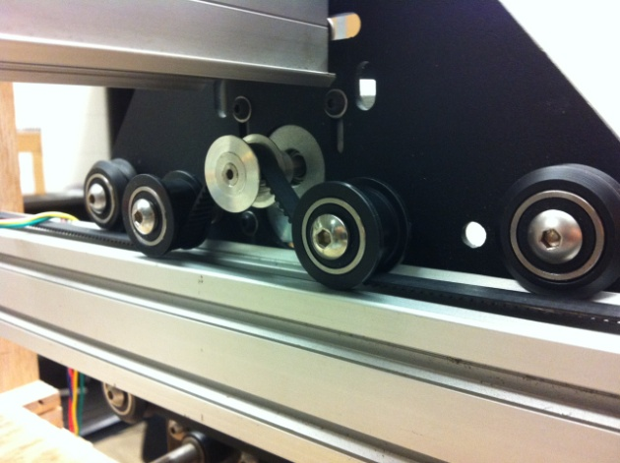

Figure : Linear motion mechanism (JC)

The belt is driven by the timing pulley, and lined up by the two idler pulleys in the near the center.

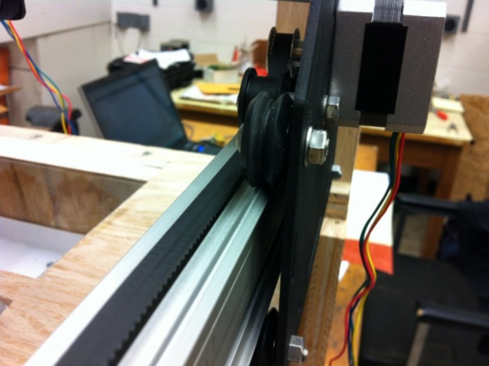

Figure : Wheels on rail system (JC)

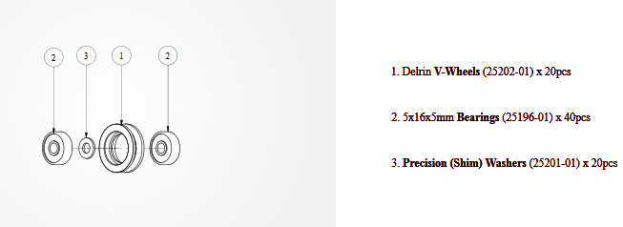

Figure : Delrin V-wheel assembly diagram (JC)

Each delrin v-wheel was specially assembled in our design lab. This image was taken from docs.shapeoko.com.

Although a very small part of the design, the eccentric nuts have proved extremely valuable to the project. Slight modifications to the nut orientation reduce wobble in the carriages and create a much smoother rod. Design drawing provided by buildlog.net.

### Costs

Table : Prototype cost of X/Y translation subsystem (JC)

|  |  |  |  |
| --- | --- | --- | --- |
| Part | Quantity | Unit Price | Subtotal |
| Makerslide 1800mm | 1 | $32.84 | $32.84 |
| Belt Clips | 3 | $5.00 | $15.00 |
| Insertion Nuts 25-pack | 1 | $4.95 | $4.95 |
| Bolt M5x10 | 6 | $.11 | $.66 |
| Total: $53.45 |  |  |  |

Table : Implementation cost of X/Y translation subsystem (JC)

|  |  |  |  |
| --- | --- | --- | --- |
| Part | Quantity | Unit Price | Subtotal |
| Smooth Rod 1/4" x 18" | 3 | $5.45 | $16.35 |
| Smooth Rod 1/4" x 12" | 3 | $6.65 | $19.95 |
| Makerslide 1800mm | 1 | $32.84 | $32.84 |
| Belt Clips | 3 | $5.00 | $15.00 |
| Insertion Nuts 25-pack | 1 | $4.95 | $4.95 |
| Bolt M5x10 | 6 | .11 | $.66 |
| 3D Part Order | 1 | $4.50 | $4.50 |
| Total: $94.25 |  |  |  |

## Roller Mechanism (JC)

The roller mechanism has been custom-designed and machined to fit the dimensions of the machine, available mounting options, and the purpose of powder-surface interaction. The mechanism is fastened to the X-Axis Carriages and mounted below, permitting contact between the smooth stainless-steel rod and the wooden surface of the printer. The smooth shaft is attached to a NEMA 17 motor and can either be held stationary to provide a sweeping motion across the surface, or rotated in synchronization with the movement of the X-Axis Carriages, compacting the powder surface much like a rolling pin. The motor and rod are supported by two separate plastic plates, which were designed by Jory in Creo Parametric and printed by a Makerbot 2 3D printer at Morris Library. One plate supports the NEMA 17 motor, while the other plate mounts a flanged bronze sleeve bearing, impregnated with polytetrafluoroethylene to hold the rod in place vertically while also permitting free rotational movement with minimal frictional resistance. The stainless-steel shaft is secured to the motor by a flexible coupler.

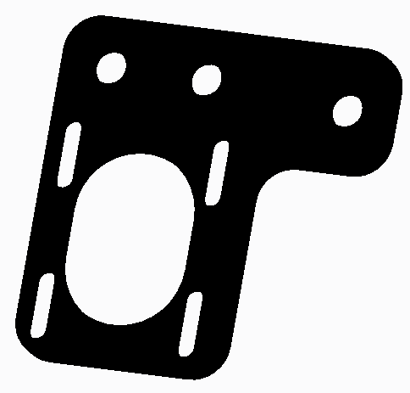

Figure : Creo parametric representation of custom motor plate (JC)

This plate mounts a NEMA 17 stepper motor.

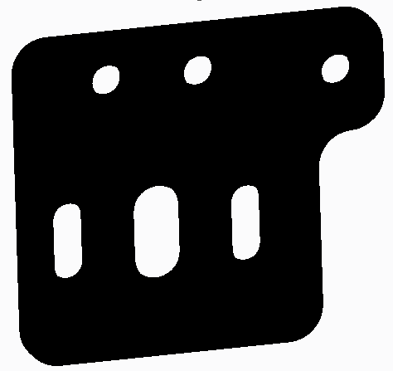

Figure : Creo parametric representation of the rolling mechanism plate (JC)

This mounts a flanged roller bearing.

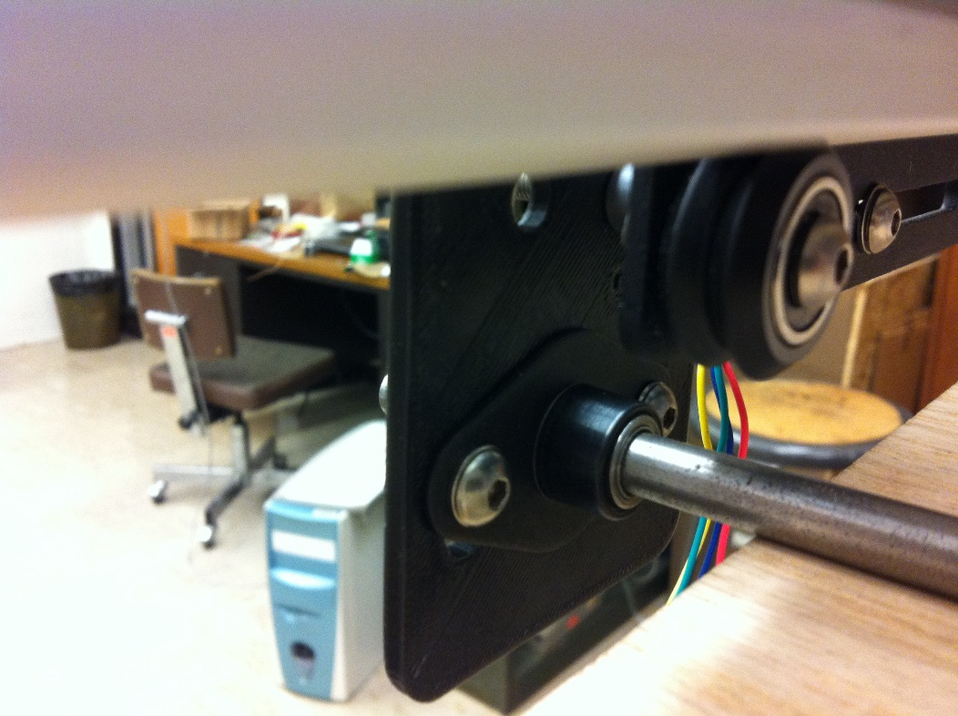

Figure : Rolling mechanism plate, mounted (JC)

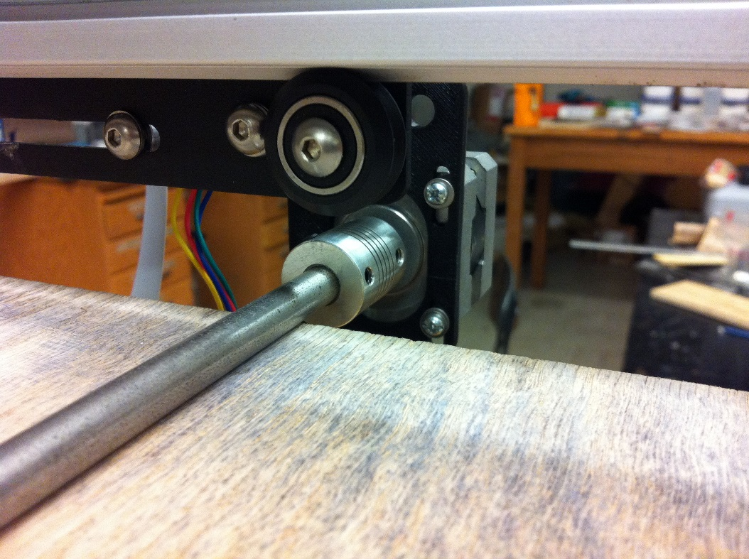

Figure : Rolling mechanism coupled with the stepper motor (JC)

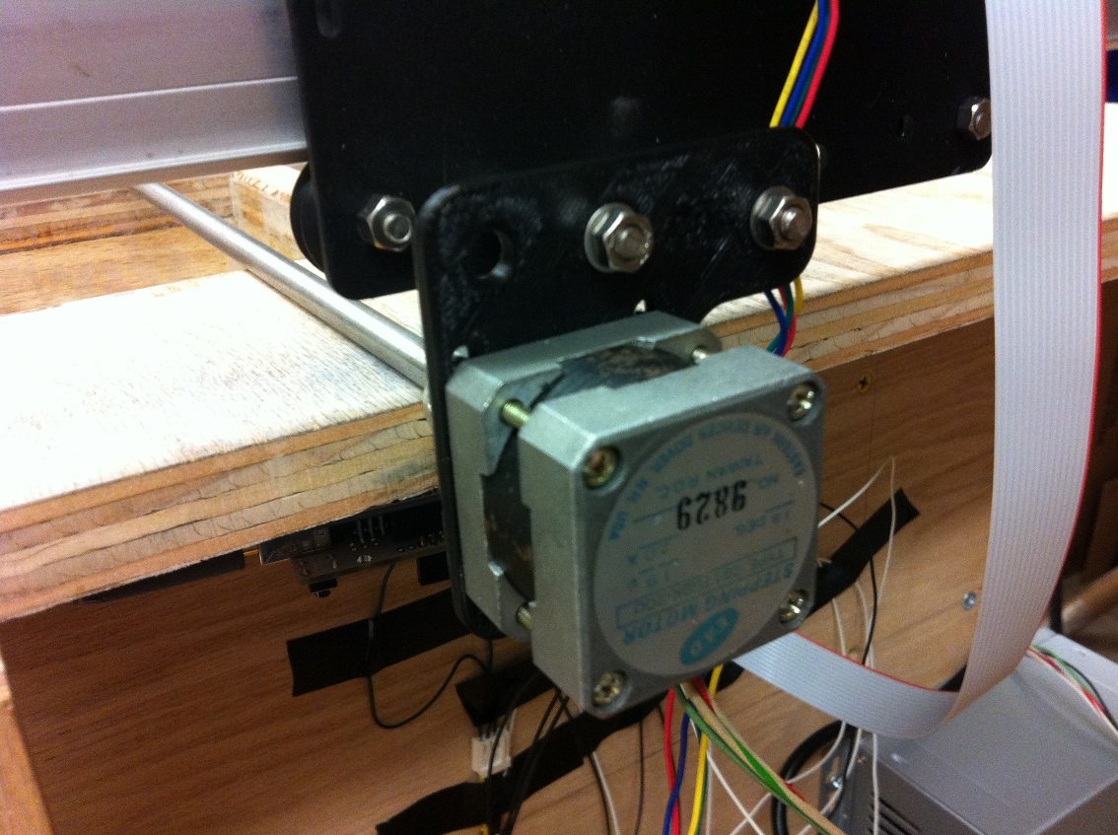

Figure : Rolling mechanism stepper motor (JC)

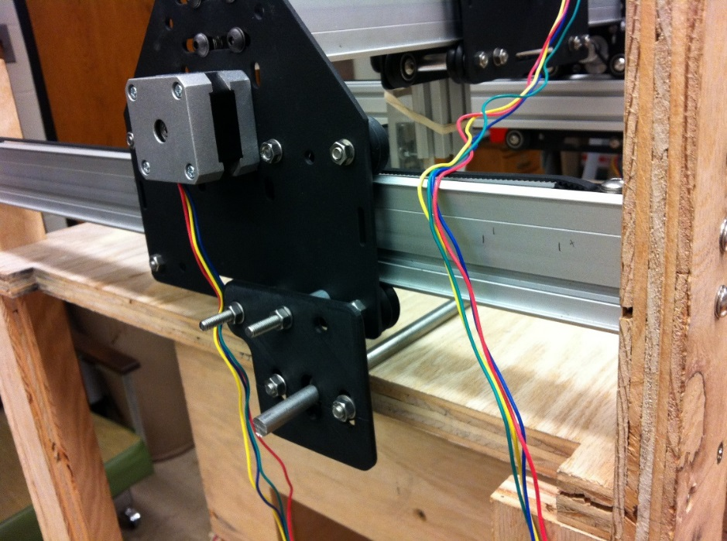

Figure : Rolling mechanism mounted to X/Y translation assembly (JC)

### Costs

Table : Production cost of roller mechanism subsystem (JC)

|  |  |  |  |
| --- | --- | --- | --- |
| Part | Quantity | Unit Price | Subtotal |
| Stainless Steel Shaft | 1 | $8.06 | $8.06 |
| Flexible Coupler | 1 | $6.95 | $6.85 |
| Flanged Bearing | 1 | $6.20 | $6.20 |
| 3D Printing | 1 | $6.00 | $6.00 |

## Powder Platforms (PZ)

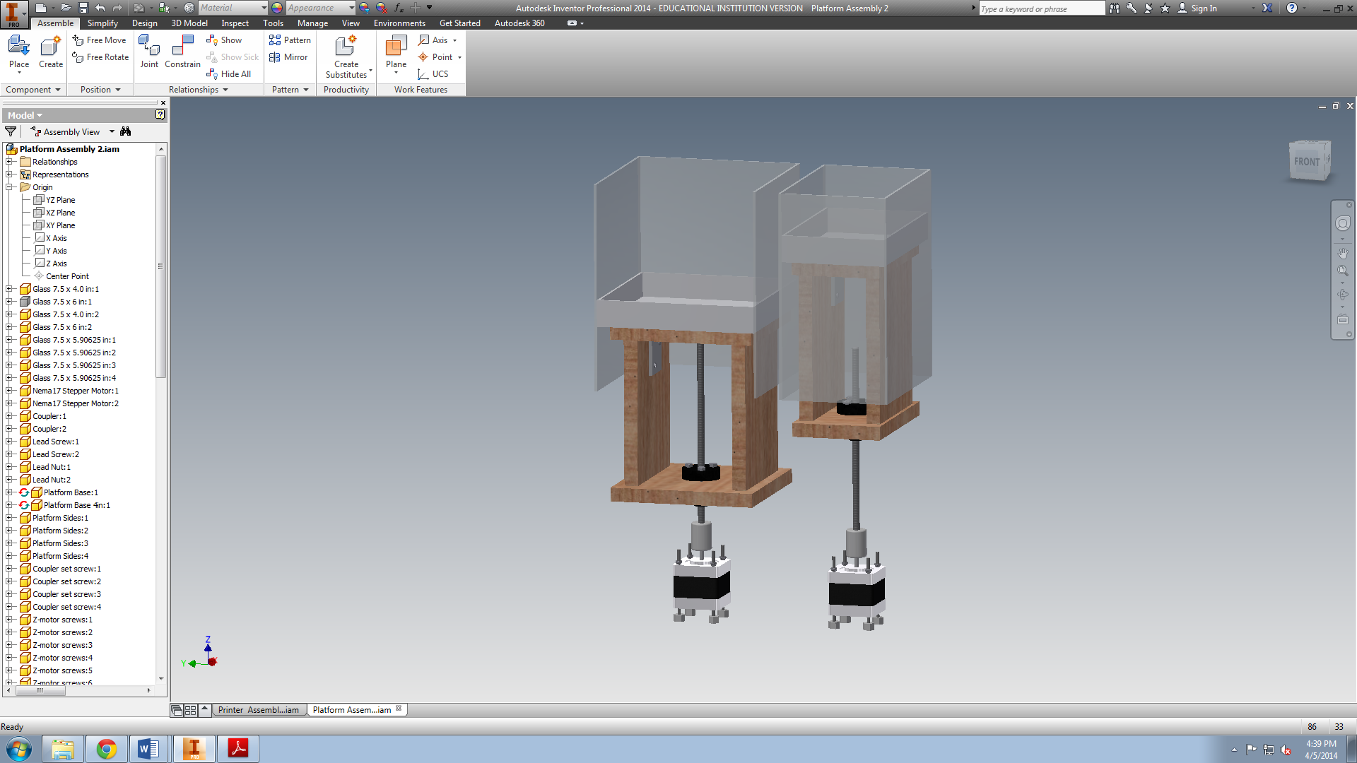

Figure : Powder Platforms Subsystem (PZ)

### Description

The Powder Platforms subsystem consists of the Powder Source Platform, the Powder Print Platform, the Linear Positioning Systems, and the Powder Platform Chambers. During the print process, the job of the Powder Platforms Subsystem is to raise the Powder Source platform and lower the Powder Print Platform at the appropriate time intervals. A printed model will develop within the Print Chamber, on the Powder Print Platform. Once one of the model’s printed layers is complete, the Powder Print Platform is lowered the distance of one layer thickness. Then the Powder Source Platform is raised far enough to allow the Rolling Mechanism to adequately spread a new layer of powder over the entire surface of the Powder Print Platform. An excess powder chamber was included in the design of the printer to allow for a relatively clean and simple collection of the extra powder. It was significantly crucial to the project for this subsystem to be designed well. Without properly functioning platforms, the printer would only have a capability to print in two dimensions. The design process focused on achieving uniform motion for both platforms. The design was based on the Pwdr. 3D printer project, shown in Figure 37.

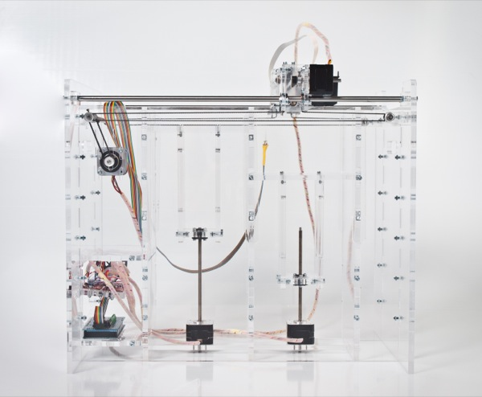

Figure : Pwdr. 3D Printer Project [10] (PZ)

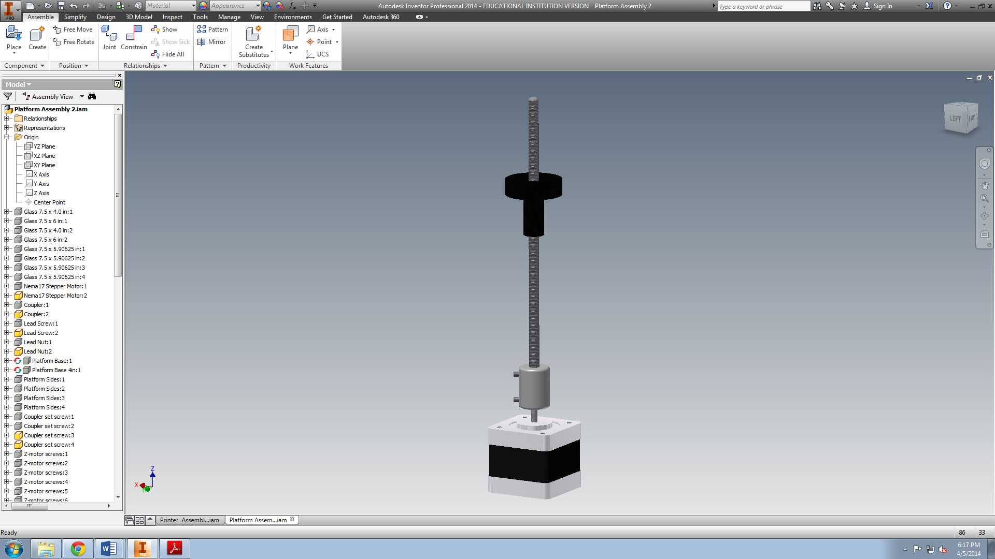 The vertical motion of the platforms is generated via the linear positioning system seen in Figure 38. It is made up of a stepper motor, lead screw, coupler, and lead nut.

Figure : Linear positioning system (PZ)

The motor is bolted to the base of the printer, the shaft of the motor is fixed to the coupler, and the coupler is fixed to the lead screw via set screws. The lead nut rides along the threads of the lead screw, and is bolted to the base of the platform. Figure 39 shows the configuration of the Powder Print Platform.

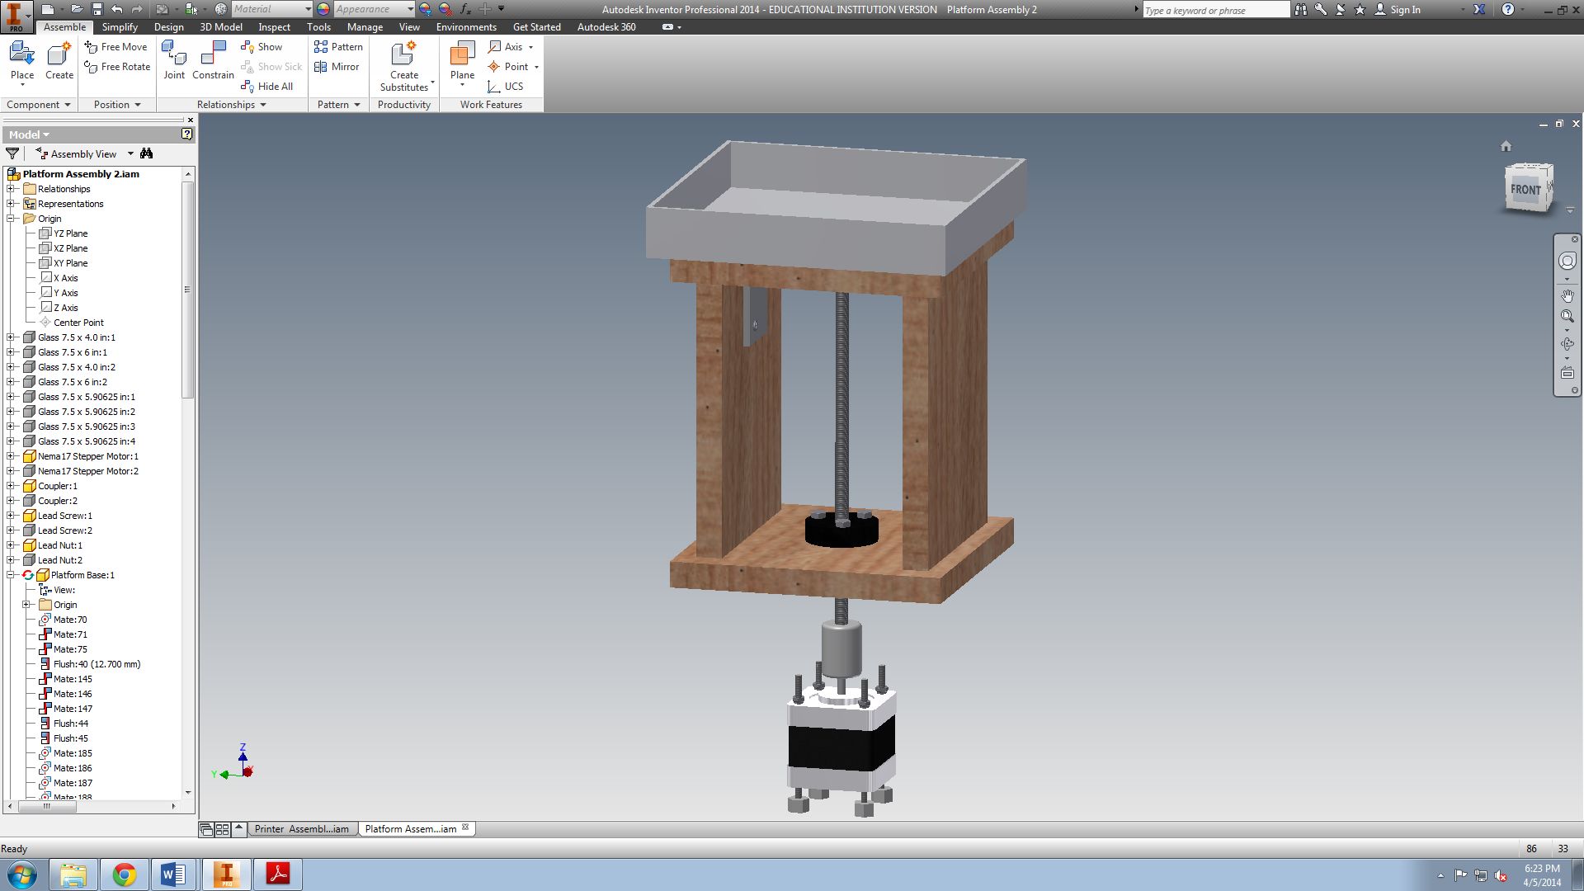

Figure : Powder Print Platform (PZ)

The Host Software will instruct the motor to rotate a specific distance, or step. Since the printer prototype has just recently been deemed operational, performance data, such as the optimum step distance for each motor, as well as the maximum and average speeds of the platforms, are still being determined. However, during the initial testing the step size will be based on the step size of similar 3D powder printers. The Host Software the team has developed allows the user to specify micro-stepping specifications, giving the user much freedom to determine the desired print layer thickness. The rotation of the motor shaft is translated to the lead screw via the coupler. The rotational motion of the lead screw is translated into the vertical motion of the platform via the lead nut. If the platforms are not constrained by the chambers they and the lead nut would rotate uniformly with the motor shaft and the lead screw. However, once the platforms are constrained by the powder chambers, they are restricted from rotational motion. Therefore, rather than rotating along with the lead screw and motor shaft, the lead nut will ride along the threads of the lead screw. This results in the vertical motion of the lead nut, resulting in vertical motion of the platforms.

### Design

The largest and most challenging design milestone for this subsystem was the relationship between the edges of the platforms and the powder chambers. If the platforms were to be designed to fit tightly within the chamber, then the friction and reaction forces between the sides of the platforms and the walls of the chamber would be too great. This would restrict the motion of the platforms, potentially damaging the motors in the process. On the other hand, the subsystem would also not function properly if the platforms were designed to fit loosely within the powder chambers. With this design, there would be a noticeable gap between the edges of the platforms and the walls of the powder chambers. This gap would allow the platform to rotate slightly, which would have devastating effects on the quality of the printed model. In addition, the gap would allow clearance for the powder on the platform to fall underneath to the base of the printer, where the Z-axis stepper motors are bolted. The loose falling powder would have the ability to potentially interfere with or damage the motor. For these reasons, it was crucial to come up with a design that would restrict powder from falling below the platforms, as well as resulting in minimum friction between the edges to the platform and the walls of the powder chambers. The initial design allowed for clearance between the powder chamber walls and the edges of the platform. However, the design focused on obtaining a minimum clearance for print quality and functionality, about 1 or 2 millimeters.

Besides this milestone, the design and assembly of the Powder Platforms subsystem seemed relatively straightforward and easy. However, in reality it was extremely strenuous and time consuming.

The initial process of assembling this subsystem focused on obtaining the linear positioning system and bolting it to the assembled frame of the printer. The initial drive system that was purchased for the platform movement is shown in below.

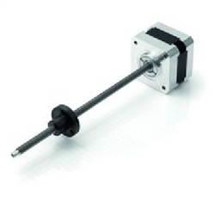

Figure : Nanotec Linear Positioning System [11] (PZ)

The motor involved in this system is one of a higher power than the common Nema17 motors being used for the X and Y translation of the Ink Assembly and Print Carriage. More powerful stepper motors were chosen in order to provide sufficient torque to allow for platform movement.

Prioir to purchase, It was unknown that the system did not include the lead nut that is in the product’s picture and discription. In addition, it was unknown that the lead screw was welded to the motor shaft. These two facts caused for subtantial delay of the project. Management had assured that assistance would be provided during the assemly process to easily and quickly tap a lead nut for the linear positioning system. Therefore, little time and effort was initially focused on this design concern.

Unfortunately, it was descovered substantially late in the project that the threaded rod (lead screw) encorporated a unique proprietary metric thread patter, T6x2, which involves a dual trapezoidal thread profile. Dies and taps for this thread pattern do not exist outside of the compny that provided the linear positioning system. Several companys were inquired regarding the fashioning of a tap that would be able to replicate the pattern within a lead nut. These companys denied the requests for the die. The next activities involved contacting the company that supplied the lead screw to see if any lead nuts were available for purchse. It was discovered that the company only had one available lead nut with the T6x2 thread pattern; the printer needs 2 lead nuts, not just one. Further discovery found that the parts needed to be shipped from Germany; it would take either a subtantial amount of money (about $125.00) for a one week delivery, or an adequate amount of money (about $25.00) for a three to four week delivery. Neither of these options were accceptable for the team. The machine shop put much effort into adjusting the lathe’s gear set up in order to be able to machine custom lead nuts for the linear posistioning system. The shop did produced two plexiglass nuts, but the thread quality was unacceptable for the printer.

Since custom lead nuts were no longer an option, the next activity focused on a new linear positioning system. This meant finding new motors and finding a lead screw and nut combination that encorporated a common replicable thread pattern. Luckily, all of these materials were obtained through resources within the engineering department. Two slightly larger Nema23 motors were found that were suitable for the printer. More than enough ¼-28 threaded rod was located in the machine shop for the lead screw. This new linear positioning system would required a coupler to translate the rotation of the motor shaft to the lead screw. Instead of purchasing two couplers for around $50.00, two couplers were fabricated in the machine shop from steel stock; two 1x1/16” set screws were provided by the machine shop for the coupler.

The CAD assembly model that was developed using *Autodesk Inventor Professional 2014* was extremely helpful while determining the appropriate dimensions for the lead screw, in realtion to the appropriate height of the platforms that allowed for the maximum print volume. The model alowed for visual analysis and assurance for the dimensions; the greater distance that the platform is able to travel, the larger the print volume. Final calculations determined that 7” lead screws would allow for maximum print volume.

The lead nuts were machined in the machine lab using delrin stock that was donated by the department. Initial design plans for the lead nut were to make it an anti-backlash nut, shown in Figure 41. The male piece of the nut (on the left of Figure 6) would be inserted into the female piece of the nut (on the right in Figure 41), and the spring would be positioned around the central shaft of the assembly; a set screw would be used to “pin” the ends of the nut together. Due to time contraints, it was decided to simply have lead nuts. In addition, it was agreed that the anti-backlash would not have a significant impact on the quality of the print; anti-backlash is most suitable for mechanisms that involve a back-and-forth type of motion. During the printing process, the powder platforms only move in one direction, up or down (+Z or –Z). Decideing to use lead nuts instead of anti-backlash nuts resultes in a cheaper, easier, and quicker fabrication and assembly.

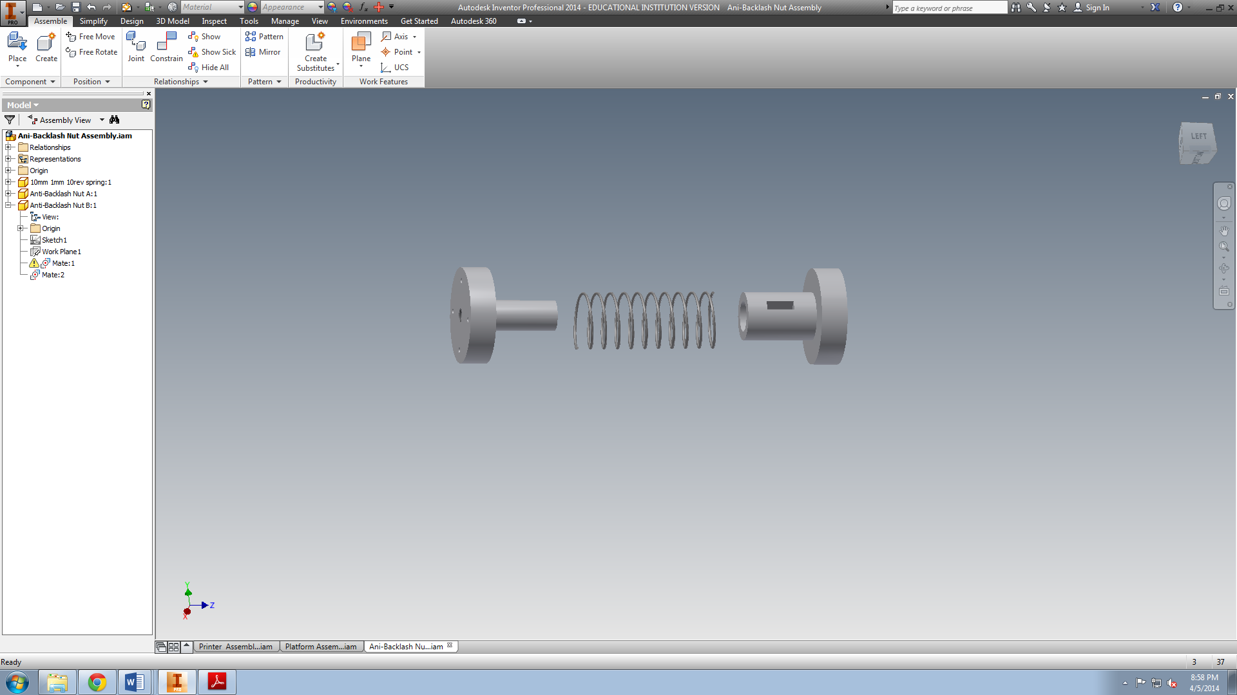

Figure : Anti-backlash nut design (PZ)

Once the motors were tested, and the couplers, lead screws, and lead nuts were gathered, the linear positioning system was assembled and bolted onto the base of the frame. 4 M5x60 steel bolts were used for each motor, in addition to 4 anti-torque M4 nuts. These anti-torque nuts, seen in Figure 42, incorporate a waxed nylon ring that restricts the hardware from becoming loose due to motion within the printer, such as vibrations, or temperature/pressure variations. This design allowed for the utmost assurance that the position of the linear positioning system would not change, assuring the print quality would not be affected by motor position.

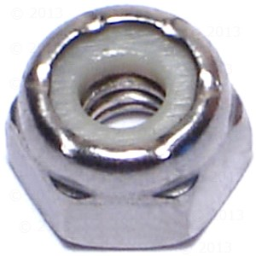

Figure : Nylon-insert nut [12] (PZ)

While the assembly and incorporation of the linear positioning system was taking place, other activities focused on the design of the relationship between the edges of the platforms and the walls of the powder chambers. Eventually it was decided to eliminate the gap, minimizing the amount of powder that would fall below the platforms. This design called for thin glass plates to be fastened to the inner walls of the powder chambers, as well as strips of Teflon that would be inserted into drilled slots within the sides of the tops of the platforms. The Teflon-glass relationship would result in minimum friction between the chamber walls and the platform, allowing the linear positioning system to function properly with the least amount of reaction torque against it.

Although it seemed relatively easy to order and attach the glass to the powder chamber walls, it was not an easy task. A local glass specialist shop, Crispin Glass & Auto Supply, was contacted to cut the plates. The thinnest flat glass available for purchase, 3/32nd inch, was chosen for purchase. The thinnest was chosen because the frame of the printer, including the powder chambers, was already assembled. Therefore, to allow for the maximum print area, the glass that was inserted within the chambers needed to be as thin as possible. It was crucial to the printer functionality that the glass was made to specific dimensions, with the least amount of error. Crispin only had the ability to cut glass to dimensions as small as 1/16th of an inch. This imposed a problem; the tolerance of the glass cutting was too great. The initial order for eight glass plates resulted in four that were usable, and four needed to be re-ordered. Luckily, the glass was extremely inexpensive, and the production time was less than one business day.

The initial design for attaching the glass to the powder chamber walls called for a glue gun. After some discussion, the design was changed to incorporate a better adhesive for the glass to wood bond. After looking around at what was available at local stores, the decision came down to either using epoxy or Gorilla Glue. After some research and discussion, the decision was made to use epoxy; it had slightly better results when gluing glass to wood.

To ensure that the glass to wood bond was as strong as possibly, the decision was made to try and etch the surface of the glass that would be bonded to the chamber walls. The initial plan was to find chemicals available through the department to etch the glass. Once finding that hydrochloric acid, a very strong and dangerous chemical, was needed to etch glass, other options were considered. A local Hobby Lobby had a retail etching cream that was available, was able to purchase just enough for about $15.00. Etching the glass resulted in a slightly course surface, allowing for more surface area and better adhesion. A significant amount of sanding and filing was needed for the wooden chamber walls to allow for proper placement of the glass plates. This sanding was undertaken to avoid ordering more glass and spending more money. It was crucial to glue the glass plates so that the top edge was flush, or slightly below, the top surface of the frame so that there would be no interference with the motion of the Rolling Mechanism.

It was difficult to obtain Teflon wiper blades, let alone finding some that had appropriate profiles for the slots. Therefore, the design was changed to incorporate a short Teflon tray for the tops of the platforms, rather than Teflon blades being inserted in the sides of the top of the platform. There were two different thin sheets of Teflon that were donated from the department, each had a different thickness. This new design originally called for the Teflon to be bent and formed into a “box-like” shape to fit flush with the top of the platform and glass plates, as seen in Figure 36. This was no easy task; it was extremely strenuous to form the Teflon to the desired tray shape. A ream paper cutter was available within the department; it was utilized to cut the Teflon so that the lengths of the cuts would be perfectly straight. After some experimentation, a tabletop vice clamp, hammer, and wooden block were used to form the Teflon sheet into the desired shape. The Teflon would be clamped so that the edge that was to be “folded” was flush with the top surface of the clamp. Then, the Teflon sheet was “bent” by hand as much as possible. The hammer was then used to “bend” the Teflon along the desired crease; a wooden block was placed on top of the hand-formed crease, and then the block was struck semi-forcefully with the hammer. It took a significant amount of trial and error to obtain a Teflon shape that fit nice and snug against the glass walls of the powder chambers. This process was crude and strenuous, but the end results were acceptable. The Teflon compensated for any variation in the vertical cross section of the powder chambers, since it has the ability to slightly change its orientation while the platform is in motion, allowing it to constantly “hug” the glass walls.

Once the Teflon was appropriately shaped, silicon sealant was used as an adhesive to bind the walls of the Teflon tub together, at the same time sealing the corners of the tub. The Teflon is fashioned to the tops of the platforms using five to eight 5/8th inch long steel wood screws. As the platform moves up and down within the chamber the sides of the Teflon tray are in contact with the glass plates; the pressure from the powder on the Teflon ensures that the Teflon remains in contact with the glass, minimizing the amount of falling powder, while allowing for minimal friction between the platform and the glass plates.

Assembly of the platform structure was carried out during the glass installation. To minimize cost, the first design plan was to utilize the extra acrylic that was ordered and not used for the project. After some research and discussion, the decision was made to use wood instead of acrylic; it was discovered that acrylic tends to fracture and crack easily during machining. Although a significant amount of ¾ inch thick Baltic birch hardwood leftover from the frame, the decision was made to purchase a small amount of wood that was thinner, ½ inch birch hardwood, resulting in lighter platforms and less stress on the linear positioning system. A table saw available within the engineering department was utilized for the wood cuts for the platform structures. The top and bottom panels were designed to allow for 3/8” clearance between them and the glass walls of the powder chambers. Due to time constraints, the decision was made to keep the structures’ design as simple and quick as possible. Simple right-angle steel brackets were found at a local hardware store to use for the structures. Due to assembly methods and physical limitations, the brackets were only able to be used to fasten the top or the bottom to the sides, not both. The decision was made to use the right angle brackets to fasten the top panel to the side panels; the bottom panel would be fastened to the sides using 1 ¾ inch brass wood screws. A drill press in the machine shop was utilized to drill the appropriate ½ inch hole in the center of the platform bases for the lead nuts, as well as the 4mm holes for the M4x25 bolts used to fasten a lead nut to the base of each platform. Nylon-insert M4 nuts were used for this assembly to ensure for minimum chance of the lead nuts becoming loose dude to vibration or temperature/pressure variations.

One setback for the team came from the new stepper motors not functioning as they should. The decision to change the linear positioning system incorporated two new Nema23 stepper motors. One of the motors incorporates a 6-wire configuration, while the other incorporates an 8-wire configuration. The printer electronics were initially set up to accommodate for 4-wire configurations. Therefore, the wiring of the new motors needed to be altered to function with the 4-wire set up. It was believed that the incorrect wiring of these motors was the cause of malfunctioning. Luckily the team found that it was a simple wiring error that was restricting the motors from operating properly. Thus, the Powder Platforms subsystem was finally operational, and the team was able to begin their initial full system tests.

### Costs

Table : Prototype cost of powder platforms subsystem (PZ)



Table : Estimated implementation cost of powder platforms subsystem (PZ)



#### Cost analysis

When comparing Table 9 and Table 10, it may be observed that the cost to implement the project is $18.43 more expensive than the prototype was. Although it is not a significant amount, it would be much more desirable if the implementation cost was lower than the prototype’s cost. However, the main reason that the prototype was cheaper was because some of the more expensive components were donated. If the lead nuts and the Teflon had not been donated, then the prototype’s cost would definitely have exceeded the cost to implement the project. Due mostly to time constraints, the components of the prototype’s Powder Platforms Subsystem were purchased quickly and locally, usually without a quality search for other vendors. Therefore, the cost to implement the project would easily be reducible by an in-depth search for the cheapest components and materials without compromising quality.

### Implementation Schedule

The following activities should be performed in this order; some slight variation in order is allowed, as well as simultaneous activities:

1. Powder Chambers
   1. For each of the eight glass panels, use etching cream to etch about 75% of the reverse side. Allow at least 30 minutes of etching time, clean off all etching cream afterwards. (1.5 hours)
   2. Use the epoxy gel syringe to glue each glass plate to its respected wall of the Powder Chambers, do not get gel on the top panel of the frame. (1.0 hours)
   3. Use silicon rubber sealant to seal any gap(s) in between each glass panel; scrape away any excess silicon with sharp razor blade. (0.75 hours)
2. Powder Platforms
   1. Using a table or band saw, carefully cut the appropriate panels for each platform. Use a belt sander to ensure that each of the side panels are flat on the sawed surfaces, as well as ensuring that each pair of side panels are the same height. (0.5 hours)
   2. Use a drill press to drill an insert hole and three bolt holes on the base panels for the lead screws. (0.25 hours)
   3. Use the platform brackets and 5/8” steel wood screws to fasten the sides of each platform to the top panel of the respected platform. (0.25 hours)
   4. Use 2 ½ “ wood screws to fasten the base panel of each platform to its respected side panels, two screws for each side panel, pre-drill each hole. (0.25 hours)
3. Teflon trays
   1. Use a paper ream cutter to make the appropriate cuts in the large Teflon sheet for each of the Teflon trays; a sharp knife (exacto-knife or razor blade) may be used for short cuts (0.25 hours)
   2. Use a hammer and small wooden block to form each Teflon tray. (1.5 hours)
   3. Use silicon rubber sealant to seal the corners of each Teflon tray (allow time to dry) (0.25 hours)
   4. Use 5/8” wood screws to fasten the Teflon trays to the tops of their respected platforms (eight screws for the Powder Print Platform and five screws for the powder Source Platform). (0.5 hours)
   5. Glue (via glue gun or other general adhesive, preferably strong) fine grade sandpaper to the base of each of the Teflon trays. (0.25 hours)
4. Linear Positioning Systems
   1. Bolt each motor in their respected positions in the Powder Chambers. (0.5 hours)
   2. Insert each lead nut into their respected holes on the base of each platform; bolt each lead nut to the platforms. (0.25 hours)
   3. Manually rotate each lead screw so that each platform is able to ride along said lead screws, until the top of each Teflon tray is beneath the top surface of the frame. (0.25 hours)

Total implementation time is around 7.75 hours.

### Health and Safety Issues

There are few health and safety issues involved with this subsystem, but it is still important to keep them in mind. While working with the motor wiring, it is important to have the power supply off to avoid any chance of electric shock. Be very careful when installing the glass plates, the edges are very sharp and have the ability to cut flesh. On that note, always be cautious of the sharp glass edges while working with the printer. Initially, through thermal imaging tests it was evident that there was an extremely small fire hazard concerning the motors getting too hot. The front panel of the printer was re-designed and cut to allow for sufficient ventilation of the powder chambers.

### Fault Analysis

Fault analysis results are generally concerned with cleanliness within the powder chambers. Loose powder can potentially damage the motor, and may get caught in the threads of the lead screw, which would compromise the printing process. Post and prior to printing, it is crucial to keep the powder chambers free of any excess powder. Use a light brush or cloth to brush away and remove any unwanted excess powder from the powder chambers. Try and monitor the cleanliness of the powder chambers during the print process; brush away unwanted powder while the printer is printing (without interfering with the platforms). Modification(s) to eliminate possible fault could include an apparatus to help shield the stepper motors from the loose powder that falls beneath the platforms. To reduce excess powder mess during part removal, a vacuum mechanism could be implemented to replace the simple brush-off process.

### Conclusions and Recommendations

There are several recommendations that apply to this subsystem. First, there should be a better method of forming the Teflon into the appropriate tray shape. Although the results were adequate, the process that was used for the current prototype was significantly crude. It would save time and increase the quality of the subsystem to find a better means to do so. One plausible solution is somehow generating the Teflon trays via a mold process; or some other sophisticated production process. Another recommendation is to alter the design of the structure of the platforms. Redesigning the platform panels to interlock with each other, rather than simply mating them and screwing them together, would significantly improve the structural soundness of each platform. It is recommended to find a glass distributor who is capable of cutting the glass panels to specific dimensions with minimal tolerances.

Last, it is highly recommended to purchase linear positioning systems that incorporate a lead screw and lead nut with common thread patterns. This would allow for much more freedom to alter or customize the components of said positioning system, while making it much easier to duplicate components if they happen to fail. Thoughts regarding the vendors of the initial linear positioning system are considerably negative. It is absurd and quite unprofessional for the vendor to sell a product that the consumer will have an extremely difficult and stressful time trying to upgrade or modify; in reference to this project is the sale of a linear positioning system that incorporates a lead screw with a proprietary thread pattern. It is recommended that the vendor offer to sell a tap and die for the thread pattern. In addition, it is recommended that the vendor remove the lead nut from the picture of the linear positioning product they sell, so that further potential customers do not get involved in the same situation.

## Powder and Binding Agents (HL)

Both the powder and binding agent subsystems are significant to an inkjet 3D printer, and they play an important role in the printing process.

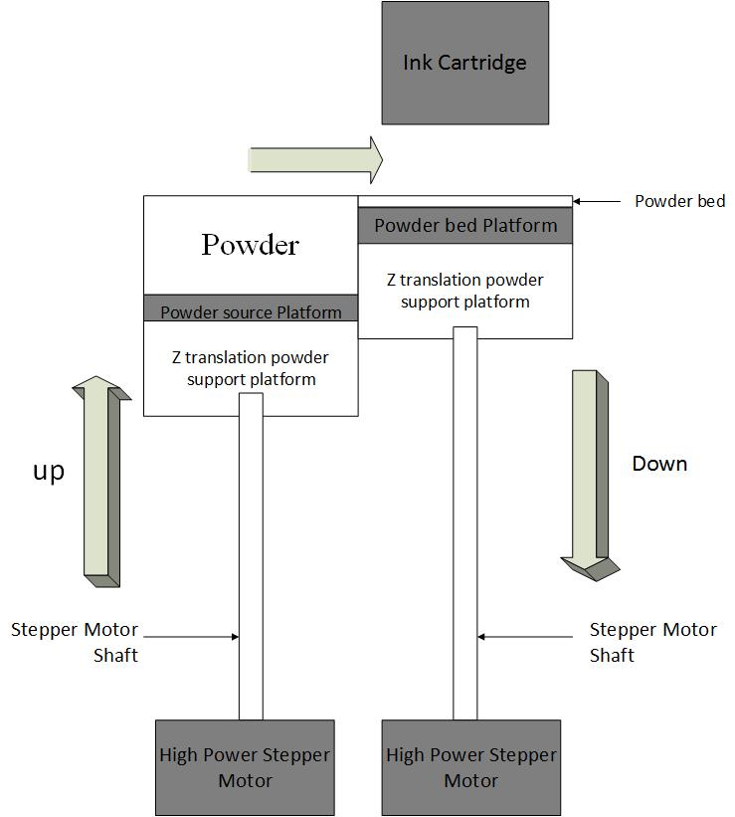 From the figure of the mechanics block diagram (shown in Figure 1), it is clear to understand that the printing powder is placed on the powder source platform. Then printer electronics will cause the powder source platform and powder bed platform to move in the Z direction. After that, the rolling bar will transfer the powder from the powder source platform to the powder printing platform as it goes back and forth. (shown in Figure 43). The ink assembly that holds the ink cartridge is positioned above the platforms. It will move the ink cartridge to the places where the binding agent should be deposited. The ink cartridge will continuously move and deposit the binding agent until the printing process is done.

Figure : Working details of the Powder Source Platform and the Powder Print Platform (HL)

More importantly, the ingredients of the powder and binding agent determine how successful the printing process will be. Recipes used to prepare the powder and binding agent mainly include the ingredients and the percentages they represent.

### Printing Powder Recipe

The printing powder recipe was found by doing many searches on the internet. Many recipes were found, but the choices were narrowed down to the two shown in Figure 44. Finally, the second design is selected to be used in the project, because the material in the first design is hard to find, and the cost of the second design is much cheaper than the first one. Both the first and second design are based upon similar types of ingredients, which included particulate mixture adhesive, filler, reinforcer, and printing aid fluid (powder).

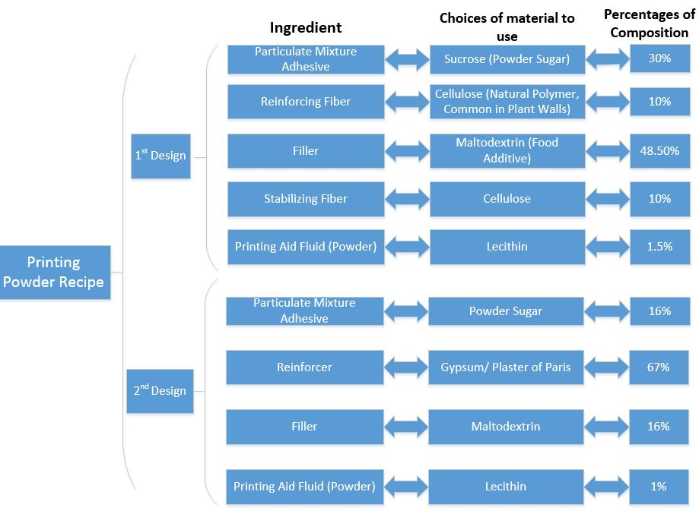

Figure : Powder Recipe Diagram (HL)

### Particulate Mixture Adhesive

The material used as particulate mixture adhesive ingredient should satisfy the characteristic of high solubility, low viscosity, high bonding strength, and low hygroscopicity. The property of high solubility assists the powder incorporate the liquid of binding agent in a short time. After incorporating the liquid, the low viscosity and high bonding strength can let the powder combine together adhesively and quickly. In order to get more adhesive area of the surface of the material, the grain size of particles should be as small as possible, preferably around ten to twenty micrometers. The property of low hygroscopicity is to allow the powder absorb water in the air as little as possible; the product would have a problem of “caking” if the powder absorbed too much water in the air. There many materials that can be used as adhesive such as water-soluble compounds, proteins, and carbohydrates. Finally, the powdered sugar (shown in Figure 45) was selected to be used as the particulate mixture adhesive because it is easy to find and inexpensive. Furthermore, it matches the characteristic of the adhesive [1].



Figure : Powdered sugar (HL)

#### Reinforcer

Reinforcer is the most important ingredient in the printing powder recipe, because it carries over sixty percent of the composition. The choices of material to use as reinforcer should satisfy the properties of high bonding strength, high hygroscopicity, and high solubility. One of the best materials to use as reinforcer is plaster of Paris because when it mixes with water, the slurry can be formed very fast. In addition, the product which made out of plaster of Paris will be smooth and strong.

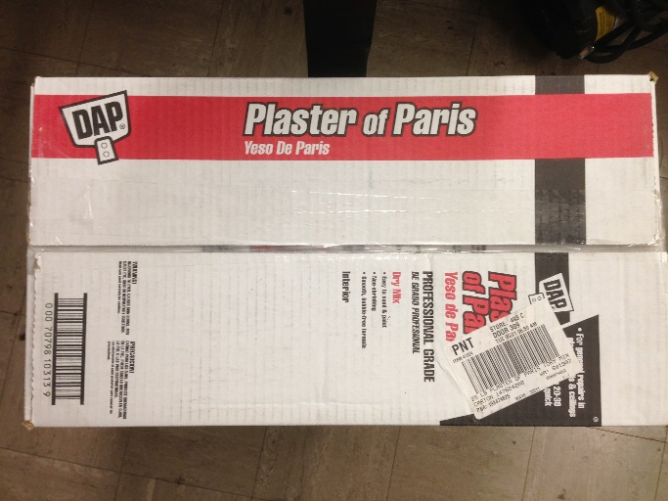

Figure : Plaster of Paris (HL)

#### Filler

The filler is one of the most important of ingredients in the powder recipe, because it can improve the hardness in the component structure. When the filler mixes with the binding agent liquid, the filler particles would be able to adhesively combine together. The material used as a filler should have low solubility, low hygroscopicity, rapid wetting, and high bonding strength. The filler ingredient can be combined with different sizes of particles, but the grain size cannot be too big or too small. The grain size range is around 200 micrometer to 20 micrometer. The large grain size particles can create large pores to let the binding agent liquid migrate quickly, and the small grain size particles can improve the strength in the component structure. In order to meet these requirements, maltodextrin (shown in Figure 47) should be one of the best materials to use as filler in the powder recipe [1].

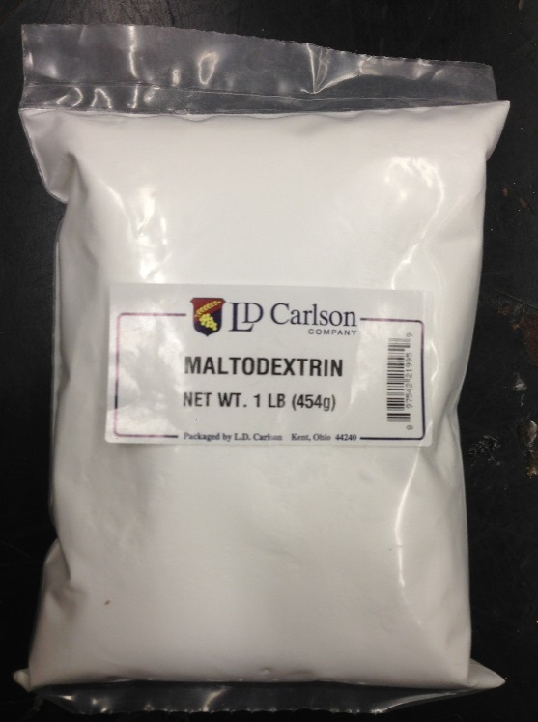

Figure : Maltodextrin (HL)

#### Printing Aid

Lecithin (shown in Figure 48) is one the best materials to use as printing aid in the powder recipe. This is because it has the ability to reduce the dust formation and adhere the grains together during the printing process. Furthermore, lecithin only dissolves in water, which is 92.98 percent of the binding agent. Although the time of the forming process is very short, the lecithin is still necessary to be used as the printing aid in the powder recipe. However, only a small amount of lecithin should be used to prepare the powder[1].

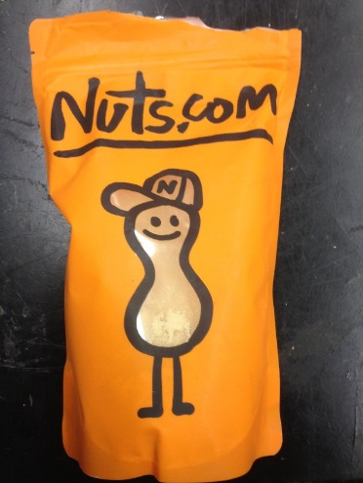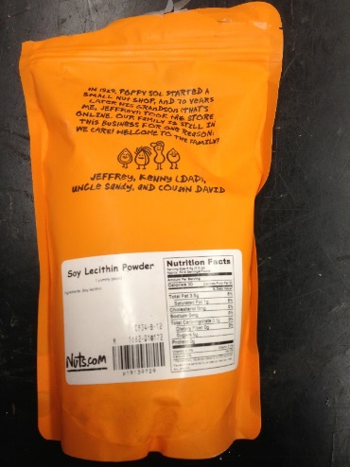

Figure : Lecithin (HL)

### Binding Agent Liquid Recipe

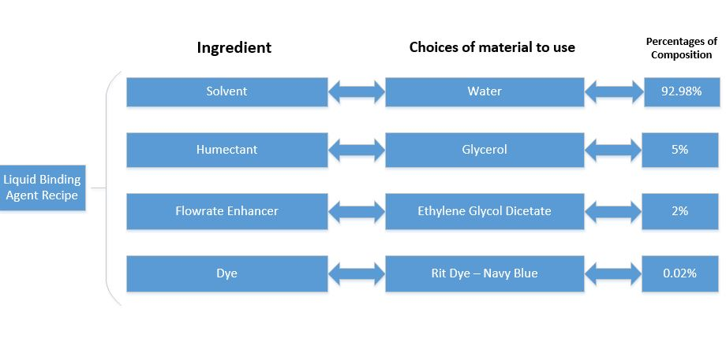 The binding agent is one of the most important subsystems in the design of ink jet 3D printer; the recipe is the most important factor as to how the binding powder solidifies into a part. The binding agent liquid recipe was based upon four ingredients: solvent, humectant, flow rate enhancer, and dye (shown on the figure 8, binding agent liquids recipe diagram). Therefore, the percentages of the composition and the choices of material will determine the properties of the liquid.

#### Solvent

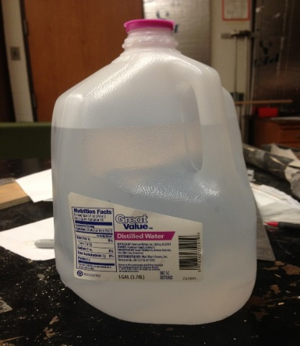 Solvent is an important ingredient because the binding agent is composed of over 90% of it. The choices of which material to use as solvent should be highly soluble, which can work well with the property of low solubility in the choice of material to use as filler in the printing powder recipe. Although, the material to use as solvent can be either aqueous or non-aqueous, the material should be aqueous in our design, because the binding agent should have a very low viscosity so that it may f appropriately fill into the ink cartridge and flow out the print nozzles. Therefore, there are a lot of material choices that can be used as solvent, such as ethyl alcohol, methylene chloride, and acetone etc. Finally, water was selected to be used as the solvent in the powder recipe, because it exactly matches the requirement of the material properties and easy to have. Furthermore, using the distilled water (shown in Figure 50) as solvent is better tap water, because tap water contain impurities which would affect the solidification of the product.

Figure : Distilled water (HL)

#### Humectant

The humectant is used to prevent the binding agent liquid drying and clogging in the printing head of the cartridge, and retard the evaporation of solvent in the binding agent. Because water is chosen to be used as solvent and powdered sugar is chosen to be used as particulate mixture adhesive in the powder recipe, the choices of material to use as humectant should correspond the properties to keep water in the sugar, and increase the toughness of the printing products. Therefore, glycerol (shown in Figure 51) is the best choice to be used as humectant when water is used as solvent.

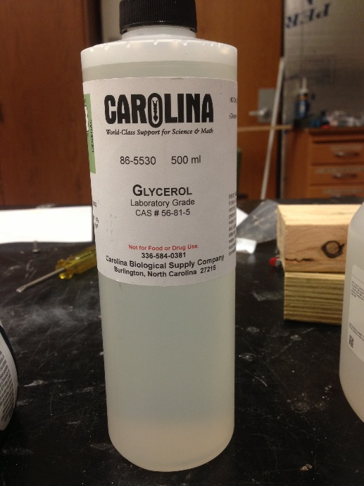

Figure : Glycerol (HL)

#### Flow Rate Enhancer

The flow rate enhancer is used to change the hydrodynamic property which reduces the viscosity and friction of the liquid binding agent liquid. Therefore, the higher volume flow rate can be transferred from the cartridge to the printing powder, which is leading the system much easier to control the thickness of each layer in the process of printing. Consequently, the choices of material to be used as flow rate enhancer should match the property of reducing liquid viscosity. Finally, ethylene glycol diacetate (shown in Figure 52) was selected to be used as the flow rate enhancer in the design of liquid binding agent recipe since it is one of the best choices when water is used as solvent.

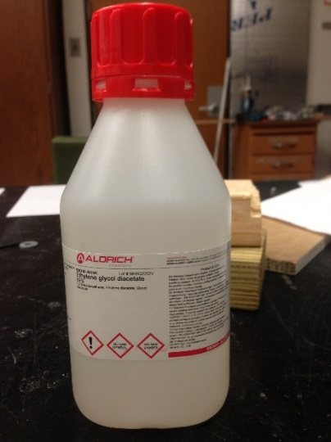

Figure : Ethylene Glycol Dicetate (HL)

#### Dye

Because the liquid is clear, the dye is used to provide color to the product. Therefore, the choices of the material to use as dye are not limited, they only depend on what color of the product is desired. Finally, the Rit dye – navy blue (shown in Figure 53) which is usually used as coloring of the cloth was selected to be used as dye ingredient in the binding agent recipe.



Figure : Navy blue dye (HL)

### Ingredients & materials

Table : Powder and Binding Agent Recipe compositions (HL)

|  |  |  |  |
| --- | --- | --- | --- |
| **Printing Powder and binding agent subsystems** | | | |
| minor subsystem | Ingredient | material to use | percentages of composition |
| **Printing powder subsystem** | **Filler/Reinforcer** | **Gypsum/Plaster of Paris** | **67%** |
|  | **Adhesive** | **Powdered Sugar** | **16.00%** |
|  | **Filler** | **Maltodextrin** | **16.00%** |
|  | **Printing Aid** | **Lecithin** | **1.30%** |
| **Liquid binding agent subsystem** | **Solvent** | **Water** | **92.98%** |
|  | **Humectant** | **Glycerol** | **5%** |
|  | **Flowrate Enhancer** | **Ethylene Glycol Diacetate** | **2%** |
|  | **Dye** | **Food Coloring** | **0.02%** |

### Equipment Needed

* Foam Bowls
* Plastic Container
* Spray Bottle
* 3 mL Syringes with needles
* Electronic Mass Scale
* Stirring glass rod or Plastic Spoon
* Beaker

### Implementation Schedule

1. Printing Powder Subsystem: ( 0.5 hours)
   1. Based on the total mass and the percentages of composition from the printing powder recipe, to determine the mass of each material.
   2. Using electronic scale to measure the detail mass of each material.
   3. Putting all the measured materials in one plastic container.
   4. Using spoon to mix all the powder together.
2. Liquid binding agent Subsystem: (2 hours)
   1. Cleaning the ink cartridge: (1.5 hours)

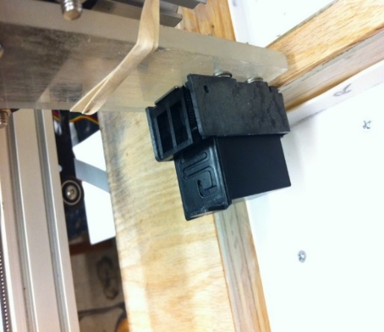

Figure : Cartridge and Ink Assembly (SA)

* + 1. Removing the ink cartridge from the ink assembly (shown in Figure 54)
    2. Taking the binding agent with a syringe with needle. Insert the needle through one of the holes on the top surface of the cartridge and slowly inject the solution.

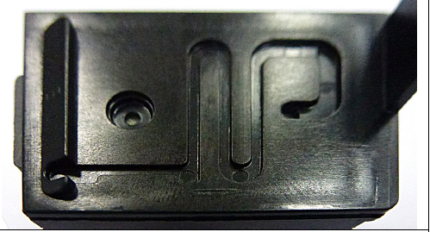

Figure : Holes on the cartridge (SA)

* + 1. About 12 mL of the solution will get the cartridge filled. If you prepare a big amount of binding agent, keep the rest of the binding agent for future use in a clean and dry reagent bottle to avoid contamination, and to guarantee a constant concentration.
    2. Moistening a sheet of a paper towel with distilled water and wipe the print head
    3. Putting the ink cartridge back in the ink assembly

1. Creating the binding agent chemical liquid: (0.5 hours)
   1. Pouring 92.98% of distilled water in the beaker.
   2. Taking 5% of glycerol and adding it to water in the beaker with the syringe.
   3. Using another syringe to add 2% of ethylene glycol dicetate to the solution
   4. Taking 0.02% of blue dye with the syringe and add it to the solution
   5. Stirring the mixture with stirring glass rod or spoon.

### Health, Safety and Environmental Issues

The health and safety issues of this subsystem are mainly focused on the use of chemical materials of Ethylene glycol diacetate and glycerol. The material safety data sheet mentions that the Ethylene glycol diacetate is a combustible liquid and it may cause harm to the skin and eyes, and respiratory irritation. [2] Also in another safety data sheet from Carolina biological supply company, the material of glycerol may cause the same irritation as the Ethylene glycol diacetate.[3]

In order to achieve a high level of health and safety, it is highly recommended to keep all the chemical materials away from heat and sunlight. Another recommendation is to wear latex gloves and breathing mask while preparing the powder and liquid binding agent. Furthermore, the chemical material of Ethylene glycol diacetate can be harmful to the aquatic life. In order to protect the environment, chemical liquids must not be disposed into the public water drains.

Not only are Ethylene glycol diacetate and glycerol toxic, but plaster of paris is as well. When the plaster of paris mixes with water liquid, it will generate heat. When the temperature becomes too high, the mixture can burn. In order to protect the eyes and skin, safety glasses and gloves are necessary while handling in the laboratory. If the mixture splash comes into the contact with eyes, plenty water should be used to rinse eyes for at least fifteen to twenty minutes. If the situation is serious, the affected person must see a doctor immediately. Furthermore, the plaster of paris is easy to disperse into the air, because it is extremely fine and light. Therefore, dust mask should be used to prevent breathing the dust in the air which irritant may cause breathing difficulties.[4]

### Costs

|  |  |  |  |  |  |  |
| --- | --- | --- | --- | --- | --- | --- |
| **Item name** | **Quantity** | **Unit price** | **Sub total** | **Source of funds** | **Item used in Prototype?** | **% Used** |
| 3mL Syringes with needles | 5 | $1.18 | $5.87 | Shaalan | Yes |  |
| Plaster of Paris - 25lb | 2 | $11.67 | $23.34 | ME dept | Yes |  |
| Maltodextrin - 1lb | 5 | $3.88 | $19.39 | ME dept | Yes |  |
| Powdered Sugar - 1lb | 5 | $1.32 | $6.60 | ME dept | Yes |  |
| Lecithin | 1 | $12.98 | $12.98 | ME dept | Yes |  |
| Distilled water-1gal | 1 | $1.98 | $1.98 | ME dept | Yes |  |
| RIT liquid dye - navy blue - 8oz | 1 | $5.45 | $5.45 | ME dept | Yes |  |
| Glycerol - 500mL | 1 | $20.52 | $20.52 | ME dept | Yes |  |
| Ethylene Glycol Diacetate 99% - 500mL | 1 | $37.50 | $37.50 | ME dept | Yes |  |
| Vinyl Touch Gloves, 100ct | 1 | $9.48 | $9.48 | On hand | Yes | 40% |
| 3M 10-Pack Sanding Respirator | 1 | $21.13 | $21.13 | ME dept | Yes | 30% |

Table : Prototype cost (PZ)

|  |  |  |  |  |
| --- | --- | --- | --- | --- |
| **Item name** | **Quantity** | **Unit price** | **Sub total** | **Vendor options** |
| Platser of Paris - 25lb | 2 | $11.67 | $23.34 | Lowe's, True Value, Home Depot |
| Maltodextrin - 1lb | 5 | $3.88 | $19.39 | LabelPeelers, Midwest Supplies, Bulk Apothecary |
| Powdered Sugar - 1lb | 5 | $1.32 | $6.60 | Walmart, Kroger, Schnucks |
| Lecithin | 1 | $12.98 | $12.98 | Nuts, Modernist Pantry, 911 Emergency Solutions |
| Distilled water-1gal | 1 | $1.98 | $1.98 | Walmart, Kroger, Schnucks |
| RIT liquid dye - navy blue - 8oz | 1 | $5.45 | $5.45 | Walmart, Jo-Ann Fabric and Craft, Craft Super Center |
| Glycerol - 500mL | 1 | $20.52 | $20.52 | Carolina, Mansion Schools, Kalyx |
| Ethylene Glycol Diacetate 99% - 500mL | 1 | $37.50 | $37.50 | Sigma Aldrich, Neobits, Grainger |
| Vinyl Touch Gloves, 100ct | 1 | $9.48 | $9.48 | Lowe's, True Value, Walmart |
| 3M Safety Mask Respirator | 1 | $6.23 | $6.23 | Lowe's, Home Depot, Menards |
| 3mL Syringes with needles | 1 | $1.18 | $1.18 | Amazon, Allegro Medical, ModoMed |

Table : Implementation Cost (PZ)

### Conclusions and Recommendations

There are some recommendations for these subsystems, which are mainly described in the lab report of the first full system test in the Appendix. First, the viscosity and solubility of the powder are both too high. Some powder adheres on the rolling bar (shown in Figure 88) leading to unsmooth surface and irregular layers of powder (shown in Figure 88). Second, the bonding strength of the powder is not strong enough. This is because of the brittleness of the product’s structure that makes the product easy to break (shown in Figure 92). Third, the mixture of the powder takes significant time to dry, which usually takes more than ten hours. This happens because the powder’s property of hygroscopicity is extremely low. Powder and binding agent recipes should be improved by doing more research on the materials properties, and by performing new tests that show how these materials will behave.

## Computer Host Software (WW)

### Overall Functional Description

The Computer Host Software serves as the main control of the printer. It allows the end user direct control of all of the printer's axes, print settings and G code file processing. The software uses a Windows COM port to communicate with the printer's electronics, using a USB cable, communicating with it using a specifically design communication protocol to serve the needs of the printer fast and reliably.

The Computer Host Software will make use of already existing open source G code slicing software, Repetier-Host[5], to allow the end user to place a part on a simulated printing bed, generating a G code file that the printer's Computer Host Software can then process, and print.

Shown here in Figure 56 is a very high level flow of the computer host software.

GUI

.GCode file

Printer

Settings

Part Processing Classes

Communication Protocol

USB

Figure : Overall Software Flow (WW)

### Design Options

There are many open source software options for 3D printing, however these almost always are categorized as only being capable of working with FDM based printing methods. Powder based printing prints line by line, sequentially, in a horizontal fashion, whereas FDM printers move in certain prescribed tool path patterns, extruding plastic. This means that, due to the fundamental differences in nature between FDM and powder based printing, entirely new control and part processing software was created to best suit the software and control needs for this project.

Although new software was written for this project, processing .STL parts still remains a complicated, and necessary process. Luckily, the G code that many FDM based printers, can be processed in such a way that is useful to powder printing. Essentially, all 3D part processing is done using an open-source FDM G code slicer, where the output G code is processed and rendered useful for this powder printing project.

### Main Design Approach

#### Printer Communication

The Computer Host Software, with the printer's electronics in mind, was designed using a command based instruction approach. For the purposes of the project, and the end product, this is the simplest, and most effective design choice for communicating and interacting with the printer. Although a more dynamic control approach could have been chosen, where the microcontroller and Computer Host Software communicate more intimately, it is much more difficult to implement, especially considering the relatively simple design architecture that a powder based printer requires. Commands are issued in a chronological fashion, designed in such a way that multiple commands can be processed by the printer at once, all the while, the Computer Host Software is aware of certain commands that *must* wait for previous commands to complete. *(This will be discussed more in detail in the Communication Protocol Section*).

Indeed, this is what RepRap open source printers use. Due to their nature of using a tool path, they implement the use of G code, a CNC based tool path language, retrofitted to be useful for FDM based 3D printing. This design approach was chosen because it keeps computations to be done on printer electronics to a minimum, but functional enough to where a printer can perform, step by step, the paths and extrusions to print out a part.

Similarly, the software written to control our powder based printer takes advantage of this same design approach. Although a special communication protocol has been created to better suit the fundamental differences of powder and FDM printing, it still uses the same linear, command processing based approach.

#### Part Processing

Due to the overwhelming options of 3D printer software for FDM based printers, the most efficient method of designing an end user solution for powder based 3D printer would include the usefulness of these. Using Repetier-Host, a user can use any .STL part, place it in the software's simulated bed, use the special output options optimized for this printer's software, and Repetier-Host will process the part, generating G code.

The G-code that Repetier-Host is actually designed to work on a FDM printer. However, using certain slicing options, it is possible for this printer's software to interpret the G code, layer by layer, and simulate in memory the overall shape of each layer of the part. From this, it is possible to generate matrices of print dots of which the powder based printer can print.

#### Graphical User Interface

The main design approach of the GUI is a button based interface where each button generates commands that will be sent to the printer to be processed and performed.

Due to time constraints on the project, the GUI could have been made more user friendly. Naturally, this can be done with more time, however, the current implementation, paired with a user that has read the user manual, should be able to use the GUI with relative ease.

The main interface of the GUI is a manual control section. In this part, the user is given the option to move any of the four axes (X, Y, and both platforms) any amount of steps they wish. Additionally, they are required (before performing an actual print), to define certain parameters of the X/Y carriage, which will be discussed later.

### Communication Protocol

A good start to understanding the software of the printer begins with the understanding of the communication protocol that is employed. As stated before, it is command based. The computer host software sends commands to the printer's electronics, where the printer acknowledges.

#### Objects of the packet sending process

This is the general flow that the program uses to take an intended action, translate it into a packet, and send that packet, awaiting for its "OK" from the printer electronics. In Figure 57, bolded names are actual class names used in the program's code.

*Someone wants to send a packet...*

**PacketHolder**

**QueueManager**

**PrinterComm**

**PacketVerificationSystem**

**SerialComm**

Figure : Communication Protocol Flow (WW)

Packet flow generally happens as shown here, Figure 58:

Packet is sent

Microcontroller processes packet

Microcontroller replies with OK

*(after waiting for the command's action to complete)*

Microcontroller replies with complete

Figure : Packet Processing Flow (WW)

Here in Figure 58, it is important to point out two important phases of the microcontroller's reply of the successful reception and completion of the packet's command.

Firstly, the microcontroller replies with an OK for every packet receives. This first reply indicates that the packet received has not been corrupted, and its contents have been stored and processed successfully. Once this occurs, it is now safely possible to send another packet to the printer, if QueueManager has more packets pending.

Secondly, and more importantly, the microcontroller will reply with a "completed" packet. This indicates to the computer host software that the command in the sent packet has finished being completed entirely.  *(Of course, all packets sent to the printer aren't always actions that require some amount of time to complete, but for simplicity, all packets will reply with this anyway, to avoid confusion with packets that do and don't take time to complete.)* It is important for the computer host software to be aware of when a packet's actions are completed, in the event that the *next* packet that will be sent, is a wait packet. This ensures that the wait packet actually waits for the pending actions to complete, before that next packet goes ahead and is sent.

##### PacketHolder

PacketHolder is a class that simply holds the data to be contained in an actual packet to be sent to the printer. It contains none of the actual packet format. Instead of the packet being formatted as soon as it is decided that a packet needs to be sent to the printer, it is better to keep the *contents* of the packet in a simple holding object, and have a separate class format the packet accordingly. This ensures that only *one* place within the code of the project actually handles formatting the packet, as opposed to multiple points in the software trying to format the packet correctly (and, all the same way, creating potential unnecessary conflicts).

PacketHolder also has the property called "wait". This is a simple boolean value that holds whether or not that this packet must wait for all previous actions before it to complete, before it is safe to send this packet. This will be explained in more detail in the QueueManager class description.

##### QueueManager

QueueManager is by far the most important class object in terms of the printer's communication protocol. The QueueManager holds a list of all queued packets to be sent to the printer, but more importantly, controls the flow of when packets are to be sent to the printer, given certain criteria.

The QueueManager uses a Thread() object to constantly (actually around once every 10ms) monitor if a packet is ready to be sent, the printer electronics has completed processing the previous packet, and that the packet is not pending the completion of all packets before it.

QueueManager makes use of the "wait" property of the PacketHolder class, which is crucial to the successful control of packet flow of the printer's communication system. Certain actions, such as translating in the X direction to print the loaded line, *must* wait for the printer head to be in position, and the line's data to be loaded into memory of the printer electronics, before it can proceed with sending the actual translate for printing packet. This is an example of a packet where PacketHolder's attribute of "wait" would be set to true. As it indicates, it must wait for all previous actions (getting into position and line data being ready), before it can tell the printer to go ahead and print the queued line.

##### PrinterComm

PrinterComm is the class that translates PacketHolder class objects, when they are ready to be sent, into the actual packet format that the microcontroller is programmed to support. It takes the data that's held in the PacketHolder.PacketData object, and encodes it appropriately.

##### PacketVerificationSystem

After the packet payload has been created by the PrinterComm class, the packet's headers and footers need to be added for the transport between the computer host software, over USB cable, to the microcontroller.

public UInt32 Enqueue(String payload)

{

UInt32 packetNum = (UInt32) _packetsSent.Count;

UInt32 checksum = calcChecksum(payload);

string packetReady = packetNum.ToString("0000000000") + payload + checksum.ToString("00000");

RawPacket newPacket = new RawPacket(packetReady);

_packetsSent.Add(newPacket);

PacketReady(packetReady);

return packetNum;

}

Figure : Appending the payload header and footer (WW)

As shown in Figure 59, the header simply consists of a 10 character unsigned integer indicating packet number. The footer is a 5 byte checksum that is performed on the payload of the packet. This checksum is calculated both by the computer host software, and the microcontroller. In the event that the checksums do not match, a packet is sent to the computer host software indicating of this failure, requesting that the same packet is resent.

private ushort calcChecksum(String cmd)

{

int cs = 0;

int x;

bool j = false;

for (int i = 0; i < cmd.Length; ++i)

{

if (j) {

x = cmd[i];

x = x << 8;

cs = cs ^ x;

} else {

cs = cs ^ cmd[i];

}

j = !j;

}

return (ushort)cs;

}

Figure : Code snippet of Checksum calculation method (WW)

Shown here in Figure 60 is the checksum method. Of course, its hashing ability wouldn't be secure for applications like bank transactions, but it works good enough for simple data corruption detection for some method of transport, like this project.

Lastly, the packet is held for storage in the PacketVerificationSystem class object. This is important in the event of transmission failure, the system will automatically resend the packet a fixed amount of tries before the user is alerted that communication with the printer has failed. Due to the design of the "OK" packet response of the communication protocol, this will not interfere with pending actions that the QueueManager would want to send next. A new packet will not send until an "OK" packet is received, indicating that the packet transmission was successful. If, in the event that they payload was corrupted, this "OK" packet simply will be replaced by a failure packet, and the QueueManager will not consider sending another packet until this "OK" is indeed sent.

##### SerialComm

Lastly is the SerialComm class, which handles the actual Windows serial port communication. It simply takes the packet generated by PrinterComm and PacketVerificationSystem, adds the end of packet character, '~' and transmits it to the microcontroller via USB.

#### Packet Format

This section shows the format used to send packets from the computer host software, to the electronics. There are two packet formats because only packets sent to the printer electronics are sensitive enough to ensure that their delivery happens successfully without any of its payload corrupted. The packet format is as follows in Figure 61.

|  |  |  |  |
| --- | --- | --- | --- |
| 10 char packet number | Packet payload, including a name, and subsequent data | 5 char checksum | End of packet char, '~' |

Figure : Sending Packet Format (WW)

### Part Processing

The part processing for the computer host software was by far the most technically complex portion of the project. It entails using the output of open source G code slicing programs, to be interpreted and represented in matrices of dots that can be printed with an inkjet head.

The given software of choice was Repetier-Host, since it integrates both a visual display of the part before and after it is rendered, along with options that can be adjusted to produce G code that is optimized for processing by this project's software.

G code typically creates tool paths that are multiple different shapes, which are easily supported by FDM printers. For the purposes of powder based printing, and to simplify the processing of the G code, it was decided that enforcing a "rectilinear" tool path style was required. "Rectilinear" means that all G code tool paths are straight lines, as opposed to straight lines and arcs. This makes processing the G code much less complicated, as rendering rectangular polygons is much easier than rendering arcs, for example.

Once the G code is produced it is saved to a file. It is then ready to be opened by the computer host software to be processed into a list of commands that would result in that part printed.

#### Objects of Part Processing

Text in Figure 62 that are bolded are actual classes in the code.

**MultiThreadLayerProcessing**

User selects a .gcode file...

**GCodeFileReader**

**LayerProcessingThreads**

**...**

**LayerProcessing** #1

**LayerProcessing** #*n*

*n* number of **LayerProcessinng** threads

**PowderPart**

**PrintCommandGeneration**

List<**PacketHolder**>

Figure : G Code Processing Flow (WW)

##### GCodeFileReader

The first part of the process is to read the user selected .gcode file. This class simply reads the text of the .gcode and creates objects that separates each G code command by their layers, so that each layer can be processed.

##### LayerProcessingThreads

LayerProcessingThreads is simply the encapsulating class that will create multiple different threads to process each G code layer. It will attempt to have the program always work on as many layers as the user wants to run at once, storing the result of each layer into a PowderPart object.

##### LayerProcessing

LayerProcessing is a computationally intensive class, hence why it has been created in such a way that many instances of it can be ran at once.

First, LayerProcessing reads each G code command that composes its respective part layer, and generates polygons in the 2D space of where the layer will be printed. It creates GPolygon objects such that they can be used to create a more digital representation of those polygons. Essentially, these polygons represents geometrically what and where a FDM printer would extrude out onto its platform as it printed the part. The computer host software takes advantage of these polygons to map out where on the 2D surface the powder based printer should be spraying dots, as opposed to extruding plastic. The code is relatively simple, and is as follows:

foreach (GPolygon poly in polygons)

{

//find the min/max x y values for this polygon, and ONLY scan that area of the bed

GPolygonMinMaxes minMaxes = poly.GetMinMaxes();

int xMin = Convert.ToInt32((double)(Math.Floor((double)(minMaxes.XMin / _dotWidth)) - (double)1));

int yMin = Convert.ToInt32((double)(Math.Floor((double)(minMaxes.YMin / _dotWidth)) - (double)1));

int xMax = Convert.ToInt32((double)(Math.Ceiling((double)(minMaxes.XMax / _dotWidth)) + (double)1));

int yMax = Convert.ToInt32((double)(Math.Ceiling((double)(minMaxes.YMax / _dotWidth)) + (double)1));

for (int i = xMin; i <= xMax; ++i)

{

for (int j = yMin; j <= yMax; ++j)

{

//first check it's not already marked as true

if (!_layerProcessed.layer[i, j])

{

xDist = _layerProcessed.getDist(i);

yDist = _layerProcessed.getDist(j);

if (poly.WithinPolygon(xDist, yDist))

{

_layerProcessed.layer[i, j] = true;

}

}

}

}

}

Figure : Code snippet of LayerProcessing (WW)

As shown in Figure 63, we iterate through all of the G code polygons, and then go through where in the print bed that polygon is expected to lay. (This is what the X/Y max/min variables are for, they help optimize the code by estimating generally where in the print bed that the polygon is likely to lie, instead of running the test on the whole print bed area). Once these estimations are made, we go through every possible location that a dot *could* be sprayed. For each potential spray location, we ask GPolygon to run the method GPolygon.WithinPolygon(), and indicate whether or not the current potential spray location is indeed inside the polygon. If it is inside the polygon, this is where we need to spray ink, because, simply put, that's where the FDM printer would have extruded out plastic.

One other small optimization that was added was that we will not perform the GPolygon.WithinPolygon() check if that particular dot is already marked as true. Due to the FDM G Code slicing process, it's possible that some polygons may overlap, in which case, the code would be checking the same location more than once unnecessarily. If it that particular dot is already marked to be sprayed, there's no point in checking whether it lies within a different polygon since it already needs to be sprayed due to a previous polygon match.

As shown in Figure 63, the code is fairly simple. However, the method of GPolygon.WithinPolygon() includes a lot of double precision operations, which are very time consuming in terms of CPU processing time. Additionally, this code has 3 nested loops, with large amount of iterations for all 3, meaning that this code can potentially be very time consuming. And of course, the above code must be ran for *every* layer of the entire part. This is why this class is considered so computationally intensive. Luckily, each layer is independent of each other, meaning multiple layers can be processed at once without any conflicts or collisions, allowing for the easy implementation of multi-threaded layer processing.

##### PowderPart

After LayerProcessing completes for each respective layer, they're added to a simple encapsulating class of processed layers called PowderPart. PowderPart takes care to make sure these layers are in order, of course. Multi-threading means some layers could finish before others unexpectedly, meaning the order could differ from the originally intended order. PowderPart ensures this does not become an issue.

##### PrintCommandGeneration

This is the last step in turning a .gcode part into packets that can be printed by this printer. It mainly proceeds by iterating through each layer, from bottom to top (the same direction that the part is built in), and looks for where dots to be printed occur. If at least one dot is found to be within the range of a print line, the PrintCommandGeneration processing processes the entire line unless it detects there are no more dots to be printed within that single line. *(Due to the nature of the HP C6602 cartridge, each print line consists of 12 vertical dots that can be sprayed. This means that each print line that is processed is a height of 12 dots, every time.)*  
 During this process, the algorithm uses the PrinterSettings class, which contains all of the distance/step ratios of all the axes, to correctly tell the motors to move the correct amount of steps. During the whole part processing process, many of the classes have access to the same instance of PrinterSettings as many of the values are required for many different processes.

### Graphical User Interface

Figure : Main GUI for Printer Control (WW)

The Graphical User Interface (as shown in **Error! Reference source not found.**) is the endpoint of all printer control that is available to the end user. It allows many operations, including:

* Manual Axis movement
* Axis speed / acceleration settings
* Distance/step ratios for every axis
* Axis position definitions
* Emergency stop
* Print processing settings

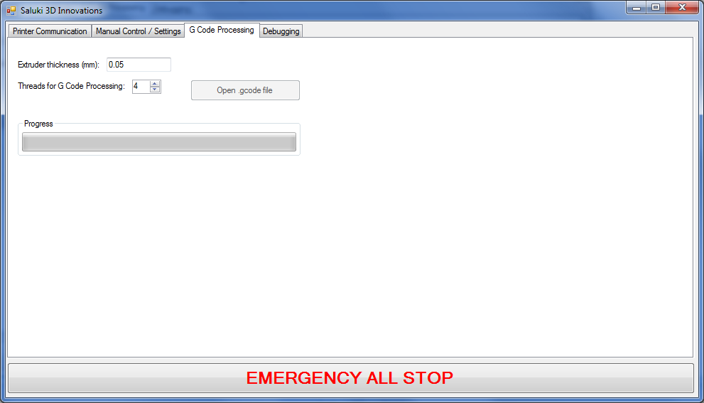

Figure : Screenshot of G Code processing tab (WW)

In addition to the "Manual Control / Settings" tab, the user is allowed to enter basic G code processing settings, including the G code slicer's extrusion thickness, and the number of threads that the layer will be processed. Additionally, the progress of the time consuming operations are displayed to the user, showing both percentage and estimated time of completion.

### Flow of Printing Operation

Figure : Flow chart of packets to print a part (WW)

The above diagram shows the general flow of how a part is printed, in terms of the communication protocol and the mechanical processes required to complete the requested actions.

### Other Important Classes and Concepts

The previously discussed classes represent the bulk, and most important features for the 3D printer, however, there are other classes that are worth mentioning here.

##### PrinterSettings

PrinterSettings is the class that holds all important values and settings that all of the software the 3D printer needs. It contains items such as

* Axis distance/step ratios
* Print thickness
* Axis translation speeds/accelerations
* Axis inversions

##### TestPart

TestPart is the class that creates the packets to print the test part, a 1cm3 cube. The class uses the PrinterSettings class to estimate the amount of print array fires, distances, etc, required to print the test shape.

##### PrintTimeEstimator

PrintTimeEstimator is a class that takes all the packets that make up a printed part and estimates, using the current printer settings, how long it would take to print the specified part. PrintTimeEstimator takes into account the baud rate of the serial communication, and an estimate amount of processing overhead that the Arduino typically takes for different packets (the amount of time if take the Arduino to reply with "ok" as it requires some amount of time to parse the packet).

##### Packets

Packets is a holding class that contains the PacketTypes enumeration, the PacketHolder class, and each special packet class that holds the info for each different type of packet.

public class PacketHolder

{

public Packets.PacketTypes PacketType { get; set; }

public object PacketData { get; set; }

public bool WaitForPrev { get; set; }

}

//(other code here hidden for illustration purposes)

public class Translate

{

public long Position { get; set; } //translate TO this position

public bool Printing { get; set; }

public Translate()

{

Printing = false; //unless otherwise noted, we aren't printing

}

}

/

Figure : Code snippet of PacketHolder and Translate classes (WW)

Shown in Figure 67 is the PacketHolder class. It contains the Packets.PacketTypes enumeration, indicating what kind of packet this PacketHolder object represents. PacketData is left as type object such that whomever needs to read PacketHolder can cast PacketData as the correct packet. For example, if PacketType = Packets.PacketTypes.TranslateX, to get the data of the packet, you would cast PacketData as theTranslateXPacket = (Packets.Translate) PacketHolder.PacketData. After this line is ran, theTranslateXPacket is now an object equal to the translation data that the PacketHolder contains. Naturally, Packets.Translate is just a general class that holds translation data for any axis, but it is the PacketHolder.PacketType that specifies which axis it refers to.

As described earlier, WaitForPrev is the indicator to the QueueManager of whether or not this packet must wait for all previous actions to complete. This is the variable that takes care of this.

##### PacketFlowInfo

PacketFlowInfo is a simple class that allows for the easy encapsulation of a PacketHolder object, which can be sent to any listening class in the whole printer software. Some points of code needs to listen for certain packets, some others, so this packet makes data available system wide to the printer, without creating any global variables. This is achieved through simple event listeners.

##### Printer

This is the top most class of the 3D printer. Through Printer, the GUI operates as required, and the GUI sends all requests and information through the Printer class, so as to provide appropriate access to the code, in a safe manner. Additionally, if multiple Printers want to be programmed later, encapsulating all of the Printer's software internals in this class, allows for this to be achieved with relative ease.

##### Rolling Mechanism Powder Distribution

Due to the nature of powder printing, a rolling mechanism must be employed to correctly distribute powder using Y axis movements. A bar parallel with the X axis is used, and rotated in the opposite direction of the Y axis during powder distribution, to as to attempt to evenly distribute powder onto each layer. Due to the nature of the radius of the rolling bar being different than that of the Y axis gears, the rolling mechanism speed must be calculated. When the Y axis is moving over the part, but not distributing powder, the rolling mechanism should move along with the Y axis, so as to simply roll on top of the printer, not creating any unnecessary stress on the newly printed layers or distributed powder. The location of the Y axis is accounted for to accomplish this.

##### Minimum System Requirements

The software is not intensive enough to have any important system requirements, however here is what's recommended. Windows XP (or higher), at least 1GB of RAM, and a processor of 1.4GHz or more.

### Experiments and Performance

Many experiments and testing occurred during the development stage of the computer host software. They are listed as below, and follow a chronological fashion so as to describe what parts of the program were tested, indicating the general order of how the program was developed:

1. QueueManager test
   1. This test was to verify the functionality of QueueManager, which was to verify that packets were able to be correctly sent to the Arduino, and it was able to process them correctly. Additionally, the wait packet feature was tested, and verified to function correctly.
   2. This was arguably the first and most important test of the software, as all the whole printer system relies on the correct function of this feature. To test this, two motors were connected to the Arduino, and their motions were monitored. A small code was created to move one motor, wait for the first one to move, then move the second. This shows that the QueueManager correctly waits for a previous command to complete, before issuing the next.
2. LayerProcessing test
   1. The main purpose of this testing was to verify that the processing of a G code layer resulted in dot locations that accurately describe the shape of a given layer. For debugging and testing purposes, when a layer was processed, a text file containing all of the points of where dots were to be sprayed were saved, and then plotted as a X/Y scatter in MATLAB, to visually see all the dots in a 2D plane. The test verified that the dots were (within small margin processing error), correctly resembled the part of which was processed. Shown in Figure 68 is the figure that MATLAB generates when showing one the layers. Each small circle is to represent a single dot sprayed by the inkjet.

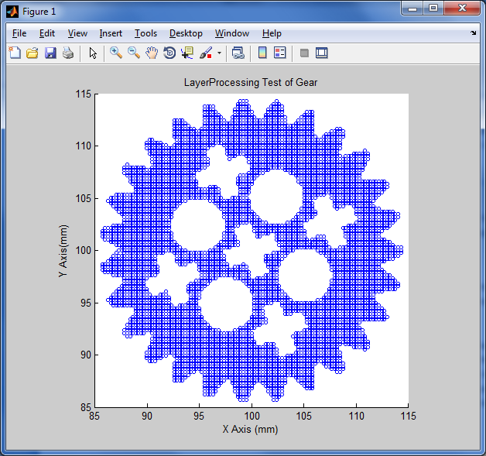

Figure : LayerProcessing Test Using MATLAB (WW)

1. TestPart
   1. Although the printer was not entirely assembled, mainly the powder platforms, it was still possible to begin trying out the TestPart code. Initial testing indicated that some of the print line packet transmission was bugged, but with a few days of time, the TestPart was shown to correctly print out a 1cm2 test square. (Only a single layer was printed because of the lack of functioning powder beds). Shown in Figure 69 is the code that printed a rectangle, but later correctly printed a square. This was due to a small bug in the communication protocol.

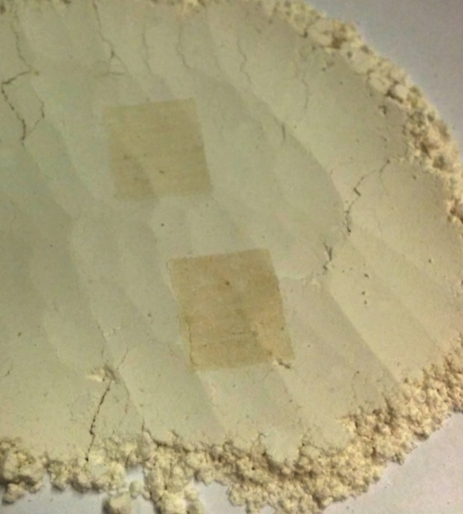

Figure : TestPart code result on some binding powder (WW)

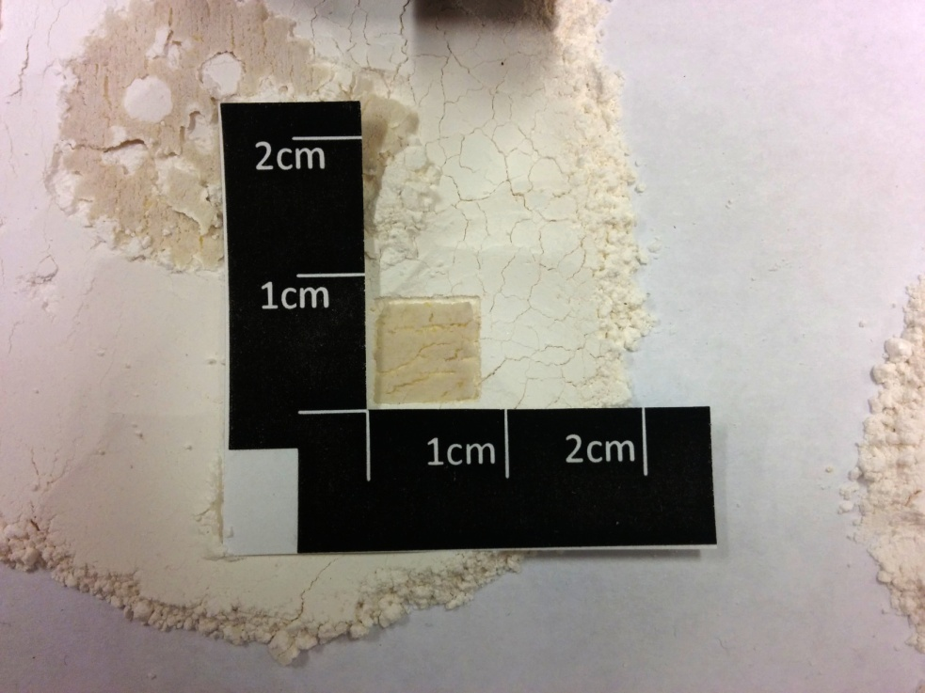

Figure : TestPart code fixed (WW)

* 1. Shown in Figure 70 is the result of a few layers of the TestPart. The scale of the dot size appears to be off, and could be fixed later in testing.

1. Print Layer Testing
   1. 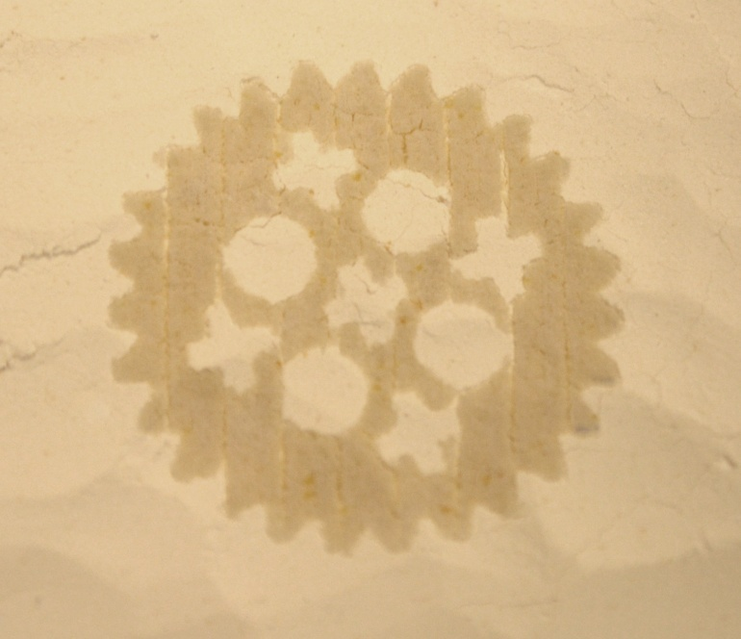This test was to verify that the printer was able to correctly print out the pattern of the G code file that was processed. Again, initial testing verified that the print line packet sending packet format was bugged, but with around a few days of testing, the printer was able to correctly print a layer of the gear, multiple times over in the same spot, with very reasonable precision.

Figure : Sliced and printed gear on some binding powder (WW)

#### PrintTimeEstimator Accuracy

A small test was created to verify the accuracy of the PrintTimeEstimator's ability to correctly predict the time a print should take. Shown here in Table 14 is the result of that test. As can be seen, the PrintTimeEstimator class only marginally estimates the time correctly, and has much more work to be done such that it is useful to the end user. Shown here is not the full time to print a part, but only a couple layers for simplicity. This is acceptable because the error is expected to be linear.

|  |  |
| --- | --- |
| Table : PrintTimeEstimator Accuracy Test Results (WW) | |
| **Estimated time by PrintTimeEstimator** | **Actual time to print** |
| 5 m 36 s | 3 m 28 s |

#### Processing Time (As Compared to GCode Slicing)

The processing of parts, as compared to the G code slicing, is surprisingly much faster than the G code processing counterpart. Although, for this printer project, the G code must be processed in addition to the original G code processing, it is worth noting that this is faster than the first.

Consider the following results:

|  |  |  |
| --- | --- | --- |
| Table : Part Processing Time Comparison (WW) | | |
| **Test Gear Size** | **Repetier-Host Slic3r Processing Time** | **Computer Host Software processing time** |
| (2x original .STL file's size) | 24 s | 5 s |
| (5x original .STL's file size) | 95 s | 28 s |

### Fault Analysis

As the software is still in development stage, and is not full proof in terms of the end user, certain precautious must be taken before using the software. These consist of:

* Make sure the printer's power is on **BEFORE** connecting the USB cable
  + The Arduino will try to power the motors through the USB cable if no power is provided to the printer, and this is a very bad idea. Ensure, every time, that the printer's power is on at any point that the USB is connected to the printer.
* Before any axis movements, press "Save and Sync All" at least once
  + Certain values must be updated with the Arduino such that axis movements can occur properly.
* Avoid using the "Debugging" tab
  + Unless you are a developer doing testing, or editing the software itself, it is unadvisable to use any of the functionality in the "Debugging" tab.

### Conclusions and Recommendations

From a software point of view, it can be stated that the Computer Host Software, although mostly functional, needs further study and is not ready for full deployment for end users. Simply put, more time for testing, and debugging, is required to ensure the correct functionality of the software. The portions of the software that fall into this category are as follows:

* Rolling mechanism synchronization with Y axis movements
  + Due to time constraints of the design report, and the last minute usage of different motors due to multiple different mechanical problems during the prototype implementation, correct functionality of this system has not been verified.
* GUI related bugs
  + Due to time constraints, there are possible ways that users can enter combinations of button presses that may render the current instance of the software inoperable. Although if the user follows the user manual correctly, this should not be an issue.
* GUI limitations
  + Again, due to time constraints, many important values have been hard coded so as to save time, and to make a proof of concept as likely as possible. For example, all the distance/step ratios, and other various are already filled in for the user upon start up. The user may alter these in the event that they simply aren't accurate, but the user has no way of saving these changes and would have to reenter these values every time the program is started.

## Electronics (WW)

### Overall Functional Description

The electronics subsystem of the printer serves to provide power, and control to the physical elements of the printer. It mainly implements the Arduino MEGA[6], InkShield[7], all the stepper motor drivers, the motors, and the power supply.

### Design options

Design options for the electronics was fairly straight forward. Appropriately sized motors were selected to suit the power and accuracy requirements of all the axis translations, appropriate stepper motor driver currents (for their respective motors), and the selection of the InkShield.

The InkShield is a board that is specially designed to fit right on top of an Arduino, allowing an easy implementation of the control of a HP C6602 based ink jet cartridge. In the Arduino code, all that needs to be done is instantiate an InkShield object, including which pin is used to create the pulse, and at appropriate moments in the code, the nozzles are fired using the correct nozzle array.

### Chosen Hardware

|  |  |  |
| --- | --- | --- |
| Table 16: Motor Selections with respective Stepper Motor Drivers (WW) | | |
| **Axis** | **Selected Motor** | **Selected Driver** |
| X axis | Mercury Motor (330 mA / phase) | EasyDriver (up to 750 mA/phase) |
| Y axis (two motors) | Mercury Motor (330 mA / phase) | EasyDriver (up to 750 mA/phase) |
| Rolling mechanism | Mercury Motor (330 mA / phase) | EasyDriver (up to 750 mA/phase) |
| Platform motors (two) | Nanotec linear position drive (1400 mA / phase) | Big Easy (up to 2000 mA/phase) |

The EasyDriver and the Big Easy stepper motor drivers were chosen for their ease of use, and flexibility. Both boards contain the current limiting circuits that allow for the easy control of maximum amounts of currents sent to the motor, as different motors are rated at different maximum currents.

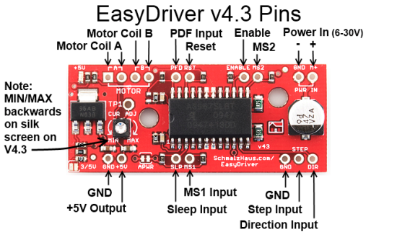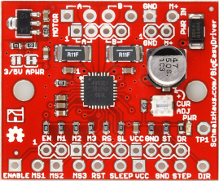

Figure : Code snippet of Checksum calculation method [7] (WW)

Figure : EasyDriver Stepper Motor Driver [6] (WW)

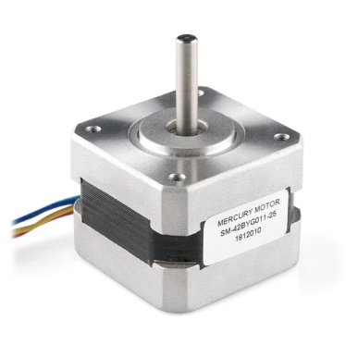

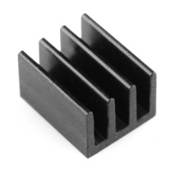

Figure : Small heatsink used for stepper motor drivers [9] (WW)

Figure : Stepper Motor Driver for X and Y axes [8] (WW)

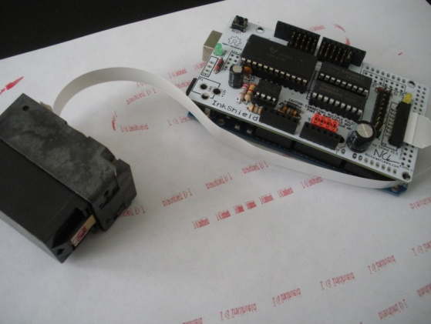

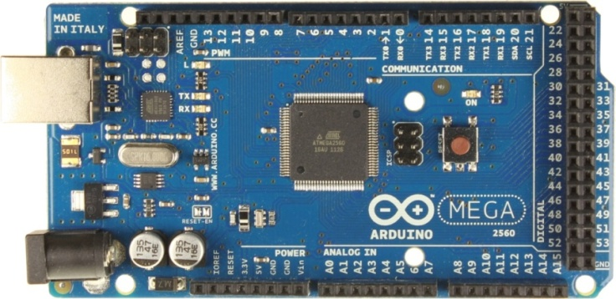

Figure : InkShield attached to an Arduino MEGA with connected inkjet cartridge [4] (WW)

Figure : Arduino MEGA [3] (WW)

### Costs

Table : Actual Design Costs (WW)

|  |  |  |  |  |  |
| --- | --- | --- | --- | --- | --- |
| Item name | Quantity | Unit price | Sub total | Source of funds | Item used in prototype? |
| 300W power supply | 1 | $16.99 | $16.99 | ECE dept | Yes |
| EasyDriver stepper motor driver | 3 | $14.95 | $44.85 | ECE dept | Yes |
| EasyDriver stepper motor driver | 1 | $ 14.95 | $14.95 | Wheeler | Yes |
| Stepper motor with cable | 1 | $14.95 | $14.95 | Wheeler | Yes |
| Stepper motor with cable | 3 | $14.95 | $44.85 | ECE dept | Yes |
| BigEasy stepper motor driver | 2 | $19.95 | $39.90 | ECE dept | Yes |
| InkShield | 1 | $66.00 | $66.00 | Wheeler | Yes |
| InkShield AUX_OUT breakout | 1 | $9.00 | $9.00 | ECE dept | Yes |
| Molex connector | 2 | $1.09 | $2.18 | ECE dept | Yes |
| Molex connector(x2 3.5mm female) | 1 | $0.79 | $0.79 | ECE dept | Yes |
| Small heat sinks | 10 | $1.95 | $19.50 | ECE dept | Yes |
| Small heat sinks | 5 | $1.95 | $9.75 | Wheeler | Yes |
| Arduino MEGA | 1 | $26.00 | $26.00 | Wheeler | Yes |
| Thermal tape | 1 | $3.95 | $3.95 | Wheeler | Yes |
| Female PCB headers, 2 conn. | 15 | $0.35 | $5.25 | Wheeler | Yes |
| Female PCB headers, 3 conn. | 3 | $0.49 | $1.47 | Wheeler | Yes |
| Female PCB headers, 4 conn. | 3 | $0.62 | $1.86 | Wheeler | Yes |
| D sub connectors | 4 | $2.95 | $11.80 | Wheeler | Yes |
| Microswitches | 2 | $3.93 | $7.86 | ECE dept | No |
| PSU cable | 1 | $6.14 | $6.14 | ECE dept | No |
| DC fan | 1 | $4.95 | $4.95 | ECE dept | No |
| Stepper motor w/ threaded shaft | 2 | $85.93 | $171.86 | ECE dept | Yes |
| Jumper wire (JST to PCB female) | 1 | $1.50 | $1.50 | Wheeler | No |
| 4 pin MOLEX connector | 1 | $0.95 | $0.95 | Wheeler | No |
| Heatsink compound | 1 | $1.95 | $1.95 | Wheeler | No |
| PCB Mounting Feet | 2 | $4.35 | $8.70 | Wheeler | Yes |
|  |  |  |  |  |  |
|  |  |  | **Total** |  |  |
|  |  |  | **$537.95** |  |  |

|  |  |  |  |  |
| --- | --- | --- | --- | --- |
| Item name | Quantity | Unit price | Sub total | Vendor options |
| 300W power supply | 1 | $ 16.99 | $16.99 | Newegg, tigerdirect, ebay |
| EasyDriver stepper motor driver, ROB-10267 | 4 | $ 14.95 | $59.80 | SparkFun, Amazon |
| Stepper motor, ROB-09238 | 4 | $ 14.95 | $59.80 | SparkFun, HobbyEngineering |
| BigEasy stepper motor driver, ROB-11876 | 2 | $ 19.95 | $39.90 | SparkFun, Amazon, |
| InkShield | 1 | $ 66.00 | $66.00 | NerdCreationsLab |
| InkShield AUX_OUT breakout | 1 | $ 9.00 | $9.00 | Nicholas C. Lewis |
| Molex connector, product #2878 | 2 | $ 1.09 | $2.18 | Monoprice, Amazon, Cable Wholesale |
| Molex connector(x2 3.5mm female), product #1314 | 1 | $ 0.79 | $0.79 | Monoprice, Endless Cables, Digikey |
| Small heat sinks, PRT-11510 | 15 | $ 1.95 | $29.25 | SparkFun, Karlsson Robotics, |
| Arduino MEGA | 1 | $ 26.00 | $26.00 | RadioShack, Newegg, Amazon |
| Thermal tape, PRT-09771 | 1 | $ 3.95 | $3.95 | SparkFun, Ebay, Amazon |
| Female PCB headers, 2 conn, S7035-ND | 15 | $ 0.35 | $5.25 | Digikey, SparkFun, Jameco |
| Female PCB headers, 3 conn, S7036-ND | 3 | $ 0.49 | $1.47 | Digikey, SparkFun, Jameco |
| Female PCB headers, 4 conn, S7037-ND | 3 | $ 0.62 | $1.86 | Digikey, SparkFun, Jameco |
| PCB Mounting Feet | 2 | $4.35 | $8.70 | Newegg, ebay, Jamma Boards |
| Stepper motor w/ threaded shaft | 2 | $85.93 | $171.86 | Walker EMD |
|  |  |  | **Total** |  |
|  |  |  | **$494.10** |  |

All items ship normally by the next business day, and are delivered with a standard 3-5 business day window. None of the components were on back order and all should be relatively available (as determined on April 9th, 2014).

Table : Implementation Costs (WW)

### Implementation Schedule

The following tasks may be performed in this order (where some items may be performed simultaneously).

##### Equipment needed:

1. Soldering iron
2. Solder
3. Scissors (to cut the thermal adhesive to size)
4. Wire cutters / strippers
5. 26 AWG "breadboard" wire, for wiring
6. Cordless power drill (drill bits and Phillips head for fastening PCB feet to frame)

##### Implementation Tasks

1. Soldering
   1. The InkShield (4.0 hrs)
   2. The Stepper Motor Drivers (3.0 hrs)
   3. Power supply connectors (1.5 hrs)
2. Miscellaneous
   1. Attach heat sinks to drivers (1.0 hr)
   2. Verify all motors turn as expected (2.0 hrs)
   3. Attach electronic boards and power supply to the frame (1.5 hrs)
3. Wiring
   1. Wire all components as specified by the electronic wiring diagram as shown in Drawing 36 (2.5 hrs).

### Fault Analysis

There are numerous problems that could potentially occur with electronics of the printer, but can be avoided with careful mounting, and good soldering practices. Problems that could occur due to a lack of following such practices include:

* Disconnection of logic wires between Arduino and the stepper drivers
  + This is less serious. If a print is in progress, simply put, the motors will either stop turning, or not turn in the correct direction. Damage could occur to the printer if the user does not notice that an axis is moving too far, or unexpectedly, without pressing emergency stop on the computer host software's GUI.
* Disconnection of motor wires from stepper drivers
  + This is a serious fault. Any kind of wire disconnection from the stepper motor drivers *during* a powered state can and will cause permanent damage to the stepper motor drivers. To avoid this, it is recommended that the motor's wire are soldered directly to the motor board, or proper precautions are taken such that the motor and the stepper motor do not become disconnected during a powered state.
* Loss of power due to wire disconnection
  + This is generally considered less serious, except for the Y axis motors. Since two motors are used to drive the Y axis, if one motor suddenly stops performing expectedly due to some sort of power outage, only one motor will be turning, and the entire Y axis may stop moving correctly, or bind on itself. If this occurs, either power down the printer immediately using the power supply button, or using the emergency stop button on the computer host software's GUI.
* Stepper motor drivers overheating
  + This is less serious. The chips onboard have auto shut off features in the event that they exceed around 150 degrees Celsius, however, during a shutoff, the motor will discontinue moving. This could cause a number of problems during operation, depending on which motor driver experiencing an overheat fault. This fault is very unlikely given the attached heat sinks, as all of them have proven to never exceed 120 degrees Celsius. It also recommended that the back of the printer (the location of the electronics) is not up against a wall, and is in a well ventilated area.

### Experiments and Performance

The implementation and testing of the electronics for the printer was relatively straight forward: simply solder and wire correctly, and use small test programs on the Arduino to verify their correct functionality individually. They are summarized below.

1. InkShield test
   1. This test was to verify that the InkShield board functioned correctly and the inserted HP C6602 inkjet cartridge fires nozzles accordingly. This worked on its very first try, and have not had any problems on this system at all.
2. Stepper motor movement test
   1. This test was to use simple code to test that the motor moves as expected. It was verified that the originally bought stepper motors functioned correctly. Unfortunately, due to time constraints, we borrowed motors that operated at different voltages and currents, and experienced trouble getting these motors to function correctly. They have since been fixed or replaced with better functioning motors.
3. Maximum stepper motor speed test
   1. As the title says, it was generally found that any speeds over around 650 steps per second, irrespective of whether the stepper driver was set to microstepping or not, would become unstable and skip steps. As a result, no speeds over 650 are used in any of the software.
4. Appropriate holding current setting for stepper motor drivers
   1. Different motors have different characteristics, internal resistances, etc. Additionally, stepper motors are rated to only safely accept a maximum amount of current, and stepper motor driver and motors both generate heat while they are energized, so it was essential to verify safe levels of current, considering maximum current ratings, and temperatures. Using an IR camera, the stepper motor's temperatures were measured, in conjunction with their respective output holding current. It was found, that for both the Big Easy and EasyDriver stepper motor drivers, that giving around 80% of their respective motor's maximum current rating was sufficient at providing excellent holding torque (as determined by simply trying to turn the shaft with bare hands) while keeping both the motors and stepper motor drivers at reasonable temperatures. In both cases, none of the boards or motors far exceeded around 120 degrees Celsius.
5. Stepper motor driver heat test
   1. Due to the stepper motor boards generating excess heat when operated above minimum current levels, it was decided that the temperature of the boards should be monitored to make sure it is not getting too close to their maximum junction temperature (around 165 degrees Celsius). Testing, of both the EasyDriver and the Big Easy drivers showed that, given around 80% of their maximum current output, they generally never got hotter than around 120 degrees Celsius.

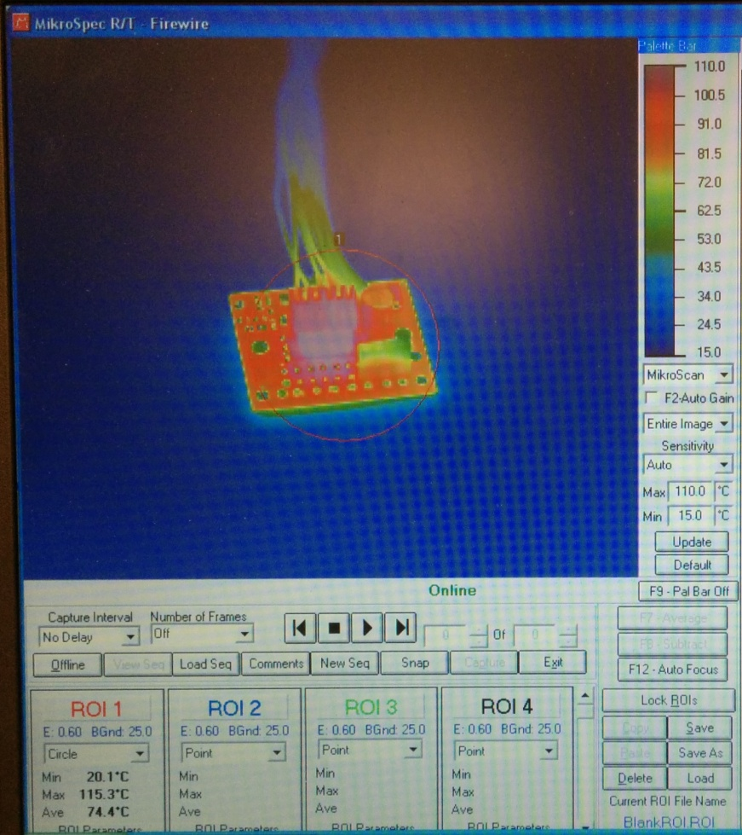

Figure : Big Easy Driver viewed with IR Camera (WW)

### Conclusion and Recommendations

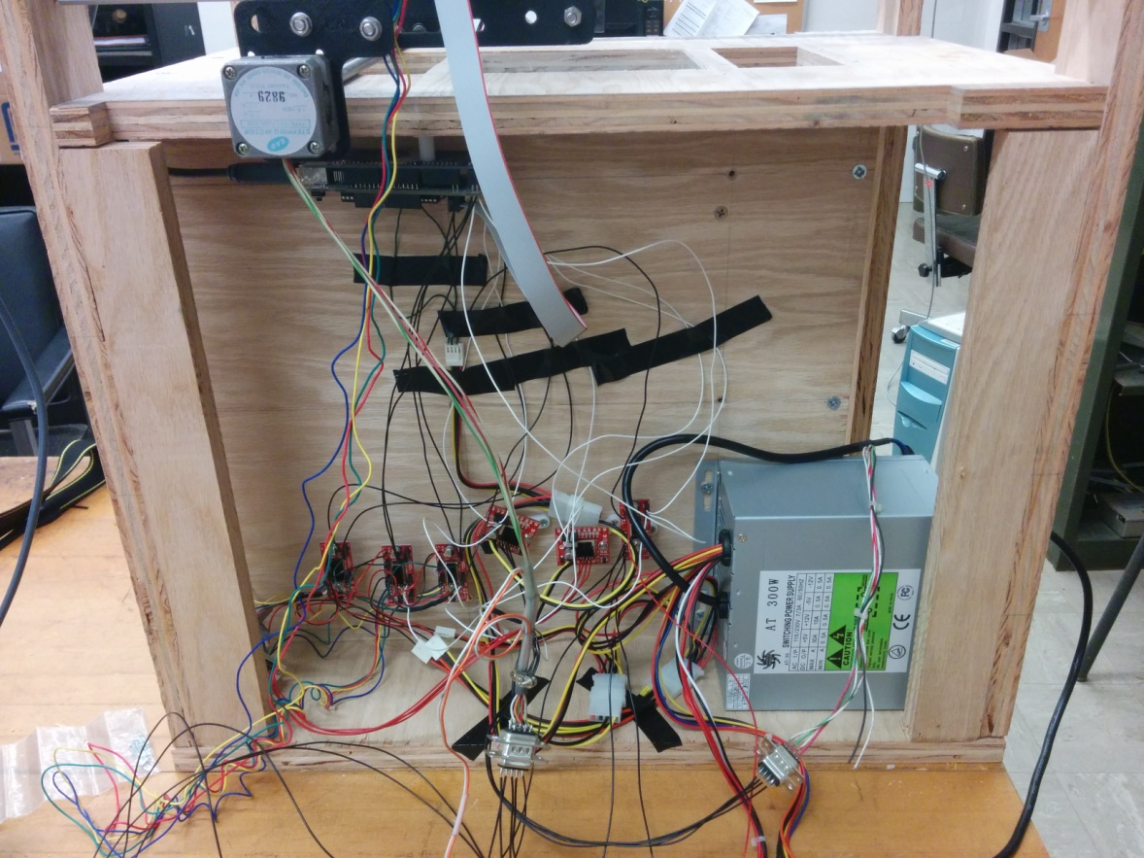

Figure : Printer Electronics Wiring (WW)

Overall, the electronics subsystem, if manufactured with the specified parts, will perform as expected. One major current design flaw with the prototype is the lack of wire management, and strong fasteners for the PCBs to connect to the printer's frame, as evidently shown in Figure 79: Printer Electronics Wiring. Although the current boards are fastened to the frame, both the boards and wires are relatively delicate and can be easily removed from their correct locations. Designs including better wire management are required for a production model of this printer.

## Microcontroller Software (WW)

### Overall Functional Description

The microcontroller software serves as the low level software control of the printer. It receives commands from the computer host software, and instructions the various systems to perform according to those instructions.

### Design Options

Similar to the computer host software, due to the fundamental differences between controlling a FDM based printer and a powder based printer, the microcontroller software had to be entirely written as original code. Whereas FDM can simply print out a part using the tool path commands G code and extrude plastic as it maneuvers through those tool paths, powder based printing prints out dots in lines, in a sequential fashion. This means that before the translation along the X axis can take place to print the line, the line's data itself must be first stored in the microcontroller's memory.

However, there were two aspects of the microcontroller software that have open source solutions. Due to the inclusion of the InkShield in the project, it already has software designed for the Arduino, to allow for directly telling the InkShield to fire the nozzle array exactly as desired. Shown in the code in the technical manual is the statement #include <InkShieldMega.h>, directing the Arduino software compiler to include the InkShield's prewritten code.

Additionally, it was possible to use the AccelStepper[8] library to control all of the axes on the printer. Stepper motors work by moving only one step every pulse that is given to the stepper motor driver. Stepper motors can't really be assigned velocities, the programmer would have to keep track of how many pulses are issued per unit of time to achieve a desired velocity. This is where the AccelStepper library proves to be critical for the easy implementation of stepper motor control. AccelStepper automatically controls stepper motor drivers to move with a specific velocity, and set acceleration, to drive to a certain step position. AceelStepper is essentially told to move towards a certain number of steps, and automatically accelerates, with the set maximum velocity, to the desired position. Luckily with AccelStepper, as many as desired can be ran at once, so multiple axis movements at once is possible.

### Design Approach

The design approach for the microcontroller is fairly straight forward. Firstly, Arduino code is required to have two methods implemented, setup() and loop(). Setup() is called when the Arduino boots, and loop() is executed continuously after setup() has completed.

#### Setup() Method

During this method, many objects are instantiated, including, but not limited to, all the AccelStepper objects that will control all the axes of the printer, the InkShield object, used to control the nozzles on the inkjet cartridge, and the serial communication that the microcontroller will listen to for commands from the computer host software.

#### Loop() Method

Figure : Microcontroller Software flow (WW)

The loop() method begins with a method to continuously look for a new character that is available on the Serial.read() buffer. Once an end of packet character has been detected, it will notify the code that a command has arrived, and is ready to be processed.

Once a packet is ready, before any actual payload processing takes place, it is important to verify the checksum of the packet, to determine (within reasonable margin of error) that the packet was not corrupted during transmission.

When the packet is beginning to be processed, the first task is to look for the first word in the packet (delimited by spaces). This tells the microcontroller what packet it is, from an axis movement, to an axis speed setting, or print line data. Once this is determined, the payload can be processed.

##### Axis Translation

if (firstWord == F("t2")) //translate powder bed platform

{

pos = payload.substring(3).toInt();

platformStepper.moveTo(pos);

platformTranslatingTo = pos;

platformMoving = true;

sendOkay();

}

Figure : Code snippet of Powder Platform Translation (WW)

Shown here, the payload of a powder bed platform translation is parsed. First, the position that the platform is expected to move to is extracted from the payload, and stored. Next the AccelStepper object that controls the platform stepper driver is instructed to move to the desired position. Next, a variable is set to true, such that the microcontroller knows to listen for it to finish translating. Lastly, the "ok" packet is sent.

The "ok" packet signifies that the command has finished processing, and the microcontroller is ready to receive and process the next packet from the computer host software. However, this platform stepper is still moving.

if (platformMoving)

{

if (platformStepper.currentPosition() == platformTranslatingTo)

{

platformMoving = false;

sendComplete();

}

}

Figure : Code snippet of Platform completion notification code (WW)

To notify the computer host software that the translation has *completed*, as opposed to just started, an if statement is used to keep track of when the platform stepper actually achieves its target position. When this happens, the if statement no longer needs to evaluate, and the "complete" packet is sent. It is important to note that the computer host software is actually unaware of what this complete packet is referring to, but in terms of the QueueManager's design for the computer host software, it is irrelevant. Only actions that require waits simply require *all* actions before it to complete, so which actions the complete packet actually refers to is information that is not needed.

##### Print Line Data Storage

The most complicated operation that the microcontroller must process is storing the encoded print line correctly into memory, such that, when the X translation for printing is issued, it can correctly print the waiting line.

if (firstWord == F("pli"))

{

int k = payload.substring(4, 7).toInt();

k = k * 13; //since we've broken up the print lines, this is the offset, 13.

int packetlength = payload.length();

int beginningOfData = 7;

int curPrintArrIndex = k;

for (int i = beginningOfData; i < packetlength; i += 3)

{

printArray[curPrintArrIndex] = (payload.charAt(i) & 15);

printArray[curPrintArrIndex] = printArray[curPrintArrIndex] << 4;

printArray[curPrintArrIndex] = printArray[curPrintArrIndex] | (payload.charAt(i + 1) & 15);

printArray[curPrintArrIndex] = printArray[curPrintArrIndex] << 4;

printArray[curPrintArrIndex] = printArray[curPrintArrIndex] | (payload.charAt(i + 2) & 15);

curPrintArrIndex++;

}

sendOkayComplete();

}

Figure : Code snippet of print line information processing (WW)

Firstly, for storing a print line, the number of the print line must be calculated. This is because an entire print line can't fit into the maximum size of a packet, which happens to be 64 characters, as limited by the serial data buffer onboard the Arduino MEGA. Additionally, the length of the packet must also be noted, since not every print line will use up all 13 nozzle arrays that can fit into the packet.

Next, the actual nozzles fires are processed, all the way to the end of the packet. Each nozzle fire takes up 3 characters, and must be padded with a constant (in this case 0x0050), due to the nature of sending characters over serial. (Any characters that are 0x000 aren't even treated as characters, so, if there was a location where the nozzles weren't supposed to be fired, it would be overlooked).

This print line information packet is one of the packets where it is permissible to send both "ok" and "complete" to the computer host controller. Once the for loop has completed, there is no longer any processing or action that is time consuming that is taking place.

# Conclusions and Recommendations (PZ)

The microcontroller software, as is, is fully ready for production. Of course, if any changes to the computer host software are made, it is vital to ensure that these changes do not conflict with the current packet format and overall printing flow that the current computer host software is envisioned to operate with.

##### Potential Improvements

1. Multiple print line buffer
   1. Sending the print line data for each line is significantly time consuming, so one potential way to speed this up is to feature two print line buffers. At any one point in time, the microcontroller could hold 2 print lines, and utilize the time that is wasted during a print X translation, to send over a new line. This currently cannot be done because the current array is already in use for the line being printed, so using a print line buffer of two or more has great potential for speed increase.

# Other Issues (SA)

## Health and Safety Consdierations

The system being examined from a design perspective is a 3D printer. This device is designed to take a CAD model and produce a three dimensional object based upon the specifications entered. There are different elements that can go wrong with a 3D printer. Any device that uses electronic parts and electricity during operation requires safety precautions. Before operation of the 3D printer, the electrical wiring of the device must be checked. The operator is looking for frayed or exposed copper wiring that would present an electrocution or fire hazard. If faulty or damaged wiring is found then use of the machine must be delayed until repairs to the wiring can be completed. Since there is exposed wiring on the device, accumulation of powder can be a problem if not cleaned on a regular basis. It is recommended that excess powder be cleaned from the machine daily. The computer where commands are entered is positioned away from the printer to prevent powder from accumulating over the computer. According to OSHA standards 29 CFR 1910, fire safety is required in all commercial settings. 29 CFR 1910 §159 requires adequate fire suppression system located near the machine operation area. Additionally, a fire extinguisher needs to be in close proximity to the machine and clearly marked. OSHA regulations state, “The employer shall provide portable fire extinguishers and shall mount, locate and identify them so that they are readily accessible to employees without subjecting the employees to possible injury” (29 CFR 1910 §157(c)(1))

As with any machine, there is the risk of a motor failure. If the motor fails the system will not work. The motor of the machine must be examined prior to use on each day the machine is in operation. The user must examine for wear and signs of engine stress. Additionally, x/y motors and z-axis motors are subject to wear and strain and should be serviced on a regular basis. This is accomplished through physical and visual examination of the motors. Any wear that is noticed must be fixed prior to operation of the machine. Preventative maintenance is important since failure of any drives will prevent the system to operate correctly and may lead to costly repairs of the machinery. The cost of the components will vary depending upon complexity and the parts required in the system. Most of the components are designed to be replaceable in an effort to keep repair costs minimal on this machine. However, without regular inspection and maintenance problems will compound and lead to major repairs or the machine becoming inoperable. The machine design could be modified to include sensors on the machine that warn if the system is not operating at peak efficiency. Since there are many moving parts, heat sensors would be among the types of sensors that could be added to the machine. These sensors would help to pinpoint that area of trouble and would allow preventive maintenance to address the problem before a failure occurs. While the sensors would not be without cost, the money saved in the prevention of complete failure and production time lost while the machine in not functioning would make this a cost effective option for this machine.

## Environmental and Societal Issues

The world is becoming conscious of waste and this machine is an important step forward in that regard. Companies lose millions of dollars every year due to waste. The advantage of this machine is that it produces the finished product with the barest use of materials. The printing process follows the pattern placed in the computer system and only applies materials to the areas that are being constructed. This eliminates the need for molds and the waste material molds inevitably produce. The ability of this machine to make a single copy, or multiple copies, is another advantage in a world that is moving towards just in time manufacturing. The end user does not need to make enough of the product to have pieces in inventory. By making only the units that are needed the inventory is kept to minimum which eliminates the potential of parts becoming too old or damaged for use. Old inventory is routinely discarded and adds to the waste generated by the industrial world. Instead, they can make as many, or as few, of a production as is required by the situation. This saves time, effort, and money. Just as importantly, since the printer is able to manufacture products without producing a lot of waste it has a positive impact on the environment. This helps to cut down on the amount of waste generated by the machine that would otherwise end up at a recycling station or at a landfill.

# Conclusions and Recommendations (PZ)

As stated numerous times throughout this report, the full system testing of the operational prototype has just recently began. Therefore, at this moment it is difficult to say whether the project should be implemented or not; we are unable to evaluate the prototype’s optimum performance. An upside is that the subsystems operate independently as they should. In order to decide whether implementation is plausible, it is crucial that further experimentation be carried out; there are just so many variables of the printing process that can be altered to obtain differing results. Additional work to be done involves experimentation with the powder and binder recipes as a result of full system tests. Experimentation with the settings of the printer would also be involved, such as the print layer thickness, overlap of liquid binder droplets, and various speeds and step settings of each motor. The amount of recommendations for this prototype could be virtually endless. Therefore, only the most influential and plausible recommendations are mentioned.

There are various components and mechanisms that if incorporated within the prototype, would more than likely increase the quality of its performance. One recommendation is to design and implement an excess powder removal system for the top panel of the frame. Although an excess powder removal system and chute has been designed and included in the prototype, there should still be more unused powder accumulating on the top panel that may end up falling off the edge. This is a result of repeated layers of powder being distributed by the rolling mechanism. It would be best to avoid this situation, because the said falling powder would have the chance to disrupt or even damage the electronics of the prototype. The initial full system tests showed that a significant amount of powder accumulates behind the rolling mechanism, near the edge of the right side of the prototype’s top panel. A design that includes a Snap-on or quick tray-removal system would be preferred, for speed and simplicity.

Another recommendation for the mechanics of the prototype would be to design and implement a rail system for the Powder Platforms Subsystem. It was discovered late in the project that most similar machines, such as tabletop CNCs, include a components that the z-axis “platforms” are able to ride as the traverse up and down. This type of system is implemented in order to ensure that the vertical movement is *perfectly* vertical; it is common for the threaded rod used for lead screws to not be *perfectly* straight. An example of said rail system can be seen in Figure 84 below.

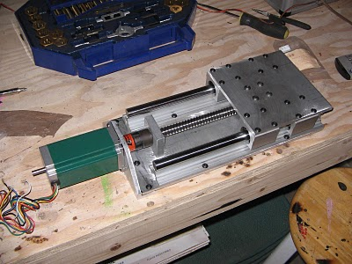

Figure : Sample for recommended platform system (WW)

In regards to this prototype, the threaded rod that was used for the lead screws was not perfectly straight. However, one of the rods was almost perfectly straight, so it was used for the Powder Printing Platform; the other rod was clearly not straight, it was used for the Powder Source Platform. The better quality rod was used for the Powder Print Platform because it is imperative that the platform’s movement is uniform, so that the printed part is not jeopardized. From the initial full system tests, we found that it is crucial to upgrade this threaded rod. The Powder Source Platform needs to traverse in unison so that an even amount of powder be distributed throughout the Powder Print Platform.

The initial full system tests also showed us that is imperative to upgrade the smoothness of the rolling bar of the Rolling Mechanism. The current rolling bar has a semi-rough surface, it is causing too much friction between itself and the powder. This friction is causing small ridges to curl up from the back side of the bar as it rolls over the powder. These ridges are one of the main reasons that "caking" occurs within the final model; the layers will not solidify together appropriately. We recommend either purchasing a high-quality smooth rod or applying a Teflon non-stick dry film lubricant (shown in Figure 85) to the outer surface of the current rolling bar.

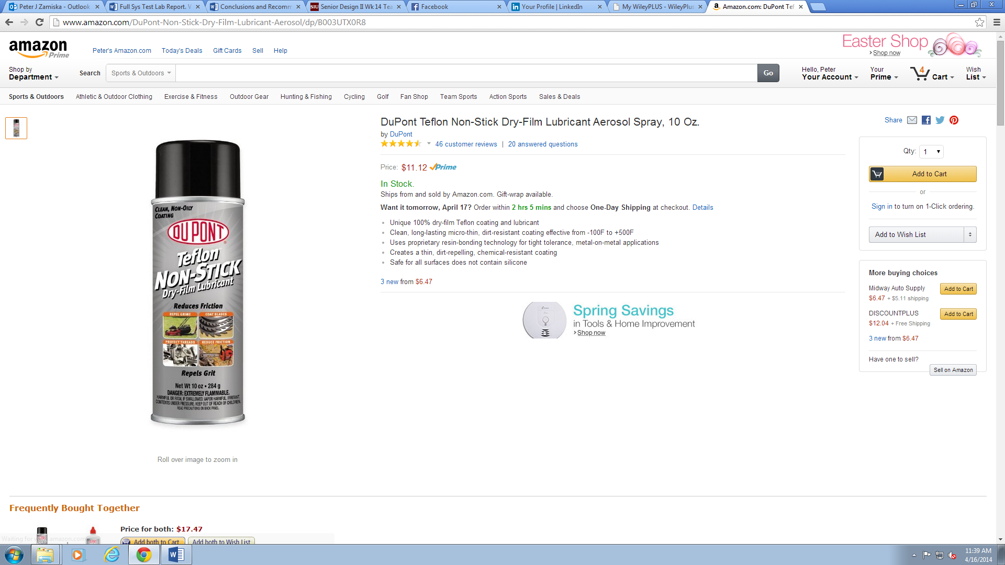

Figure : DuPont Teflon non-stick dry film lubricant product [15] (WW)

Due to time constraints, the prototype incorporates many significantly heavy, but high quality, components for the X/Y translation system. It is recommended that these components be reproduced or custom made out of a lighter material. Many of the steel mounting plates can be machined out of common Plexiglas, as the Ink Assembly was. That would significantly decrease the weight of the X/Y Translation subsystem, as well as the printer as a whole. Theoretically this would reduce the stress on the involved stepper motors, decreasing the fault risk, possibly increasing speed possibilities.

The prototype’s frame should be enhanced, in regards to the simplicity of assembly and structural soundness of the printer as a whole. Looking back, it was quite crude to use wood as the material for the frame. However, at the time the financial benefits seemed to outweigh the mechanical deficiencies. A design that implemented a metal or composite frame would be preferred. It is recommended that each of the panels of the frame are designed to interlock and be bolted together, rather than screwed together. An example of such design, also used for a 3D printer, can be seen in Figure 86 below.

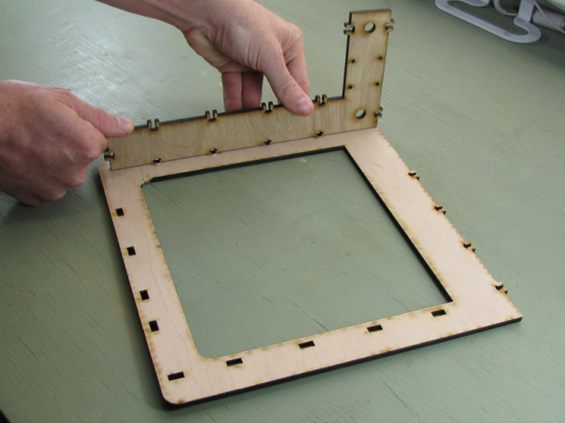

Figure : Example of frame design recommendation (WW)

As of now, there are few recommendations for enhancements of the software and the electronics of the printer. One applicable activity for the electronics is to improve the wire management. A recommendation for the software is to implement a save feature for the GUI. Therefore, the user would be able to save certain values that were calculated and used in previous printing operations.

# Appendices

Bibliography

|  |  |
| --- | --- |
| [1] | J. F. Bredt, T. C. Anderson and D. B. Russell, "IP Research & Communities," 09 07 2002. [Online]. Available: http://www.freepatentsonline.com/6416850.html. |
| [2] | S. Aldrich, "Matrial Safety Data Sheet," Sigma-Aldrich Co. LLC, 19 01 2012. [Online]. Available: sigma-aldrich.com. |
| [3] | "Glycerol," Carolina Biological Supply Company, 12 11 2012. [Online]. Available: www.carolina.com. |
| [4] | P. T. S. Division, "Hazard Alert - Plaster of Paris," Pembina Trails School Division, [Online]. Available: http://www.pembinatrails.ca/wsh/Hazard%20Alerts/HAZARD%20ALERT%20-%20Plaster%20of%20Paris.pdf. |
| [5] | "Repetier Software | The software driving your 3d printer," [Online]. Available: http://www.repetier.com/. |
| [6] | "Arduino - ArduinoBoardMega," [Online]. Available: http://arduino.cc/en/Main/arduinoBoardMega. |
| [7] | "InkShield | Nicholas C Lewis," [Online]. Available: http://nicholasclewis.com/projects/inkshield/. |
| [8] | "AccelStepper: AccelStepper library for Arduino," [Online]. Available: http://www.airspayce.com/mikem/arduino/AccelStepper/. |
| [9] | "EasyDriver Stepper Motor Driver," SparkFun Electronics, [Online]. Available: https://www.sparkfun.com/products/10267. [Accessed 17 November 2013]. |
| [10] | "Big Easy Driver Bipolar Motor Controller," RobotShop, [Online]. Available: http://www.robotshop.com/en/big-easy-driver-bipolar-motor-controller.html. [Accessed 17 November 2013]. |
| [11] | "Stepper Motor with Cable - ROB-09238," SparkFun Electronics, [Online]. Available: https://www.sparkfun.com/products/9238. [Accessed 17 November 2013]. |
| [12] | "Small Heatsink - PRT-11510 - SparkFun Electronics," [Online]. Available: https://www.sparkfun.com/products/11510. |
| [13] | "Pwdr - Open source powder-based rapid prototyping machine," [Online]. Available: http://pwdr.github.io/. |
| [14] | "Linear Positioning Drives," [Online]. Available: http://www.walkeremd.com/Linear-Positioning-Drives-LS4118S1404-T6x2-150-p/ls4118s1404-t6x2-150.htm. [Accessed December 2013]. |
| [15] | "Monster Fastener," 2014. [Online]. Available: http://monsterfastener.com/itemview.aspx?itm=LNSS-131&gclid=CMDzytPkyr0CFcdaMgodcQ4AKQ. [Accessed 5 April 2014]. |
| [16] | "Shop - Sports and Outdoors," Amazon, [Online]. Available: http://www.amazon.com/DuPont-Non-Stick-Dry-Film-Lubricant-Aerosol/dp/B003UTX0R8. [Accessed 16th April 2014]. |

## Full System Test Lab Report (WW/PZ/HL)

### Objective

The purpose of this report was to test the full functionality of all subsystems of the printer, serving as our first full system test. Specific key operations and results were observed, recorded, and commented upon:

* software integrity
* frame/structural integrity
* layer print time
* axis movement performance
* rolling mechanism operation
* powder distribution
  + uniformity, etc.
* binding agent performance
* X/Y translation rail performance
* excess powder trough and trapping cup
* quantity of powder dislodged from each platform
* post processing
  + part removal
* post printing cleanup

### Procedure

1. Initiate communication between the computer host software and the printer electronics.
2. Setup all axis definitions.
3. Move the rolling mechanism out of the way so powder can be loaded into the beds, and packed a decent amount.
4. Use the already sliced gear, process and print the part, monitoring the printer until competition.
5. Allow for several hours of drying/solidification time.

### Results

Two separate prints have been done, so as to maximize the amount of results obtained from our full system tests. The first test was a 1:1 scale of the gear to be printed, and the second was a 2:1 scale of the same gear, with a few of the printer settings changed.

#### Test 1

The very first thing that was noticed during the first test is that the rolling mechanism left many ridges in the powder severely affecting the quality of the layers as they were printed.

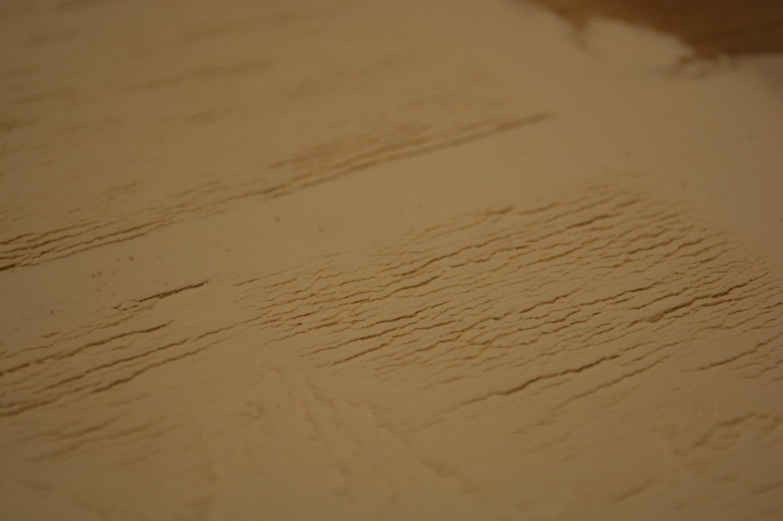

Figure : The surface of powder on the platforms (WW)

As a result, the printed part experienced what is referred to as "caking", where the printed layers do not absorb the binding agent uniformly.

During and after the print, we did not observe any faults or failures throughout the frame of the prototype. The experiment did not result in any concerns regarding the structural integrity of the frame. However, it is important that we continue monitoring the frame during and after each print so that any fault of failures may quickly be attended to.

The part removal and post-processing of the printed model was somewhat crude for the first full system test. Trying our best not to compromise the printed part, significant care was involved with removing said part from the powder print platform. We simply used a 1/3 cup measuring spoon and plastic spoon to "dig" the part out and set it on the table.

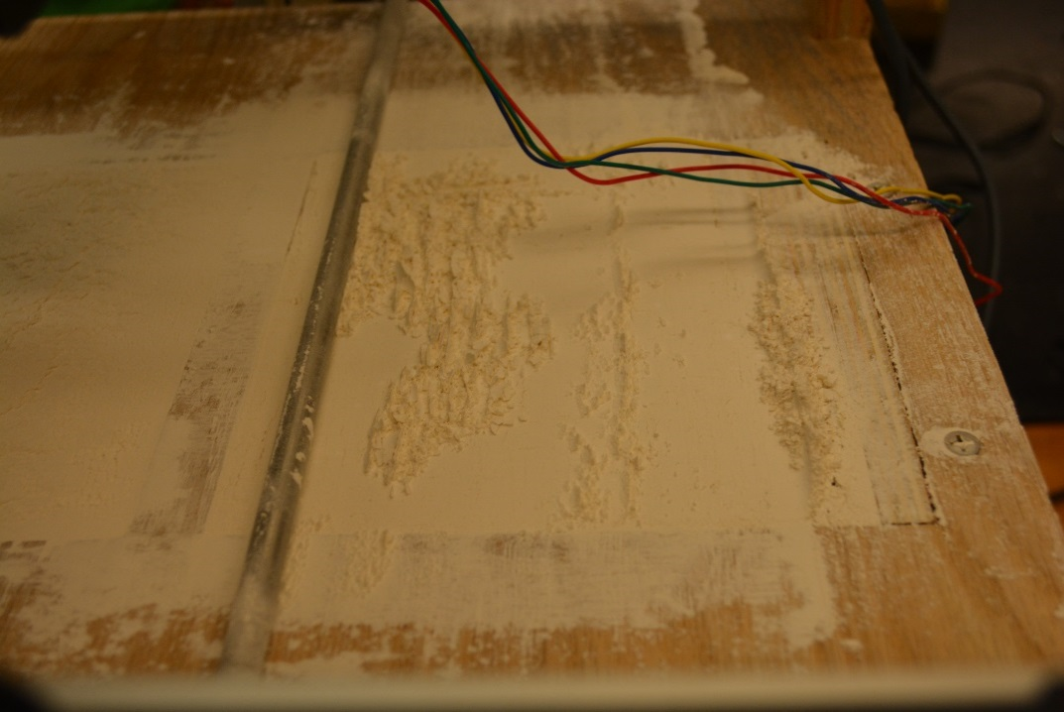

Figure : Powder sticking on the rolling bar (WW)

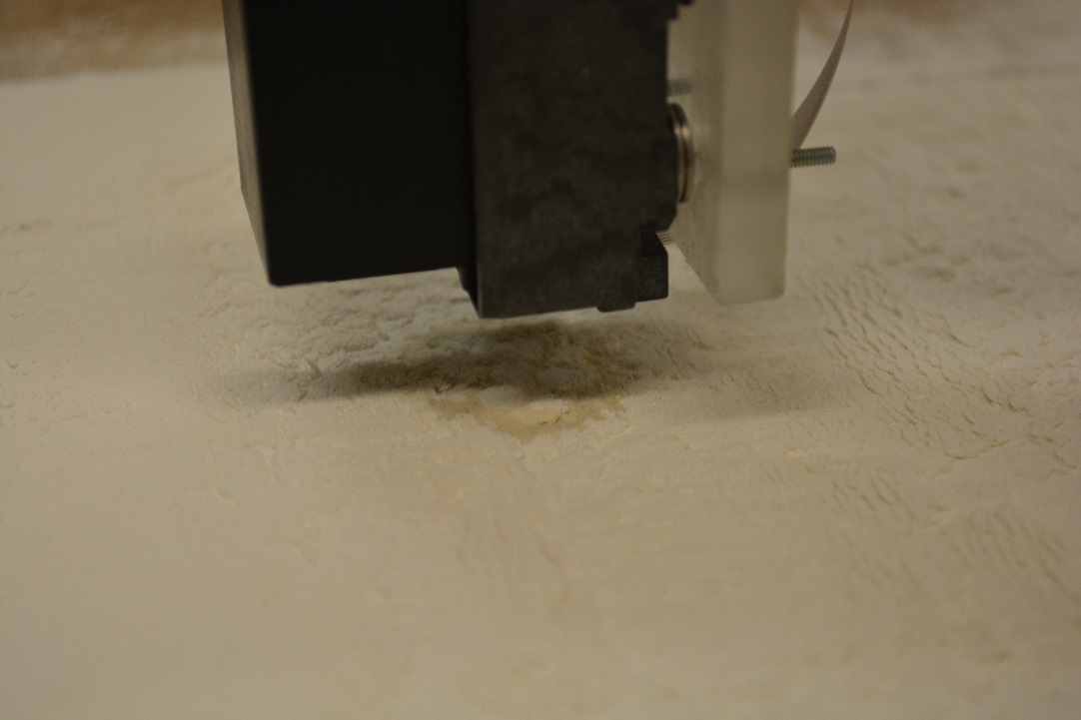

Figure : Unsmooth surface on the platform and product (WW)

Both of Figure 88and Figure 89 were taken during the printing process. It is clear to see some powder is adhering on the rolling bar, leading to an unsmooth surface of powder. This problem is related to the material properties of solubility and viscosity, which is controlled by the ingredients chosen for an adhesive, reinforcer, and filler in the powder recipe. 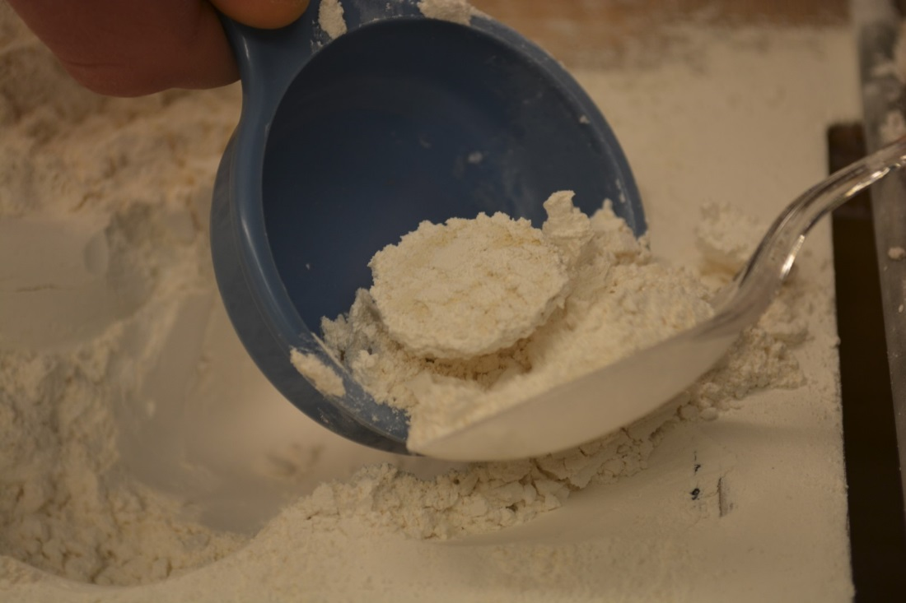

Figure : Recover of part from powder bed (WW)

At this point, we were unsure as to what was the best, safest method of removing the excess powder from the printed part. Prior to this test, we were unsure if we would even be capable of removing the printed part, let alone incorporate post processing. On hand in the lab, we had a brush that had smooth bristles and some tweezers; these components were deemed the most viable method.

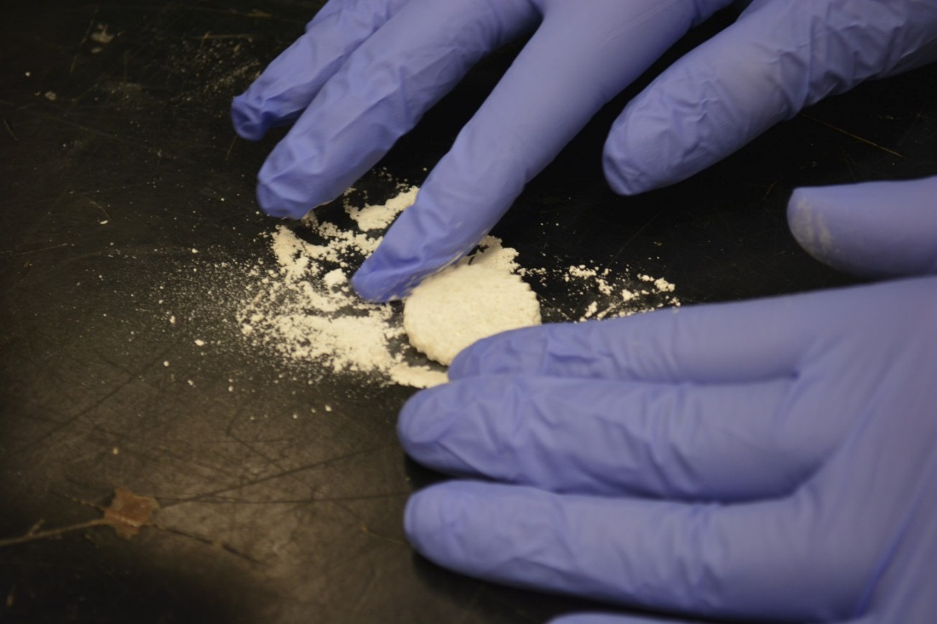

Figure : Dusting off of recovered part (WW)

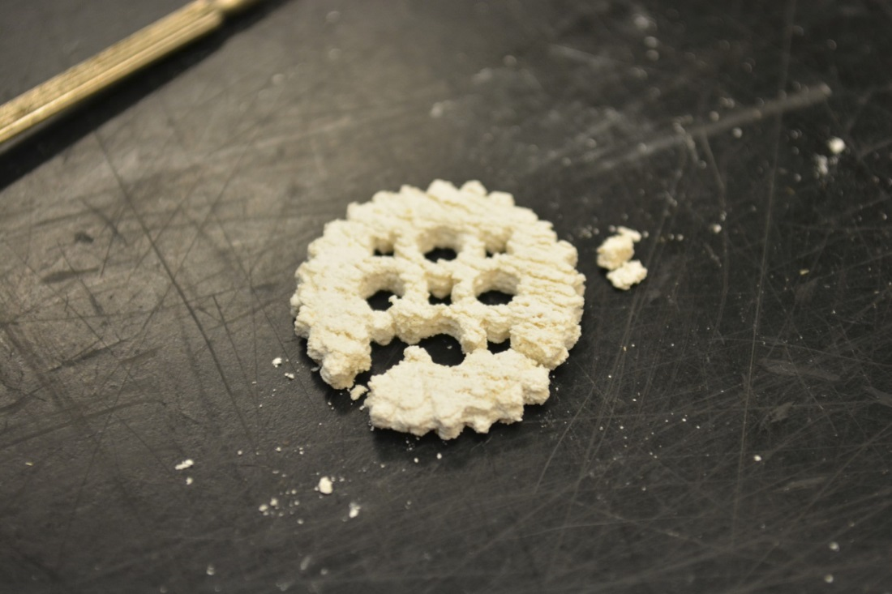 This method resulted in some progress, but not enough. Therefore, we attempted to simply blow the powder off of the part while holding it with the tweezers. The results from this method were good at first, but then a section of the part, about 20% of the whole part, unfortunately snapped off.

Figure : Broken Product (WW)

It was actually pretty surprising just how much force the printed part was able to withstand without fracture; similar projects' first full system tests usually result in the part crumbling apart upon removal.

The hardness of the product was too low; it was easily broken (shown in Figure 92). This can be related to the properties of bonding strength, which is controlled by the ingredient of adhesive and filler in the powder recipe.

##### Further Improvements

The experiment could be improved by using a different rolling bar that would produce uniformly distributed layers of powder. This new and improved bar would of superior quality; it would be extremely smooth to the touch. In theory, a smoother bar would incorporate less friction between it and the powder, resulting in less (or hopefully no) ridges forming in the powder. In addition, we plan to experiment with various forms of rotation and powder distribution, in regards to the rolling mechanism.

The printed part should be left to rest for more time so that the binding agent can fully bind the powder. Another improvement would be using a very soft brush that would not cause harm to the printed part while cleaning it from excess powder. Taking these improvements into account will produce more precise and accurate results.

#### Test 2

This second full system test resulted in several faults. First, the rolling bar was not spreading equal amounts of powder along the X axis. This had a devastating effect on the printed part, since each of the powder layers were not of equal thicknesses; some layers even "ran out" of powder to spread to the part, as seen below.

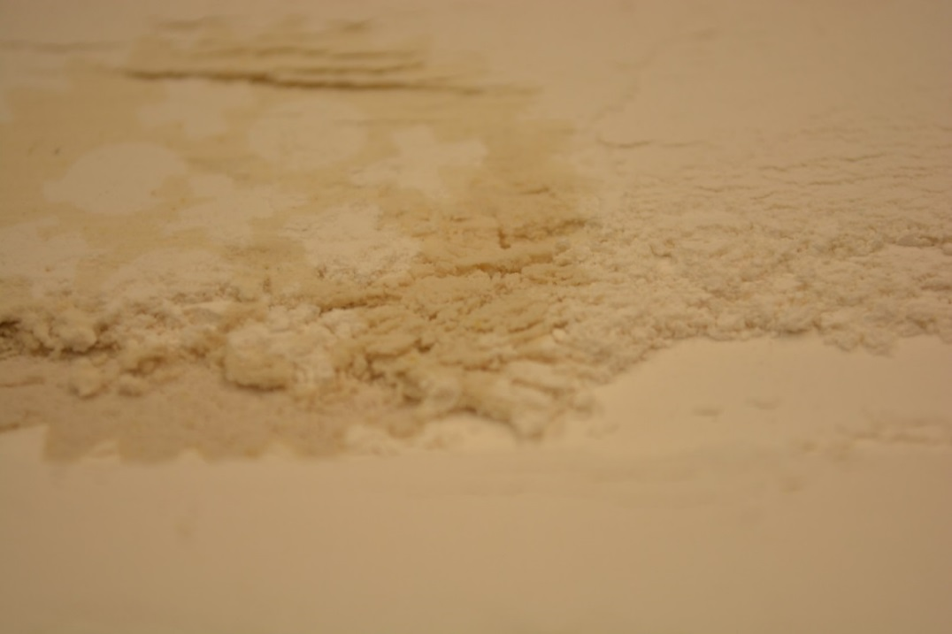

Figure : Uneven powder distribution (WW)

Another fault that was observed during this experiment was the density of the powder. Beforehand, the team had theorized that the printing process would be more effective if the powder was compressed within the powder chamber. This led to be false. The powder was so compacted within the chamber that it would not traverse down as the platform was lowered. Since the powder would stay in one place, the rolling bar kept destroying each previous layer of powder.

##### Further Improvements

We have concluded that the un-uniform powder distribution is mainly a result of the quality of the threaded rod that was used for the lead screw of the powder source platform. Due to severe time and financial constraints, the threaded rod that we had obtained was not perfectly straight. This offset greatly compromised the platform's ability to traverse in unison along the Z-axis. It is imperative that a new, higher quality lead screw is obtained to take the faulty one's place within the linear positioning system of the powder source platform. Luckily for us, interchanging the components will not involve much labor since each of the lead screws are coupled onto the stepper motor shafts. It is recommended that the powder not be forced, or compacted, into the chamber. Rather, the user should only compact the powder within the Teflon tray. The rest of the powder should simply be inserted within each chamber and leveled off with the rolling mechanism; it should not be pressed into the chambers.

## Drawings

The following pages contain all engineering drawings referring to the above stated design.

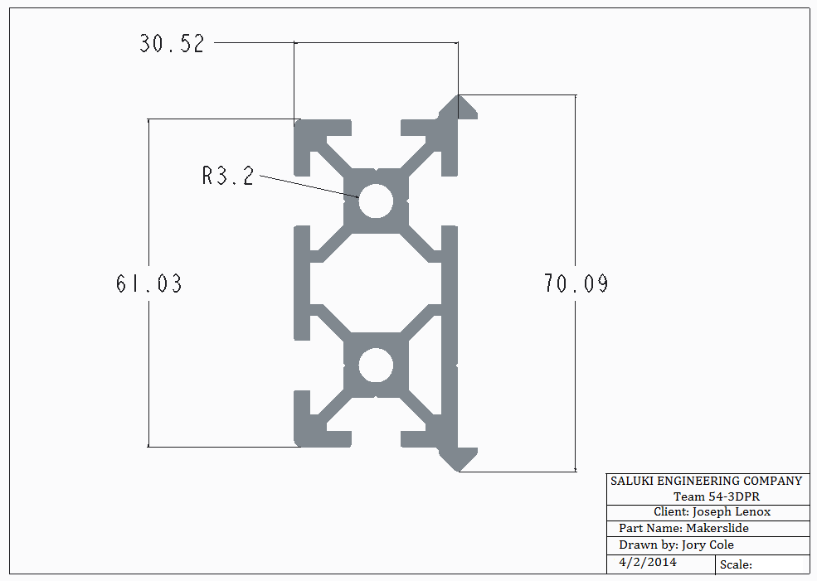

Drawing : Makerslide cross section (JC)

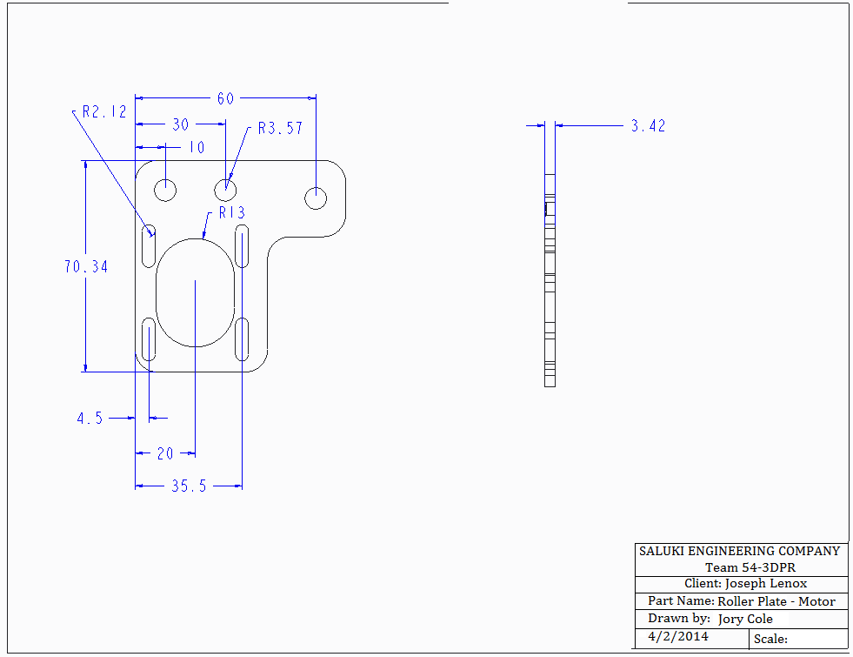

Drawing : Roller plate - Motor (JC)

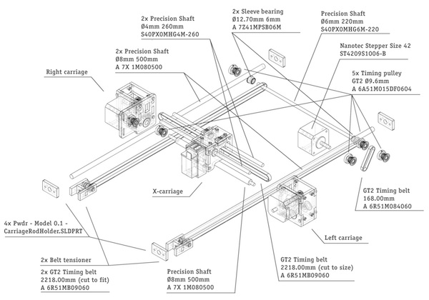

Drawing : Pwdr. Project's X/Y Translation assembly drawing [13] (JC)

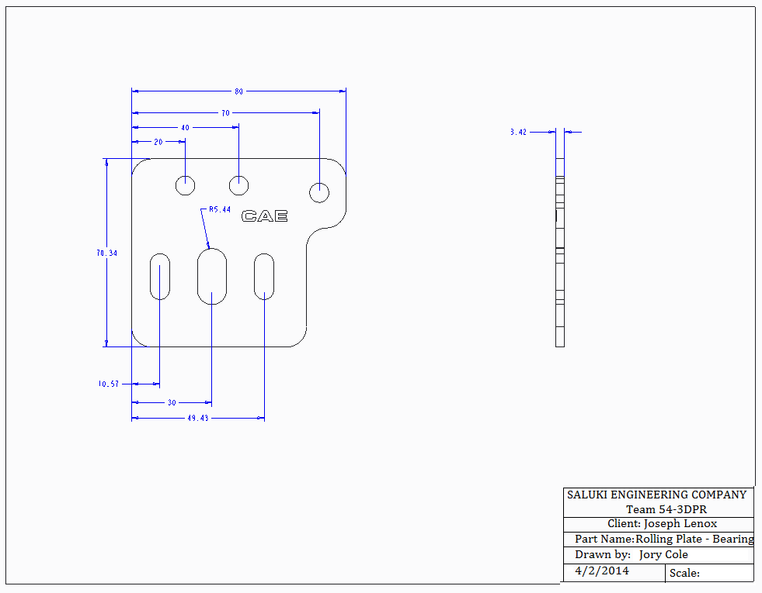

Drawing : Rolling Plate - Bearing (JC)

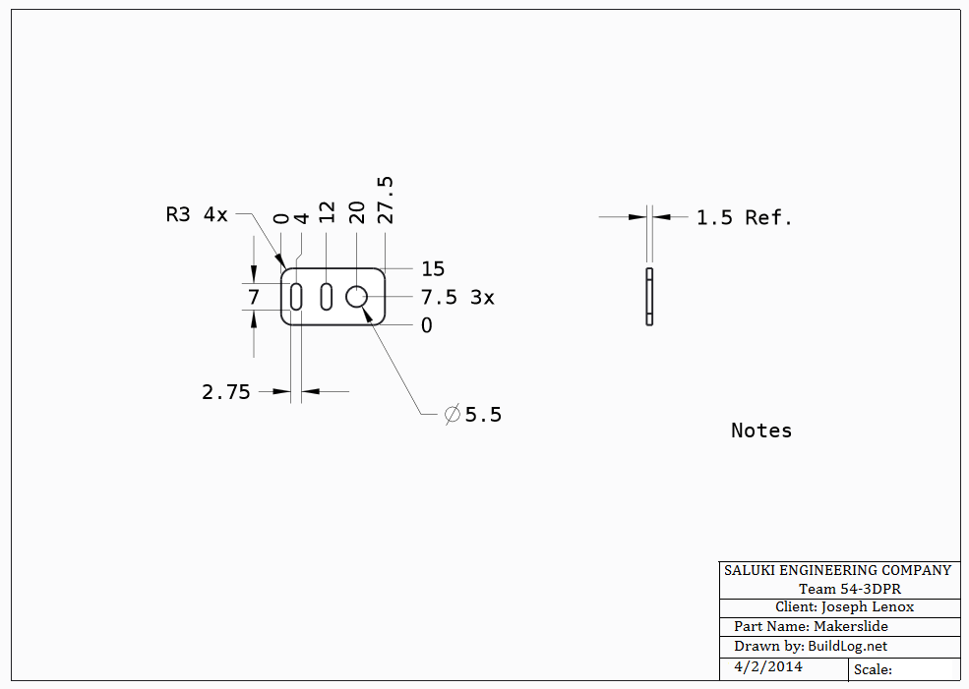

Drawing : Makerslide belt clip (JC)

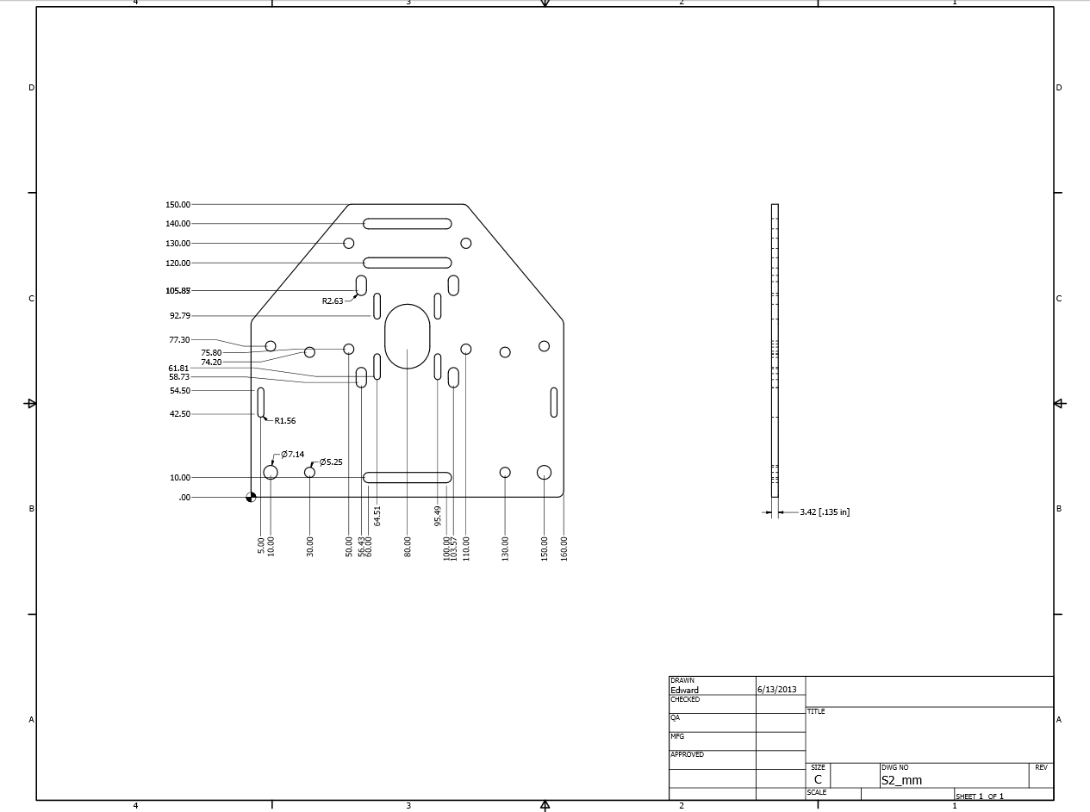

Drawing : Makerslide motor mounting plate (JC)

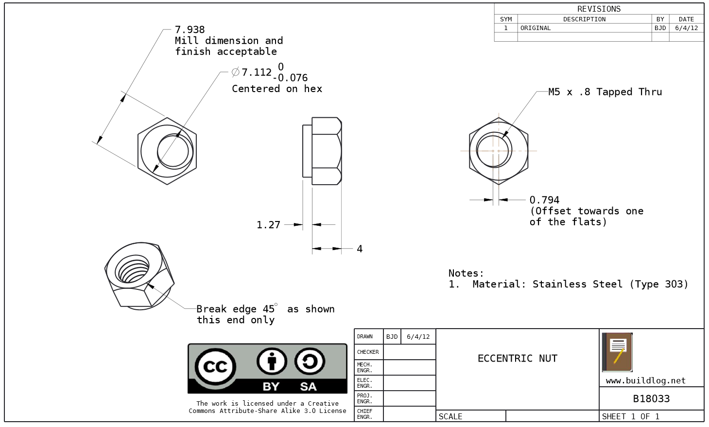

Drawing : Makerslide eccentric nut (JC)

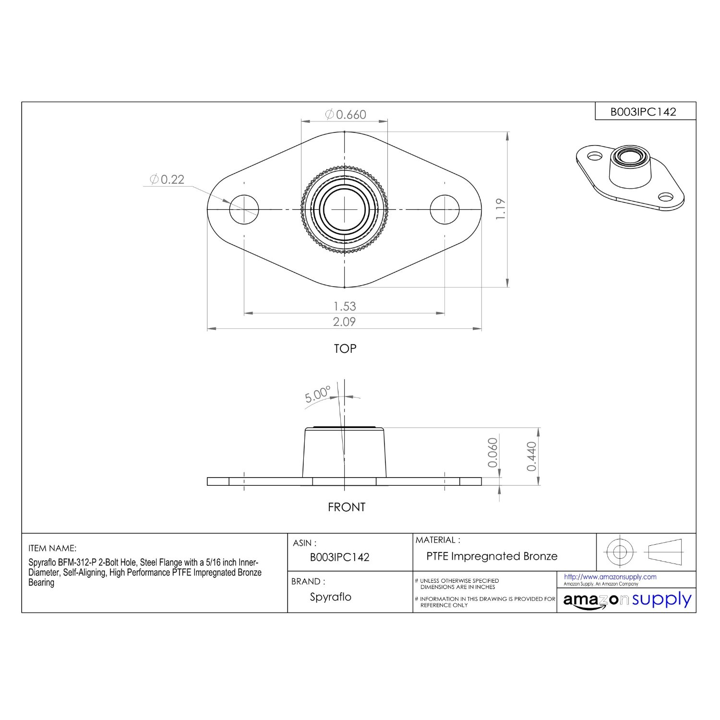

Drawing : Rolling Mechanism Flange (JC)

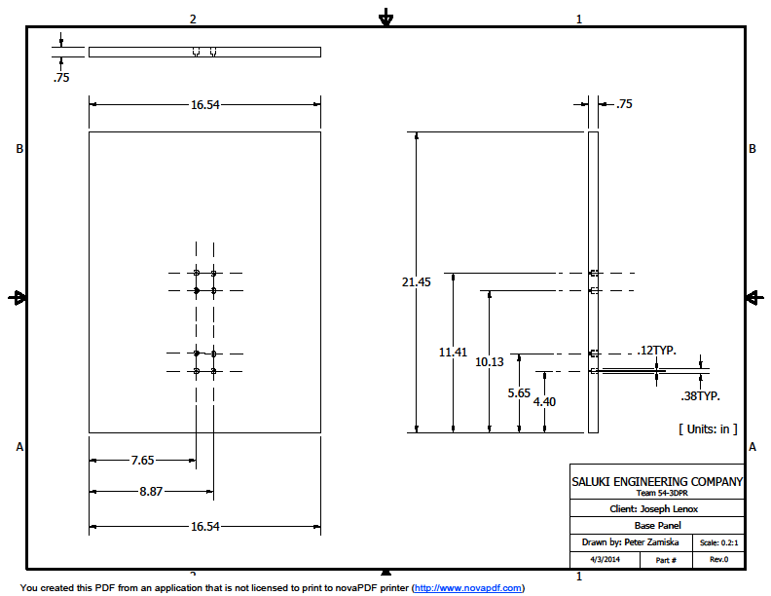

Drawing : Base Panel (PZ)

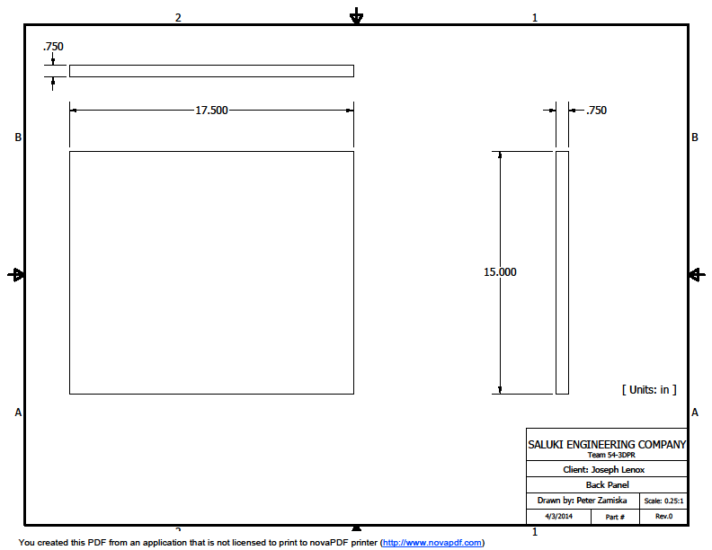

Drawing : Back Panel (PZ)



Drawing : Coupler Set Screw (1/16th) (PZ)



Drawing : Coupler (PZ)



Drawing : Frame Column A (PZ)

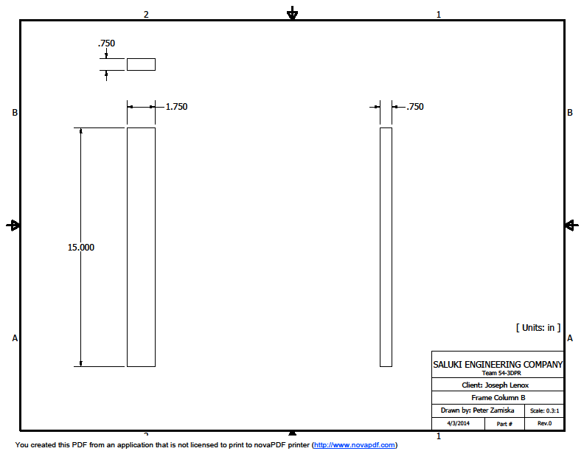

Drawing : Frame Column B (PZ)



Drawing : Front Panel (PZ)



Drawing : Glass Panel 7.5 x 4 in (PZ)



Drawing : Glass panel 7.5 x 6 in (PZ)



Drawing : Glass side panel (PZ)



Drawing : Lead Nut (PZ)

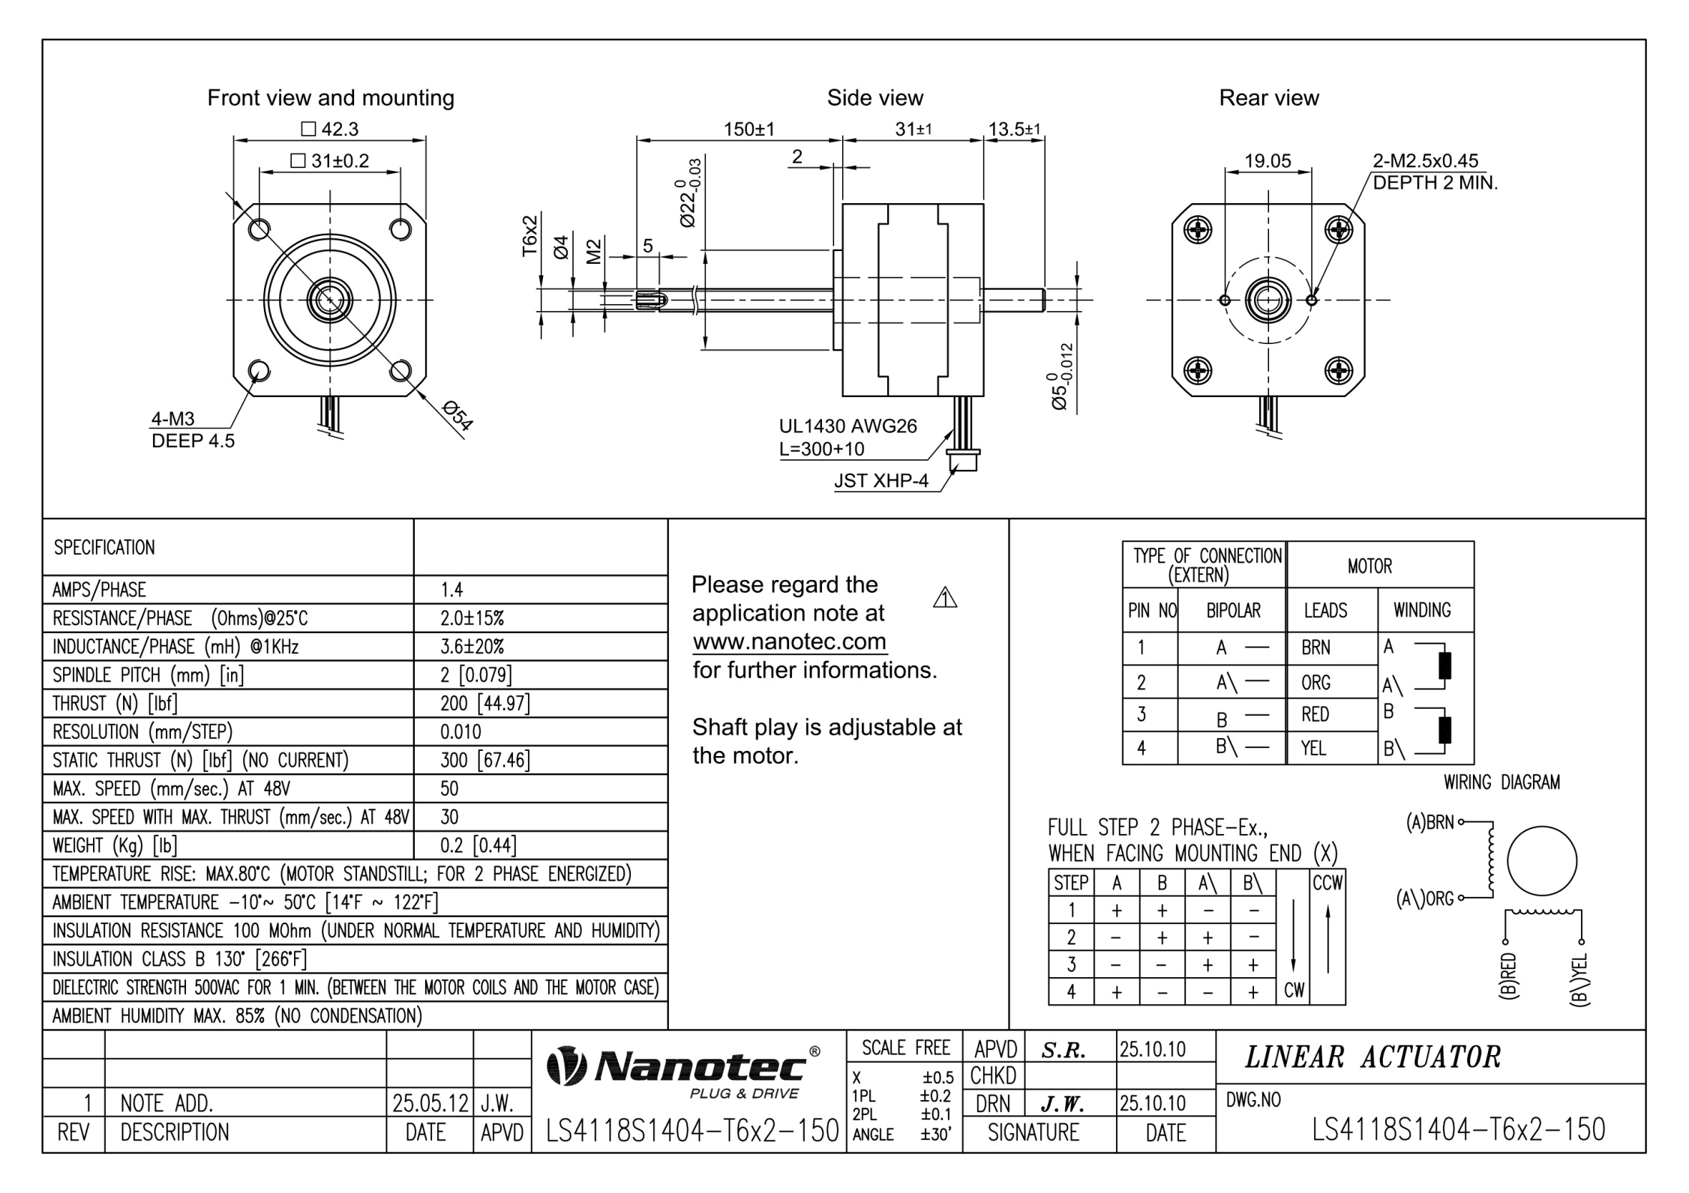

Drawing : Nema stepper motor [17] (PZ)



Drawing : Platform panel bracket (PZ)



Drawing : Platform Subsystem (PZ)



Drawing : Platforms Exploded View (PZ)



Drawing : Powder Platform side panel (PZ)



Drawing : Powder Print Platform base panel (PZ)



Drawing : Powder Print Platform top panel (PZ)



Drawing : Powder Source Platform base panel (PZ)



Drawing : Powder Source Platform top panel (PZ)



Drawing : Side Panel A (PZ)



Drawing : Side Panel B (PZ)



Drawing : Teflon - Powder Print Platform (PZ)



Drawing : Teflon - Powder Source Platform (PZ)



Drawing : Wood Spacer (PZ)



Drawing : Z Motor Screw (PZ)



Drawing : Ink Assembly - plexiglass mounting plate (PZ)

**Stepper motor**

**A**

**A'**

**B**

**B'**

**Stepper motor**

**A**

**A'**

**B**

**B'**

**Arduino MEGA**

|  |  |
| --- | --- |
| **VIN**  **Ground** | **Digital I/O (2)**  **Digital I/O (20)**  **Digital I/O (21)**  **Digital I/O (22)**  **Digital I/O (23)**  **Digital I/O (24)** |
| **USB** | **Digital I/O (25)**  **Digital I/O (48)**  **Digital I/O (49)**  **Digital I/O (50)**  **Digital I/O (51)**  **Digital I/O (52)**  **Digital I/O (53)**  **Ground** |

+12V

**InkShield**

|  |  |
| --- | --- |
| **VIN**  **Ground** |  |
| **Pulse Pin** | **14 Pin Ribbon** |

**HP C6602**

**14 Pin Ribbon**

+12V

**EasyDriver**

|  |  |
| --- | --- |
| **VIN**  **Ground** |  |
| **Enable**  **MS1**  **MS2**  **Ground**  **Step**  **Direction** | **A**  **A'**  **B**  **B'** |

Y axis motor B

+12V

**EasyDriver**

|  |  |
| --- | --- |
| **VIN**  **Ground** |  |
| **Enable**  **MS1**  **MS2**  **Ground**  **Step**  **Direction** | **A**  **A'**  **B**  **B'** |

**Stepper motor**

**A**

**A'**

**B**

**B'**

Rolling mechanism motor

**EasyDriver**

|  |  |
| --- | --- |
| **VIN**  **Ground** |  |
| **Enable**  **MS1**  **MS2**  **Ground**  **Step**  **Direction** | **A**  **A'**  **B**  **B'** |

**Stepper motor**

**A**

**A'**

**B**

**B'**

X axis motor

+12V

+12V

**EasyDriver**

|  |  |
| --- | --- |
| **VIN**  **Ground** |  |
| **Enable**  **MS1**  **MS2**  **Ground**  **Step**  **Direction** | **A**  **A'**  **B**  **B'** |

Y axis motor A

+12V

**BigEasy Driver**

|  |  |
| --- | --- |
| **VIN**  **Ground** |  |
| **Enable**  **MS1**  **MS2**  **Ground**  **Step**  **Direction** | **A**  **A'**  **B**  **B'** |

**Stepper motor**

|  |
| --- |
|  |
| **A**  **A'**  **B**  **B'** |

Platform motor

+12V

**BigEasy Driver**

|  |  |
| --- | --- |
| **VIN**  **Ground** |  |
| **Enable**  **MS1**  **MS2**  **Ground**  **Step**  **Direction** | **A**  **A'**  **B**  **B'** |

**Stepper motor**

|  |
| --- |
|  |
| **A**  **A'**  **B**  **B'** |

Source motor

+12V

USB cable

Drawing : Electronics Circuit Wiring Diagram (WW)

|  |  |  |  |
| --- | --- | --- | --- |
|  | | | |
| *SALUKI ENGINEERING COMPANY*  SEC Reference # Team 54-3DPR | | | |
| Client: Joseph Lenox | | | |
| Title: Printer Electronics Circuit | | | |
| Drawn by: Wheeler Weise | | Scale: N/A | |
| Date: 4/1/2014 | Drawing Number: | | Rev. 0 |